AKHBAR EL-YOM ACADEMY

Computer Science

4th Year

GRADUATION PROJECT

**“Medical services website & Application”**

**“Medipulse”**

**TEAM:**

1-Mohamed Osama fekry 2-Mohamed Yousry Abdelmagid

3-Mohamed Ahmed Sayed 4-Omar Sherif Ibrahim

5-Mohamed Ramadan Abdelrazik 6-Abdelrahman Ahmed Elwy

7-Mohamed Ziad Mohamed 8-Mariam Fathy Zidan

9-Salma Emad Abonashy 10-Abeer Samir Mahmoud

11-Ramez Gomaa Ibrahim

**Supervised by**

**Dr. Mohamed Kamel Elmahy**

(2024/2025)

**ABSTRACT**

MediPulse is an innovative healthcare platform developed to provide patients with quick and accessible medical support. It offers a combination of an easy-to-use website and a mobile application, allowing users to access essential services such as symptom checking, doctor and facility search, telehealth consultations, and medication tracking. The system aims to assist individuals in managing their health needs remotely, especially when immediate access to healthcare professionals is challenging.

The project was designed with a strong focus on user experience, reliability, and accessibility. It ensures that patients can navigate medical services easily, obtain preliminary guidance about their health conditions, and find the appropriate medical support without unnecessary delays. Through a simple and efficient interface, MediPulse helps bridge the gap between patients and healthcare resources, making healthcare management more approachable for everyone.

In addition to service delivery, MediPulse places great importance on the security and safety of user information. A thorough assessment was conducted to identify and resolve potential vulnerabilities, ensuring that users can trust the platform for handling sensitive data. MediPulse represents a significant step forward in supporting healthcare access through smart, user-friendly, and dependable digital solutions.

Acknowledgment

First and foremost, we thank Allah for granting us the strength, determination, and ability to complete this graduation project successfully. Without His blessings, none of this would have been possible.

We extend our sincere appreciation and gratitude to our respected supervisor, Dr. Mohamed Kamel Elmahy, for his valuable guidance, continuous encouragement, and unwavering support throughout the project journey. His insights and expertise were instrumental in shaping the quality and success of our work.

We would also like to express our heartfelt thanks to the faculty members and staff of Akhbar-Elyom Academy for providing us with a strong academic foundation and an environment conducive to learning and innovation. Their efforts have deeply contributed to our growth and development.

Finally, we dedicate this work to our families and friends, whose endless patience, motivation, and belief in us have been a constant source of strength. Their support gave us the inspiration and perseverance needed to complete this significant milestone in our academic journey.

OBJECTIVE

**MediPulse is an integrated healthcare platform offering both a responsive website and a mobile application. It empowers users to self-check symptoms, find doctors and facilities, access telehealth services, and track medications all through a user-friendly, accessible system designed to improve healthcare reach and experience**

**SCOPE OF THE PROJECT**

**The MediPulse project aims to provide an easy-to-use platform that helps users check their symptoms and access basic healthcare services online. It is designed to support people who may find it hard to visit a doctor in person. The system includes a website and mobile app for easy access. The focus is on improving healthcare accessibility and user experience.**

Table of Contents

**ABSTRACT …………………………………………………………………………………………………………………………….2**

**ACKNOWLEGEMENT………………………………………………………………………………………………………………3**

**OBJECTIVE ……………………………………………………………………………………………………………………………4**

**SCOPE OF THE PROJECT….……………………………………………………………………………………………………. 4**

**1 CHAPTER ONE – Introduction ……………………………………………………………………………………………. 9**

* 1. Overview ………………………………………………………………………………………………………………….….10
  2. Problem definition……………………………………………………………………………………………………….11
  3. System objectives…………………………………………………………………………………………………………11
  4. Methodology………………………………………………………………………………………………………………..11
  5. Scope of the project……………………………………………………………………………………………………..11
  6. Process plan of the project……………………………………………………………………………………….…12
  7. Document structure………………………………….………………………………………………………………….12

**CHAPTER TWO – System Design and Analysis…………………………………………………………………….…14**

2.1 Functional requirements………………………………………………………………………………………………15

2.2 Non-functional requirements……………………………………………………………………………………….18

2.3 Sequence diagram………………………………………………………………………………………………………..23

2.4 Use-case diagram…………………………………………………………………………………………………………24

2.5 Database diagram………………………………………………………………………………………………………..25

**CHAPTER THREE – UI/UX (User interface & User experience) ………………………………………………26**

3.1 Definition of UI/UX design……………………………………………………………………………………………….…27

3.2 Difference between UI/UX ………………………………………………………………………………………………...28

3.3 Importance of UI/UX design ………………………………………………………………………………………………29

3.4 UI/UX Overview and design principles……………………………………………………………………………….31

3.5 The 8 stages of UX design process………………………………………………………………………………………32

3.6 Color scheme and font……………………………………………………………………………………………………….33

3.7 website design……………………………………………………………………………………………………………………34

3.8 Mobile application design…………………………………………………………………………………………………..46

**CHAPTER FOUR: Full-stack Development……………………………………………………………………………..54**

4.1 System Architecture……………………………………………………………………………………………………..56

4.2 Front-end Implementation………………………………………………………………………….………………..59

4.3 Back-end Implementation…………………………………………………………………………………………….77

4.4 API & Communication……………………………………………………………………………….………………….79

**CHAPTER FIVE: AI……………………………………………………………………………………………………….………..85**

* 1. Project Overview…………………………………………………………………………….…….……………………..86
  2. System Architecture…………………………………………………………………………….……………………….87
  3. Implementation Highlights…………………………………………………………………………….…………….94
  4. Features & Workflow…………………………………………………………………………………………….….….99

5.5 Appendices…………………………………………………………………………….…………………………………..100

**CHAPTER SIX: APPLICATION……………………………………………………………………………………………….111**

6.1 Project overview…………………………………………………………………………………………………………113

6.2 Goals…………………………………………………………………………….……………………………………………113

6.3 Problem statement…………………………………………………………………………….………………………114

6.4 Scope…………………………………………………………………………….……………………………………………114

6.5 Limitations…………………………………………………………………………….……………………………………115

6.6 Technology stack…………………………………………………………………………………………………………115

6.7 System architecture …………………………………………………………………………………………………..116

6.8 Features & Workflow…………………………………………………………………………….……………………119

6.9 Sequence diagram………………………………………………………………………………………………………121

**CHAPTER SEVEN: SECURITY………………………………………………………………………………………………..134**

7.1 Testing……………………………………………………………………………………………………………………..…135

7.2 Threat modeling & Vulnerability assessment…………………………………………………….……….135

7.3 Security recommendations…………………………………………………………………………….…………..136

7.4 Roadmap to be secured…………………………………………………………………………….……………….136

**CHAPTER EIGHT: CHALLENGES & LIMITATIONS……………………………………………………………………138**

* 1. Data limitations for symptom checker accuracy…………………………………………………….……139
  2. Internet dependency in low-connectivity regions……………………………………………………….139
  3. Cross-platform consistency challenges……………………………………………………………………….139
  4. Security testing with dummy data………………………………………………………………………………139
  5. Multilingual interface complexity………………………………………………………………………….……140
  6. Coordination across a large team……………………………………………………………………………….140

**CHAPTER NINE: FUTURE WORK & ENHANCEMENTS……………………………………………………………141**

* 1. Upgrade AI engine with machine learning………………………………………………………………….142
  2. Support for wearable devices…………………………………………………………………………….……….142
  3. Expand telehealth features…………………………………………………………………………………………142
  4. Add multilingual support…………………………………………………………………………….………………142
  5. Advanced user authentication and security……………………………………………………………..…143
  6. Smart facility locator………………………………………………………………………………………………..…143
  7. Personalized medicine schedules……………………………………………………………………………….143
  8. Health authority dashboards………………………………………………………………………………………143

**CHAPTER TEN: CONCLUSION ……………………………………………………………………………………………..144**

**CHAPTER ELEVEN: REFERENCES…………………………………………………………………….……………………146**

**Chapter One**

**Introduction**

**1.1 Overview**

MediPulse is an innovative healthcare platform developed to provide patients with quick and accessible medical support. It offers a combination of an easy-to-use website and a mobile application, allowing users to access essential services such as symptom checking, doctor and facility search, telehealth consultations, and medication tracking. The system aims to assist individuals in managing their health needs remotely, especially when immediate access to healthcare professionals is challenging. The project was designed with a strong focus on user experience, reliability, and accessibility. It ensures that patients can navigate medical services easily, obtain preliminary guidance about their health conditions, and find the appropriate medical support without unnecessary delays. Through a simple and efficient interface, MediPulse helps bridge the gap between patients and healthcare resources, making healthcare management more approachable for everyone. In addition to service delivery, MediPulse places great importance on the security and safety of user information. A thorough assessment was conducted to identify and resolve potential vulnerabilities, ensuring that users can trust the platform for handling sensitive data.

**1.2 Problem Definition**

Access to timely and convenient healthcare services remains a significant challenge for many individuals. Traditional healthcare systems often involve long waiting times, geographical barriers, and difficulties in navigating complex medical information. Patients may struggle to get immediate advice for non-emergency symptoms, find suitable doctors or facilities, or manage their medications effectively. This can lead to delayed treatment, increased anxiety, and suboptimal health outcomes. Furthermore, the lack of integrated platforms that offer a comprehensive suite of healthcare services, from symptom checking to telehealth consultations, forces users to rely on multiple, often disconnected, tools. This fragmentation can be confusing and inefficient, particularly for those managing chronic conditions or requiring regular medical attention. The MediPulse project aims to address these problems by providing a unified, accessible, and user-friendly digital solution that empowers patients to take control of their health management.

**1.3 System Objectives**

The primary objectives of the MediPulse system are as follows:

1. To provide a comprehensive and user-friendly platform for accessing essential healthcare services, including symptom checking, finding doctors and facilities, telehealth consultations, and medicine tracking.
2. To enhance patient convenience by enabling remote access to medical support and information, reducing the need for unnecessary physical visits to healthcare facilities.
3. To improve health outcomes by facilitating early symptom assessment and guiding users towards appropriate medical care.
4. To empower patients in managing their health by providing tools for tracking medications and accessing reliable health information.
5. To ensure the security and privacy of user data through robust security measures and adherence to data protection best practice.
6. To bridge the gap between patients and healthcare providers by offering an efficient communication and consultation platform.
7. To design and develop a scalable and reliable system that can accommodate a growing user base and evolving healthcare needs.

**1.4 Methodology**

**1.5 Scope of the Project**

The scope of the MediPulse project encompasses the design, development, and deployment of a web and mobile healthcare platform with the following core features:

1. Find a Doctor: A searchable database of healthcare professionals, filterable by specialty, location, and other criteria.
2. Find a Facility: A directory of hospitals, clinics, and pharmacies, with details on services offered and location.
3. Symptom Checker: An interactive tool that allows users to input their symptoms and receive preliminary guidance and recommendations.
4. Medicine Tracker: A feature for users to log their medications, set reminders for doses, and track adherence.
5. Telehealth: Secure video and chat-based consultation services with registered healthcare providers.

The project includes the development of both front-end interfaces (website and mobile application) and a robust back-end system to manage data, user accounts, and service logic. Security and data privacy are integral to the scope, ensuring compliance with relevant healthcare data regulations. The project does not include the provision of emergency medical services, which will be clearly communicated to users.

1.6 Process Plan of the Project

(Details of the process plan will be added after reviewing the project’s GitHub repositories and website. This section will outline the key phases of the project, timelines, resource allocation, and risk management strategies.)

1.7 Document Structure

This document is structured to provide a comprehensive overview of the MediPulse project.

1. Chapter One (Introduction): Provides an overview of the project, defines the problem it addresses, outlines the system objectives, describes the methodology and scope, details the process plan, and explains the structure of this document.
2. Chapter Two (System Analysis and Design): (This section will discuss existing solutions, relevant research, and technologies in the field of digital health and telehealth.)
3. Chapter Three (UI/UX): (This section will detail the system architecture, database design, user interface design, and functional requirements.)
4. Chapter Four (Full-stack Development): (This section will describe the development process, tools and technologies used, and key implementation details of the front-end and back-end components.)
5. Chapter Five (AI): (This section will outline the testing strategies, test cases, evaluation results, and user feedback.)
6. Chapter Six (Application): (This section will summarize the project, discuss its limitations, and suggest potential areas for future development and enhancement.)
7. Chapter Seven (Security)
8. Chapter Eight (Challenges & Limitations)
9. Chapter Nine (Future work & Enhancements)

**Chapter Two**

**System Design and Analysis**

**System Design and Analysis**

**2.1 Functional Requirements**

The Medical Services System is engineered to create a streamlined and secure environment for interactions among patients, healthcare providers (doctors), and administrative staff. Its primary goal is to optimize the management of medical data, appointment scheduling, and associated administrative processes. The core functional requirements are detailed below, ensuring clarity on the system's capabilities.

A. User Management and Authentication:

The system must effectively manage different user types and ensure secure access. This involves supporting distinct roles: Patient, Doctor, and Administrator, each with specific privileges and access levels. New patients and doctors must be able to register for accounts through a straightforward process, while administrator accounts are typically pre-configured or managed through a separate administrative interface. Secure authentication is mandatory for all users, employing robust credentials such as username/password combinations, with the potential for multi-factor authentication to enhance security. Upon successful authentication, users gain access to functionalities pertinent to their assigned role. Furthermore, all users must have the capability to manage their profile information. Patients will manage their contact details and emergency contacts. Doctors will manage their specialization, clinic information, and availability schedules.

B. Patient-Specific Functionalities:

Patients require a suite of tools to manage their healthcare journey effectively. The system must enable patients to discover and obtain information about doctors. This includes searching for doctors using criteria like specialty, name, or clinic location, and viewing comprehensive doctor profiles that detail qualifications, experience, consultation fees, and potentially patient reviews. A critical component is appointment management, allowing patients to view available appointment slots for their chosen doctors, book new appointments, and manage existing ones by viewing, rescheduling, or canceling them. Patients will also receive automated appointment confirmations and reminders to minimize missed appointments. Access to personal medical records is another key feature, enabling patients to view their medical history, including past diagnoses, treatments, prescribed medications, and lab results uploaded by their doctors. They should also be able to download or print these records for their personal use or for sharing with other providers. Secure communication channels must be provided for patients to interact with their doctors regarding appointments or health-related queries, possibly through an integrated messaging system.

C. Doctor-Specific Functionalities:

Doctors need tools to manage their practice and patient care efficiently. The system must provide robust appointment schedule management, allowing doctors to define and update their availability and manage appointment slots. They will be able to view and manage all booked appointments, including confirming, rescheduling, or canceling them as needed. Comprehensive patient record management is essential, granting doctors access to the medical records of patients with scheduled appointments, always adhering to patient consent and privacy regulations. Doctors will use the system to record patient symptoms, diagnoses, treatments, and to prescribe medications. They will also be able to upload and manage various medical documents, such as lab reports or imaging results, directly into the patient's record. Secure communication features will also be available for doctors to interact with their patients regarding their care.

D. Administrator-Specific Functionalities:

Administrators play a crucial role in maintaining the system's integrity and operational efficiency. The system must provide administrators with comprehensive user account management capabilities. This includes creating, modifying, suspending, or deleting patient and doctor accounts, as well as managing other administrator accounts. System configuration and management tools are also necessary, allowing administrators to configure system-wide parameters such as available medical specializations, clinic information, and other relevant settings. They will also monitor system activity and performance to ensure smooth operation. Data management and reporting functionalities are required for administrators to generate reports on system usage, appointment statistics, and other key metrics. They will also oversee data backup procedures and ensure overall data integrity. To maintain security and compliance, the system must feature audit trails, maintaining detailed logs of critical system events and data access for security reviews and regulatory compliance purposes.

E. General System Functionalities:

Several general functionalities are essential for the overall usability and effectiveness of the system. Robust search and filtering capabilities must be implemented across all relevant modules, enabling users to easily find doctors, patients, appointments, or other information. An integrated notification system is required to alert users to important events such as appointment reminders, new messages, or updates to prescriptions, tailored to each user type. Security and privacy are paramount. The system must ensure strict compliance with relevant medical data privacy regulations (e.g., HIPAA, GDPR, or local equivalents). This includes implementing strong data encryption for data at rest and in transit, and enforcing role-based access control to protect sensitive patient information from unauthorized access.

**2.2 Non-Functional Requirements**

Beyond the specific functionalities, the Medical Services System must adhere to a stringent set of non-functional requirements. These requirements are critical as they define the quality attributes of the system, ensuring its effectiveness, reliability, user satisfaction, and overall successful adoption and operation in a demanding healthcare environment. These are not merely optional enhancements but foundational aspects of the system's architecture and performance.

A. Performance:

The system's performance is paramount to providing a satisfactory user experience and ensuring operational efficiency. This encompasses several key aspects. Firstly, Response Time: The system must deliver a highly responsive user experience. Critical operations, such as user login, searching for doctors, loading patient medical records, and booking appointments, are expected to complete within a very short timeframe, ideally within 2 to 3 seconds under normal operational load conditions. This rapid response is crucial for maintaining user engagement and productivity. Secondly, Concurrency: The system must be architected to robustly support a significant number of concurrent users. This includes the ability to handle hundreds of patients and dozens of doctors accessing and utilizing the system simultaneously without any perceivable degradation in performance or responsiveness. The system's design must prevent bottlenecks even during peak usage periods. Thirdly, Scalability: The system architecture must be inherently scalable to accommodate anticipated future growth. This includes the capacity to expand in terms of the number of registered users, the volume of stored data (including medical records, images, and administrative data), and the rate of transactions. Scalability should address both database capacity and application server resources, allowing for horizontal or vertical scaling strategies as needed to meet increasing demands over time.

B. Reliability and Availability:

Given the critical nature of healthcare services, the system's reliability and availability are non-negotiable. The system must achieve High Uptime: It should aim for exceptionally high availability, with a target uptime of at least 99.9%, excluding meticulously planned and communicated scheduled maintenance periods. This level of availability ensures that healthcare services supported by the system are accessible whenever needed, minimizing disruptions to patient care and administrative workflows. Furthermore, Fault Tolerance is essential. The system must be designed to be resilient to both hardware failures (e.g., server crashes, disk failures) and software failures (e.g., application errors, database issues). Robust mechanisms for redundancy (e.g., clustered servers, redundant power supplies) and automated failover for critical components must be implemented to minimize service disruption and ensure continuity of operations. Lastly, Data Integrity and Durability are of utmost importance. All patient data, including sensitive medical records, appointment information, and billing details, must be stored reliably and protected against any form of loss or corruption. This necessitates the implementation of regular, automated backup procedures, as indicated in the provided SQL data management notes (e.g., "Regular backups using SQL Server tools"). Additionally, robust data recovery procedures, including point-in-time recovery options, must be configured and regularly tested to ensure patient safety and data recoverability in the event of a disaster.

C. Security:

Security is a cornerstone of the Medical Services System, given the highly sensitive nature of patient health information (PHI). The system must implement comprehensive security measures across multiple layers. Data Confidentiality is paramount; PHI must be rigorously protected from unauthorized access, disclosure, or alteration. This involves the implementation of strong encryption mechanisms for data both at rest (within the database and storage systems) and in transit (over internal and external networks). Access Control must be strictly enforced through a robust Role-Based Access Control (RBAC) model. This ensures that users (Patients, Doctors, Administrators) can only access data and functionalities that are explicitly appropriate to their defined roles and responsibilities. Granular permissions should be configurable to support the principle of least privilege. Authentication and Authorization mechanisms must be secure and reliable. This includes multi-factor authentication options and strong password policies. Every operation attempted by a user must undergo rigorous authorization checks to verify their permissions before execution. Auditability is another critical security requirement. The system must maintain comprehensive and immutable audit logs for all significant events. This includes, but is not limited to, data access attempts (successful and failed), data modifications, security-related configuration changes, and administrative actions. These audit trails are essential for security monitoring, incident investigation, and demonstrating compliance with regulatory requirements. Finally, Compliance with all relevant healthcare data privacy and security regulations (such as HIPAA in the United States, GDPR in Europe, or other applicable local and international equivalents) is mandatory. The system design, including database schema elements like CHECK constraints (e.g., on Gender, Appointment Status) and FOREIGN KEY constraints, must actively contribute to data integrity and support these compliance efforts.

D. Usability:

The system's success heavily depends on its usability for all intended user groups. The User Interface (UI) Design must be intuitive, user-friendly, and efficient. It should cater to users with varying levels of technical proficiency, from tech-savvy individuals to those less familiar with complex software. Clear navigation, consistent design language, and logical workflows are essential to minimize the learning curve and enhance user satisfaction. Accessibility is also a key consideration. The system should strive to meet recognized accessibility standards (e.g., Web Content Accessibility Guidelines - WCAG) to ensure that it can be effectively used by people with disabilities, including those with visual, auditory, motor, or cognitive impairments. Learnability should be a design goal. New users should be able to quickly learn how to use the system's core functionalities with minimal formal training. Comprehensive online help resources, tooltips, and user documentation should be readily available within the system to support users.

E. Maintainability:

To ensure the long-term viability and cost-effectiveness of the system, it must be designed for maintainability. A Modular Architecture is crucial. The system should be broken down into well-defined, loosely coupled modules. This approach facilitates easier updates, targeted bug fixes, and the independent development and deployment of new features without impacting other parts of the system. Code Quality must be high. The codebase should be well-documented, adhere to established coding standards and best practices, and be structured in a way that is easily understandable and modifiable by developers. This reduces the effort required for maintenance and future enhancements. Testability is another important aspect. The system should be designed to be easily testable at various levels (unit, integration, system). Support for automated testing frameworks and practices should be incorporated where possible to improve the efficiency and reliability of the testing process. Schema Management, as noted in the provided information, must be handled systematically. Changes to the database schema should be managed using migration scripts with robust version control (e.g., using Git in conjunction with SQL scripts or a dedicated database migration tool). This ensures that schema changes are tracked, reversible, and can be applied consistently across different environments.

F. Portability and Interoperability (Future Considerations):

While the initial system specification may define a particular technology stack (e.g., Microsoft SQL Server as the database system), considerations for future Platform Independence and portability are prudent. Designing the system with abstractions and minimizing dependencies on platform-specific features can make it easier to migrate to other database systems or operating environments if required in the future. Data Exchange Standards are also a critical future consideration, especially if the system needs to exchange data with other external healthcare systems, such as Electronic Medical Records (EMRs), laboratory information systems (LIS), or pharmacy systems. To facilitate seamless data exchange and interoperability, the system should be designed to support relevant healthcare interoperability standards, such as HL7 FHIR (Fast Healthcare Interoperability Resources) or other widely adopted protocols.

G. Localization and Internationalization:

If the Medical Services System is intended for use in diverse linguistic regions or by a multilingual user base, Language Support becomes an important non-functional requirement. The system architecture and UI should be designed to support multiple languages effectively. This involves more than just translating text; it also includes considerations for date formats, number formats, and cultural conventions. The presence of a LanguagesSpoken field in the Doctors table within the database schema suggests a potential existing or future need for multilingual capabilities within the system, or at least the ability to track and display language proficiency for healthcare providers.

Adherence to these comprehensive non-functional requirements is essential to ensure that the Medical Services System is not only functionally complete but also a robust, secure, performant, usable, and maintainable platform. These qualities will contribute significantly to providing a high-quality experience for all its users and ensuring its long-term success in the complex healthcare domain.

**2.3 Sequence Diagram**

Example: Booking an Appointment

2.3.1 Patient logs into the system.

2.3.2. Patient search for available doctors.

2.3.3 Patient selects a doctor and chooses an available date/time.

2.3.4 The system creates a new record in the Appointments table.

2.3.5 Confirmation is shown to the patient.

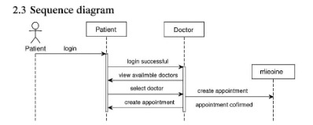

**2.4 Use Case Diagram**

Actors: Patient, Doctor, Admin

Use Cases:

- Register/Login

- Search Doctors

- Book Appointment

- Manage Appointments

- View Medicine Info

- Manage Users (Admin only)

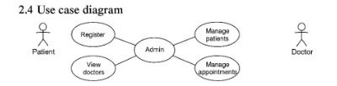

**2.5 Database Diagram Tables:**

* Patients (PatientID, FullName, Email, PhoneNumber, Gender, DateOfBirth)
* Admins (id, FullName, password)
* Doctors (DoctorID, Name, gender, Specialization, Email, Phone, Clinic Name, LOCATION, Languages Spoken, Consultation Fee, Online Consultation, City, Experience)
* Appointments (AppointmentID, PatientID, DoctorID, AppointmentDate, Status)
* user (id, userName, Email)
* medicine (id, Name, Description, user_id) Relationships: - Appointments linked to Patients and Doctors. - medicine linked to user table.

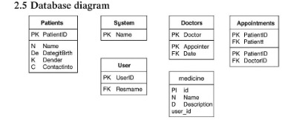

**Chapter Three**

**UI/UX**

**UI/UX**

This chapter covers MediPulse’s user interface and experience design, consolidating all UI/UX content from the original report. It includes the process of understanding user needs, creating visual layouts, and prototyping the application interface in Figma. Original design materials and style guidelines are organized here.

**3.1 Definition of UI/UX design**

UI/UX design refers to the process of enhancing user satisfaction by improving the usability, accessibility, and interaction between the user and the product. In the case of MediPulse, it plays a critical role in ensuring users, including those with limited technical skills, can easily access medical services through a visually pleasing and intuitive interface.

**3.1.1 What is UI?**

User Interface (UI) design focuses on the look and feel of the product. It includes everything the user sees and interacts with—buttons, icons, spacing, typography, colors, and overall layout. In MediPulse, UI ensures the platform is visually appealing, responsive, and accessible across devices.

**3.1.2 What is UX?**

User Experience (UX) refers to the user's overall experience while using the platform, including the effectiveness, efficiency, and satisfaction derived from it. UX design involves user research, journey mapping, and ensuring that tasks like symptom checking or finding a doctor are smooth and intuitive.

**3.2 Difference between UI & UX**

**3.2.1 UI Design**

UI design is about the interface and visual elements. It answers:

* Is it beautiful?
* Is it modern and professional?
* Are the visual components consistent?

In MediPulse, UI includes consistent card layouts for doctors and facilities, soft color palettes to reflect trust and care, and clean navigation.

**3.2.2 UX Design**

UX focuses on how users interact with the system. It answers:

* Is the symptom checker easy to use?
* Can the user find what they need quickly?
* Is the experience smooth from login to diagnosis?

UX in MediPulse ensures even elderly users can access services with minimal clicks, guiding them through step-by-step paths.

**3.2.3 Key Differences**

| Aspect | UI Design | UX Design |
| --- | --- | --- |
| Focus | Visual aesthetics | User interaction and experience |
| Tools | Figma, Adobe XD | User research, wireframes, usability testing |
| Purpose | Makes the interface attractive | Makes the interface functional and usable |
| Outcome | Appealing screens | Seamless user journeys |

**3.3 Importance of UI/UX design**

UI/UX design is a critical component in the development of any digital platform, especially in healthcare-related services such as MediPulse. A well-crafted user interface (UI) combined with a thoughtful user experience (UX) directly influences how users perceive, interact with, and benefit from the system. The following are key reasons why UI/UX design is essential in the context of MediPulse:

**1. Enhances User Trust and Credibility**

In medical and health-related platforms, trust is paramount. Users are sharing sensitive personal information and relying on the system for potentially life-impacting insights. A clean, professional, and consistent UI design reflects credibility and gives users the confidence that they are using a reliable service. MediPulse uses a calm color palette and an intuitive layout to immediately convey a sense of care and professionalism.

**2. Simplifies Complex Processes**

The healthcare domain can be complex, especially for users unfamiliar with medical terms or technology. UX design helps simplify these complexities by offering easy-to-navigate interfaces, step-by-step flows (e.g., for symptom checking), and minimal cognitive load. MediPulse’s interface was designed to guide users through symptom entry, diagnosis suggestions, and connecting to a doctor with minimal effort.

**3. Improves Accessibility and Usability**

Good UI/UX design ensures that users of all ages, backgrounds, and technical skill levels can comfortably use the platform. This is especially important for MediPulse, which serves users who may not be tech-savvy—such as elderly individuals or those in rural areas. Features like larger font sizes, high-contrast buttons, tooltips, and clear instructions enhance accessibility and allow everyone to benefit from the services.

**4. Increases User Engagement and Retention**

First impressions are formed in seconds, and a poorly designed interface can drive users away. On the other hand, a smooth and visually appealing experience encourages users to return. MediPulse’s consistent layout, minimalistic design, and responsive interface make it easy for users to trust and engage with the platform repeatedly for different services—whether it’s checking symptoms or finding nearby medical facilities.

**5. Supports Efficient Navigation**

A user-centric design minimizes the number of steps it takes to perform a task. With intuitive navigation and logical content grouping, users can complete their goals without confusion or frustration. MediPulse was structured so that critical actions—such as locating doctors or accessing telehealth—are available within one or two clicks from the homepage.

**6. Reduces Support Costs and Errors**

When users can successfully navigate the platform without assistance, it reduces the need for customer support. Additionally, clear and error-preventive UI elements reduce the chances of mistakes—such as entering incorrect data or misunderstanding a diagnosis prompt. For example, MediPulse uses input validation, tooltips, and confirmation prompts to help users provide accurate information and avoid confusion.

**7. Strengthens Brand Identity**

A coherent and well-executed UI/UX design reinforces the brand identity of MediPulse as a modern, patient-centric, and innovative platform. Consistent use of brand colors, fonts, and visual language across all components helps build recognition and trust among users and stakeholders.

**8. Facilitates Scalability and Future Development**

Well-planned UI/UX designs provide a solid foundation for future scalability. As MediPulse expands its services—like integrating AI-powered diagnostics or multilingual support—a modular and user-tested UI system makes it easier to add features without disrupting the existing user flow or creating confusion.

**3.4 UI/UX Overview & Design Principles**

This section provides an overview of the user experience (UX), and user interface (UI) design principles applied across both the MediPulse website and mobile application. The design philosophy centers around creating a trustworthy, accessible, and efficient platform for users seeking healthcare services.

Core Design Principles:

1. Consistency: A unified design language is maintained across both the website and mobile app. This is evident in the consistent use of the blue and white color palette, similar typography styles (clear, sans-serif fonts), and shared iconography. Key components like doctor profile cards and booking interfaces share structural similarities, adapted for their respective platforms, ensuring a familiar user experience regardless of the device used.

2. Clarity and Simplicity: The interface prioritizes clarity and ease of understanding. Clean layouts with generous white space reduce cognitive load. Information is presented hierarchically using clear headings, distinct sections, and high-contrast text. Icons are simple and universally recognizable. This minimalist approach ensures users can quickly find information and complete tasks without confusion.

3. User-Centricity: While specific user research data (surveys, personas mentioned in pasted_content_2.txt) was not directly available for this analysis, the design clearly caters to the primary tasks of target users (patients). Features like prominent search bars, easy access to doctor/facility listings, straightforward booking processes, and the medicine tracker directly address common healthcare needs.

4. Navigational Ease: Both platforms employ intuitive navigation patterns. The website uses a standard header and comprehensive footer, while the mobile app utilizes a persistent bottom navigation bar for core sections (Home, Schedule, Notifications, Profile) and a slide-out menu for less frequent actions. Clear back buttons and logical information architecture allow users to move through the application seamlessly.

5. Visual Hierarchy: Information is organized effectively using visual cues. Font sizes, weights, colors, and spacing are used to differentiate between headings, subheadings, body text, and interactive elements. Important actions, like booking buttons, are often highlighted with distinct colors (blue or red/orange) to draw user attention.

6. Accessibility: Although a full accessibility audit requires interactive testing, the design incorporates elements that support accessibility. The high contrast between text and background colors aids readability. Clear, large fonts and well-spaced interactive elements improve usability for users with visual impairments or motor difficulties. The structured layout also benefits users by relying on screen readers.

7. Trust and Professionalism: The chosen color palette (predominantly blue and white) evokes feelings of trust, calmness, and professionalism, which are crucial for a healthcare application. The clean design, professional imagery (stock photos of doctors/patients), and clear presentation of information contribute to building user confidence in the platform.

Visual Style Guidelines (Observed):

• Color Scheme: Primary: Shades of Blue (headers, buttons, active states, icons). Secondary: White/Light Grey (backgrounds). Accent: Red/Orange (critical action buttons like "Book", "Login"), Green (medicine tracker icons), Yellow (ratings). Grey tones are used for text and borders.

• Typography: Sans-serif fonts are used exclusively for optimal screen readability. Variations in size and weight establish clear hierarchy.

• Iconography: Simple, line-style or filled icons are used consistently for navigation, actions, and representing medical specialties.

• Imagery: Professional, high-quality stock photos are used for doctors, patients, and facilities.

These principles and style guidelines work together to create a cohesive, user-friendly, and trustworthy experience across the MediPulse digital platforms.

**3.5 The 8 stages of UX design**

1. User Research: Interviews and surveys to understand user needs.
2. Personas: Creating fictional users to represent key audiences (e.g., elderly users).
3. User Journey Mapping: Mapping how users interact with the platform from start to finish.
4. Wireframing: Sketching interface layouts for different pages (done in Figma).
5. Prototyping: Creating clickable mockups for real-time user testing.
6. Usability Testing: Testing how real users navigate the system and identifying pain points.
7. UI Design Integration: Applying color, typography, icons, and spacing to wireframes.
8. Iteration: Updating the design based on feedback and performance.

**3.6 Color scheme and font**

The MediPulse application uses a thoughtfully selected color palette designed to promote trust, clarity, and ease of use in a healthcare environment. The following table summarizes the primary and secondary colors used in the platform:

| Color Usage | Color Code | Purpose & Meaning |
| --- | --- | --- |
| Primary Blue | #2260FF | Main brand color; used for buttons, headers, and icons. Evokes trust and reliability. |
| Soft White | #FFFFFF | Background and content areas; provides clarity and visual breathing space. |
| Light Gray | #F1F1F1 | Used for input fields, cards, and subtle sectioning. Adds structure without distraction. |
| Accent Green | #00AF0F | Highlights success messages, confirmations, and positive actions. Suggests health and success. |
| Alert Red | #B80000 | Indicates errors, warnings, or critical health flags. Captures user attention. |
| Dark Gray (Text) | #7E7E7E | Main text color for high readability and contrast against the white background. |
| Muted Blue (Hover) | #022849 | Used for hover states, active navigation tabs, and selections. Enhances interactivity. |
| Secondary Blue Gray | #CAD6FF | Used for subtitles, icons, and less prominent UI elements. Maintains a clean look. |

**3.7 Website Design**

This section details the user interface (UI) and user experience (UX) design for the MediPulse website, based on the provided visual designs. It covers the key screens, visual style, and user interaction flows.

**3.7.1 Website UI Overview**

The website design aims for a clean, professional, and user-friendly interface, primarily utilizing a blue and white color scheme which evokes trust and calmness, suitable for a healthcare application. Key visual elements and layouts observed across the provided screens include:

• Header: Consistent header across pages featuring the MediPulse logo, navigation links (though partially obscured or minimal in some views), and an account/sign-in icon.

• Footer: A comprehensive footer is present on most pages, containing links to About Us, Careers, Press, Search options (Speciality, Hospital, Clinic, Area), information for doctors, contact details, and social media links.

• Color Palette: Dominated by shades of blue (primary action color, backgrounds, icons) and white (backgrounds, text), with accents of red/orange for important actions like booking or confirmation buttons, and grey for text and borders.

• Typography: While specific fonts are hard to determine from images, the design uses clear, sans-serif fonts for readability. Heading and body text sizes vary appropriately to establish hierarchy.

• Iconography: Simple, universally understood icons are used for navigation, services, and contact information.

• Layout: Generally clean layouts with ample white space. Content is organized into clear sections using cards, distinct background colors, and headings.

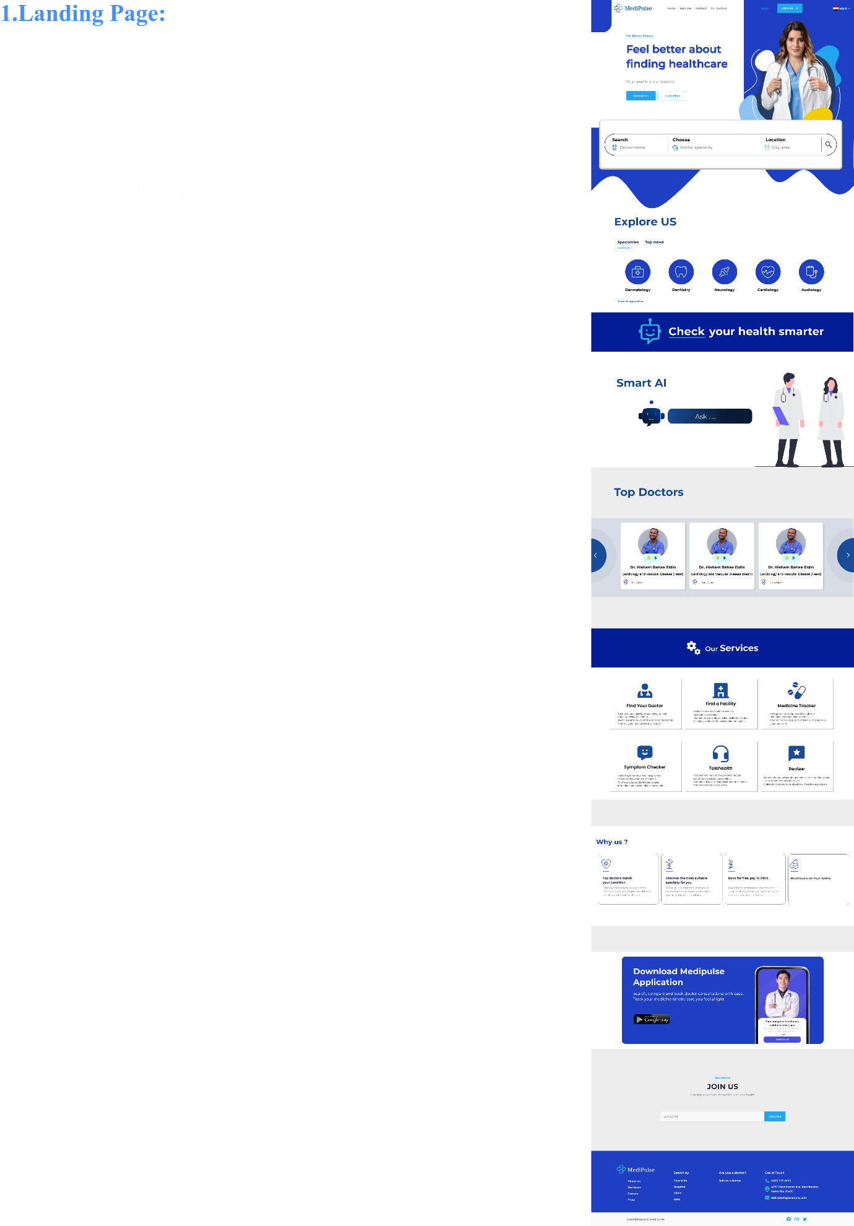

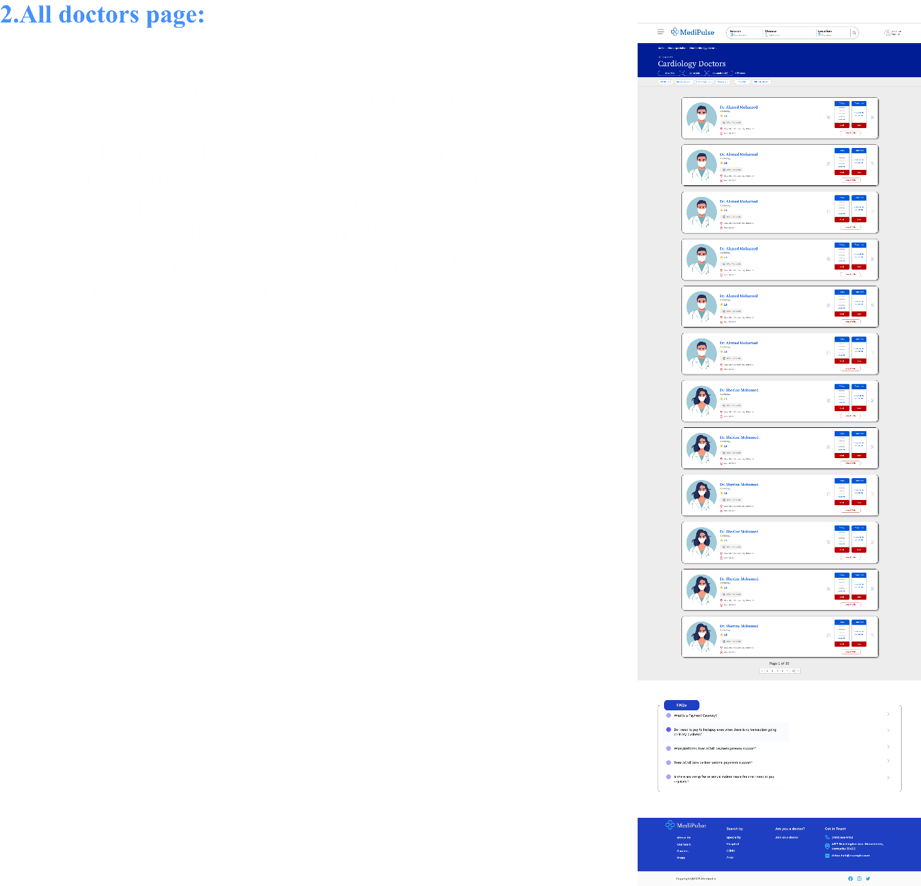

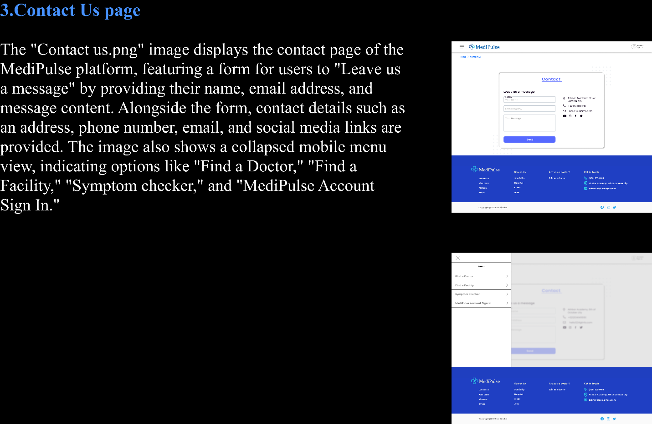

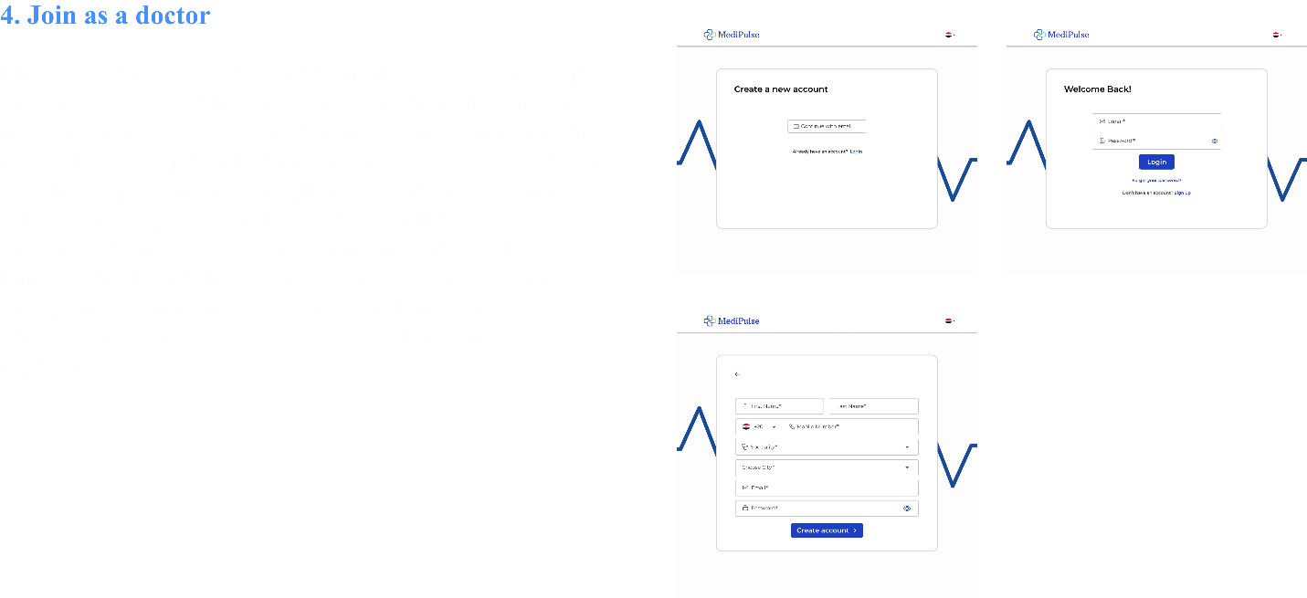

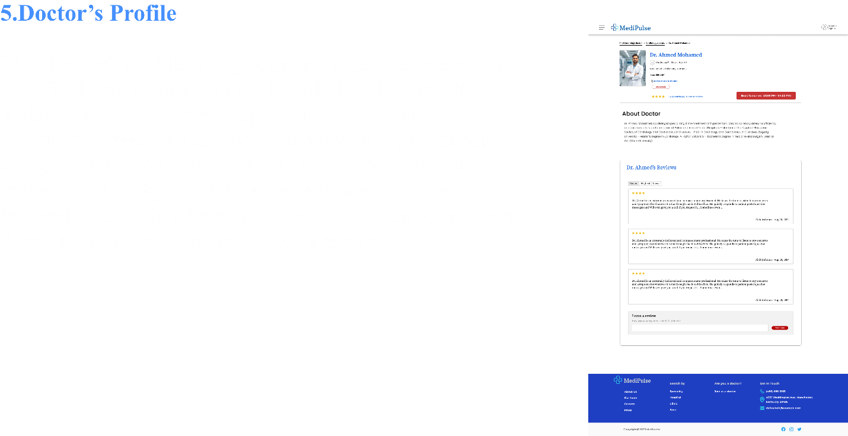

**6.Website Workflow**

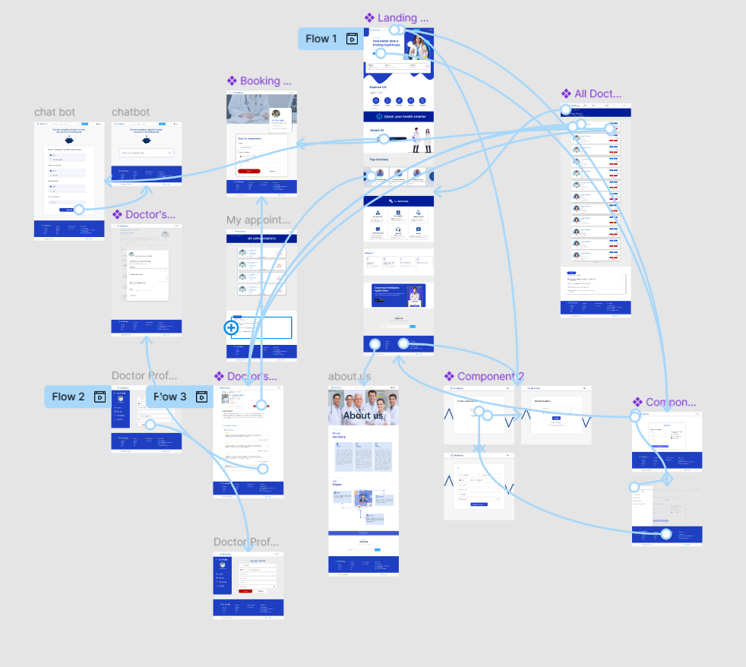

**3.7.2 Website Wireframing & Visual Design**

Landing Page (Landing page.png):

• Hero Section: Features a prominent headline ("Feel better about finding healthcare"), a brief description, call-to-action buttons (e.g., "Find a Doctor"), and an illustrative image of a healthcare professional.

• Search Bar: A key feature allowing users to search for doctors/services based on speciality, location, etc.

• Explore Us/Specialties: Icons representing different medical specialties (e.g., Neurology, Dentistry, Cardiology) for quick navigation.

• Smart AI Feature: Highlights an AI-powered health check feature.

• Top Doctors: A carousel or section showcasing featured doctors with brief profiles.

• Our Services: Grid layout detailing the services offered (e.g., Find Your Doctor, Find a Facility, Medicine Tracker, Symptom Checker, Telehealth, Reviews).

• Why Us? Section highlighting key benefits or unique selling points.

• Download App: Call-to-action to download the mobile application, showing a preview on a phone screen.

• Join Us: Email subscription input field.

• Overall Impression: Designed to be informative and guide users towards key actions like searching for doctors or exploring services.

Doctor's Profile Page (Doctor's profile.png):

• Layout: Displays detailed information about a specific doctor.

• Doctor Information: Includes photo, name, specialty, credentials, location, fees, and telehealth availability.

• Ratings & Reviews: Shows average star rating, number of ratings, and a link to leave a review. Displays individual patient reviews below.

• Booking: A prominent button (e.g., "Book Tomorrow") allows users to initiate the booking process.

• About Section: Provides a detailed biography or description of the doctor's background and expertise.

• Review Section: Lists patient reviews with options to sort (Recent, Highest, Lowest). Includes a form or link to "Leave a review".

Contact Page / Menu (Component 1.png):

• Contact Form: A standard form for users to leave a message, including fields for Name, Email Address, and Message.

• Contact Details: Displays address, phone number, email, and social media links alongside the form.

• Side Menu (Overlay): The lower part of the image shows a slide-out menu (likely triggered by the hamburger icon visible in other screenshots) with navigation options like Find a Doctor, Find a Facility, Symptom Checker, and MediPulse Account Sign In.

Booking Page (Booking a doctor.png):

• Context: Shows the booking interface, likely accessed from a doctor's profile.

• Doctor Info: Displays the selected doctor's name, specialty, clinic, and available time slot.

• Booking Form: Fields for patient's Name, Phone number (with country code selection), and Email address.

• Action Buttons: "Book" (primary action, red/orange) and "Cancel" (secondary action, white) buttons.

Review Submission Page (Doctor's profile- review submit.png):

• Modal/Overlay: Appears as a pop-up or overlay on the doctor's profile page for submitting a review.

• Rating: Star rating selection (e.g., "How likely are you to recommend this provider?").

• Review Fields: Input for Review Title and detailed comments ("Tell us more about your visit"). Character limits are indicated.

• Telehealth Question: Asks if the visit was a telehealth appointment (Yes/No options).

• Email Confirmation: Requires email for confirmation (not displayed in the review).

• Action Button: "Save and continue" button.

Authentication Pages (Component 2.png):

• Create Account: Options to continue with email or log in if an account already exists.

• Login: Standard email and password fields with a "Login" button. Includes links for forgotten passwords and signing up.

• Sign Up Form: Fields for First Name, Last Name, Phone Number (with country code), Specialty (dropdown), City (dropdown), Email, and Password.

All Doctors Page (All Doctors.png):

• Search/Filter Bar: Likely includes options to filter/search doctors (partially visible at the top).

• Listing: Displays a list of doctors (e.g., Cardiology Doctors) in a card format.

• Doctor Card: Each card shows the doctor's photo, name, specialty, rating, location, available time slots, and booking buttons.

• Pagination: Indicates multiple pages of results (e.g., "Page 1 of 36").

• FAQs Section: Includes frequently asked questions related to payments or services.

SITEMAP

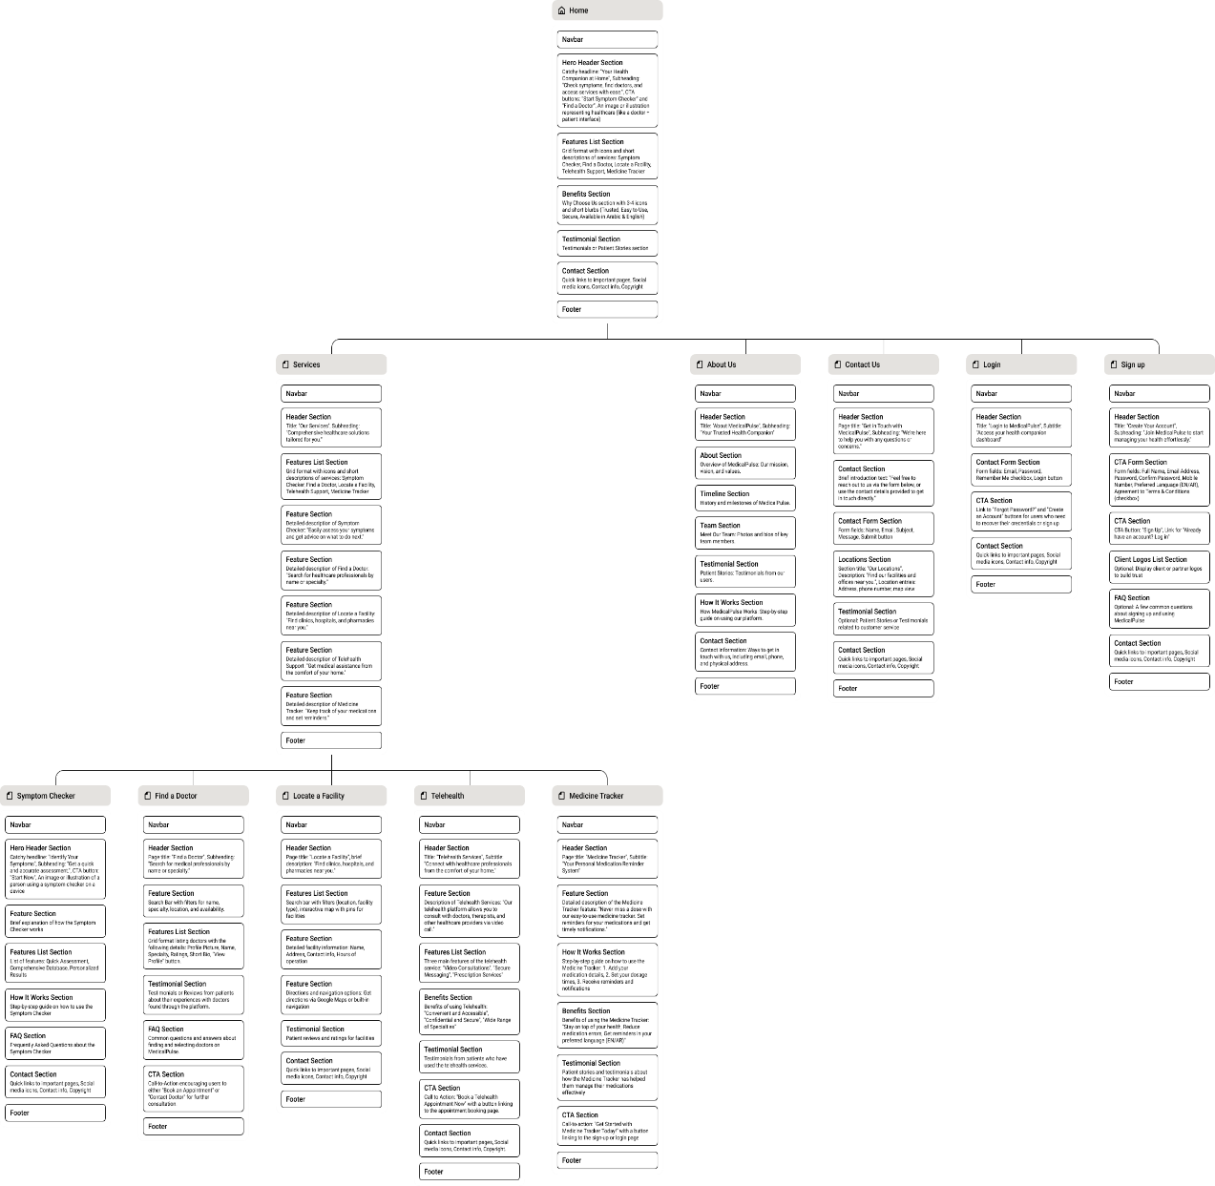

WIREFRAME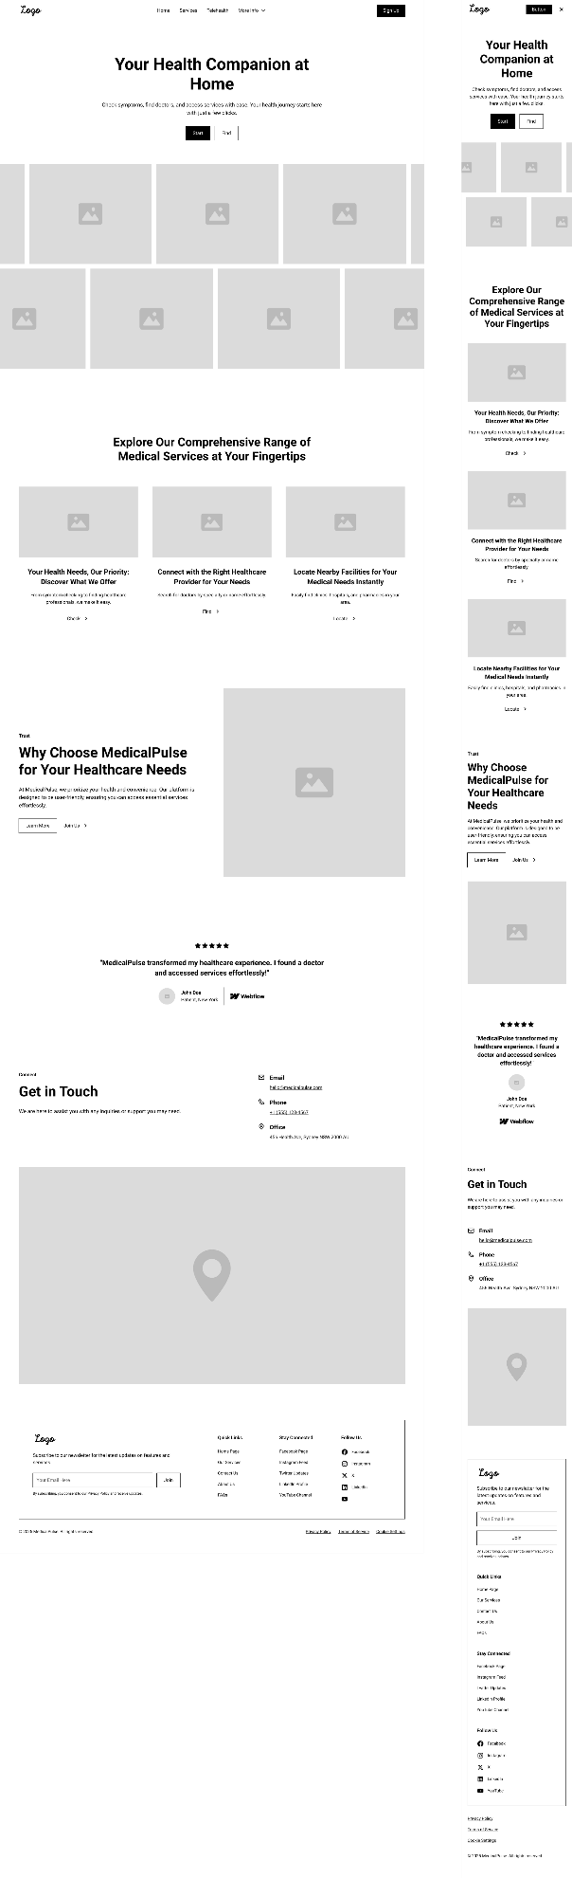

**3.8 Mobile Application Design**

This section details the user interface (UI) and user experience (UX) design for the MediPulse mobile application, based on the provided visual designs. It covers key screens, visual style, navigation, and core functionalities.

**3.8.1 Mobile App UI Overview**

The mobile application design mirrors the website's clean and professional aesthetic, adapted for a mobile-first experience. It maintains the blue and white color scheme, emphasizing clarity and ease of use for healthcare-related tasks.

• Navigation: Primarily uses a bottom navigation bar with icons for Home, Schedule, Notifications, and Profile. A hamburger menu icon (visible on the Home page) likely reveals a side drawer menu (shown in menu.png) for additional options like My Account, Symptoms checker, Medicine tracker, find a facility, Invite friends, Settings, and Language selection.

• Headers: Most screens feature a clear header with a back arrow for navigation and the screen title (e.g., "New Account", "Medicine tracker", "All Facilities").

• Color Palette: Consistent use of blue for primary actions, headers, and active states. Red/Orange is used for important actions like booking or logging. White and light grey form the background, ensuring high contrast and readability.

• Typography: Clear, sans-serif fonts are used throughout, with appropriate size variations for titles, labels, and body text.

• Iconography: Simple, filled icons are used in the bottom navigation bar and side menu. Specific icons represent medical specialties and actions.

• Layout: Content is presented in scrollable lists and cards, suitable for mobile viewing. Forms are clearly laid out with distinct input fields and buttons.

APP WOEKFLOW

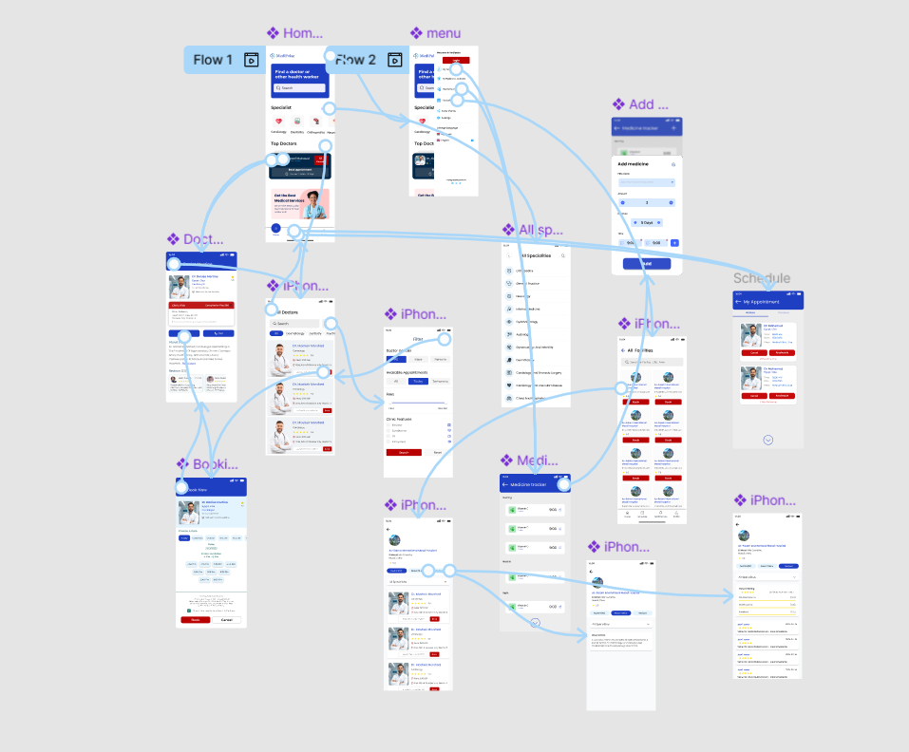

**3.8.2 Mobile App Wireframing & Visual Design**

* Sign-up (Sign-up.png): Standard form fields for Full name, Password (with visibility toggle), Email, Mobile Number, and Date of Birth. Includes a primary "Sign Up" button, options for social sign-up (Google, Facebook), and a link to log in.
* Login (Login.png): Fields for Email or Mobile Number and Password (with visibility toggle). Includes a "Log In" button, a "Forget Password" link, and a link to register.
* Forget Password (Forget Password.png): Input field for email address to receive password reset instructions, with a "Send Password" button.
* Set New Password (Set new password.png): Fields for New Password and Confirm Password (both with visibility toggles), and a "Create New Password" button.
* Core Functionality Screens:
* Home Page (Home page.png): Features a prominent search bar ("Find a doctor or other health worker"), sections for browsing Specialists (Cardiology, Dentistry, etc.), viewing Top Doctors (with profile cards and booking options), and a promotional banner. Includes the bottom navigation bar.
* Menu (menu.png): Shows a side-drawer menu overlaying the home screen content. Provides access to My Account, Symptoms checker, Medicine tracker, find a facility, invite friends, Settings, and Language selection (Arabic/English shown).
* Medicine Tracker (Medicine tracker.png): Displays scheduled medications categorized by time (Morning, Midday, Night). Each entry shows the medicine name, dosage, time, and an edit icon. A '+' icon in the header allows adding new medication.
* Add Medicine (Add medicine.png): A modal/pop-up form for adding medication to the tracker. Includes fields for Pill name (dropdown), Amount (stepper control), Duration (stepper control), and Time (multiple time pickers with add/remove options). An "Add" button confirms the entry.
* Find a Facility (Find a facility.png): Displays a list of facilities (e.g., As-Salam International Maadi Hospital) in a grid of cards. Each card shows an image, name, address, rating, and a "Book" button. A search bar at the top allows filtering by Facility, City, or Area. Includes the bottom navigation bar.
* Facility's Details (Facility's Details.png, Facility's Details_2.png, Facility's Details_3.png): Shows detailed information about a selected facility. Includes the facility name, address, rating, and tabs for Doctors, About Clinics, and Reviews.
* Doctors Tab: Lists doctors associated with the facility, showing their photo, name, specialty, rating, fees, location, availability, and a "Book" button. A dropdown allows filtering by specialty.
* About Clinics Tab: Provides a text description of the clinic/facility.
* Reviews Tab: Shows the general rating breakdown (Medical Service, Waiting Area, Assistant) and lists individual visitor reviews with ratings and dates.
* All Specialists (All specialists.png): A list view of various medical specialties with corresponding icons (e.g., Orthopedics, General Practice, Neurology). Includes a back arrow and a search icon in the header.
* All Doctors (All doctors.png): Displays a list of doctors, filterable by specialty using tabs (All, Dermatology, Dentistry, etc.). Includes a search bar and filter icon. Each doctor is shown in a card format with a photo, name, specialty, rating, fees, location, availability, and a "Book" button.
* All Doctors Filtration (All doctors Filteration.png): A filter overlay screen allowing users to refine the doctor search based on Doctor Gender (All, Male, Female), Available Appointments (All, Today, Tomorrow), Fees (slider control), and Clinic Features (checkboxes for Elevator, Conditioner, TV, E-Payment). Includes "Search" and "Reset" buttons.
* Doctor's Profile (Doctor's Profile.png): Displays detailed information for a specific doctor, including photo, name, location, specialty, experience, telehealth availability, and rating. Shows clinic visit details (address, fees, follow-up info). Includes "Book Now" and "Call" buttons. An "About Doctor" section provides a biography, and a "Reviews" section lists patient feedback.
* Booking (Booking.png): The appointment scheduling screen for a selected doctor. Displays the doctor's details, allows choosing a date (Today, Tomorrow, specific dates) and an available time slot. Includes a checkbox for sharing medical files and Terms and Conditions text. Final action buttons are "Book" and "Cancel".

**3.8.3 App Visuals Screens**

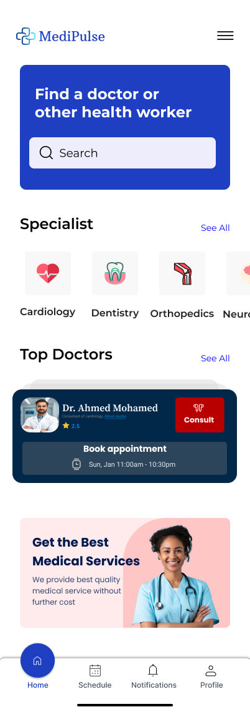

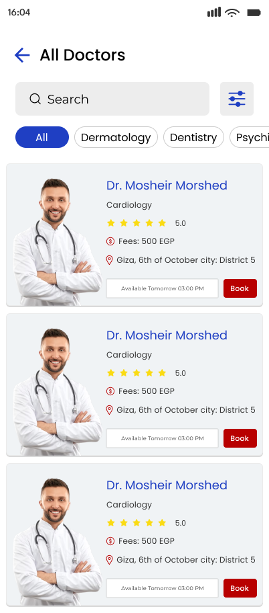

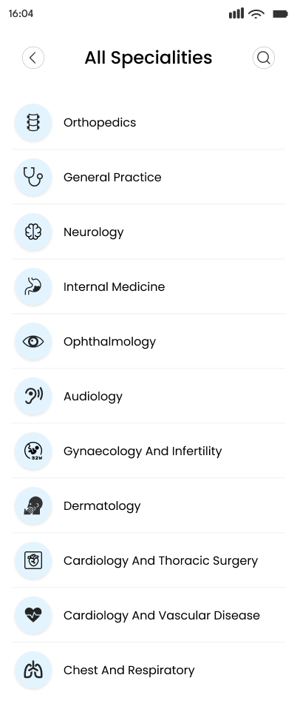

**Chapter Four**

**Full-Stack Develop**

**FULL-STACK DEVELOPMENT**

**Introduction**

The purpose of Medipulse is to offer a comprehensive solution for providing an easy, friendly way for all people to connect with their health. Whether you're a healthcare professional, administrator, or end-user, Medipulse aims to enhance the overall experience and streamline daily tasks with its powerful and user-friendly features.

**Overview**

The system is organized with a modular architecture, consisting of both frontend and backend components. These components work together to deliver the core functionalities, with a clear distinction between the user interface and business logic.

* Frontend: The client-side application, built using [React.js, Angular, etc.], provides a responsive, modern, and dynamic user interface. It ensures seamless communication with the backend via API calls, offering a smooth and interactive experience.
* Backend: The server-side logic is developed using [Node.js, Express, or another backend technology], handling business logic, authentication, data storage, and API responses.

This documentation will guide you through the architecture, technologies used, and the overall structure of Medipulse, giving developers and collaborators a clear understanding of how the system works and how to contribute to its future development.

Key Features

* Responsive UI: Built with [Tailwind CSS, Bootstrap, or other CSS frameworks], ensuring the app is fully responsive and accessible across different devices.
* State Management: Utilizes [Redux, Context API, or other state management tools] for consistent state across the application, improving the overall user experience.
* Secure Authentication: Implements [JWT or other security measures] for user authentication and protection of sensitive data.
* API Integration: The system is designed to communicate efficiently with external services and APIs for real-time data processing and synchronization.  
  1. **System Architecture**

The Medipulse system follows a modern and scalable architecture that ensures efficiency, maintainability, and high performance. The system is divided into two main components: the Frontend (Client-Side) and the Backend (Server-Side). These components are designed to interact seamlessly and deliver a robust experience for both users and developers.

1. High-Level Architecture

The system is split into two main parts:

1. Frontend (Client-Side)
   * The frontend handles the presentation layer and user interactions. It is responsible for rendering the user interface and making requests to the backend API.
   * Built with modern technologies such as React.js .The frontend ensures a dynamic and responsive user experience across multiple devices.
2. Backend (Server-Side)
   * The backend processes business logic, data storage, and communication with the frontend via APIs. It handles the application’s core functionality, including user authentication, data management, and external integrations.
   * Built using Node.js and Express.js, the backend is optimized for high performance and scalability.
3. Frontend-Backend Communication

* API Communication
  + The frontend communicates with the backend through RESTful APIs. HTTP requests (using tools like Axios or Fetch) are sent from the frontend, and the backend processes them and returns data in JSON format.
* Authentication and Authorization
  + JSON Web Tokens (JWT) are used for authentication. Once users log in, they receive a token that is included in the header of API requests to authorize access to protected routes.

1. Data Flow
2. Frontend (Client-Side)
   * Users interact with the UI, such as submitting forms, navigating through pages, etc.
   * The frontend sends API requests to the backend to fetch or send data.
   * The backend processes the request, performs necessary operations ,and sends the response back to the frontend.
   * The frontend updates the UI based on the data received from the backend.
3. Backend (Server-Side)
   * The backend receives and processes API requests from the frontend.
   * It communicates with the database to fetch or store data.
   * After processing the request, it returns the response to the frontend, which updates the user interface accordingly.
4. Key Components
5. Frontend (Client-Side)
   * UI Components: The frontend is composed of reusable components (e.g., forms, buttons, tables), which ensure a modular and scalable structure.
   * State Management: State management is handled using tools such as Redux or Context API to manage global application state.
   * Routing: React Router is used to handle client-side routing and navigation within the application.
6. Backend (Server-Side)
   * API Routes: The backend exposes API routes that handle various functionalities, such as fetching user data, updating records, or authenticating users.
   * Authentication and Security: Secure authentication is managed using JWT or OAuth to ensure that only authorized users can access protected resources.
   * Database Interaction: The backend interacts with the database to store, retrieve, and manipulate data (using MongoDB, PostgreSQL, or another database system).
   * Middleware: Middleware is used to handle tasks such as logging, error handling, and validating incoming API requests.
7. Security Considerations

* HTTPS
  + All communication between the frontend and backend is encrypted using HTTPS to prevent unauthorized interception of data.
* JWT Authentication
  + The backend verifies the authenticity of incoming requests by checking the JWT token in the header, ensuring that only authorized users have access to specific resources.
* Data Encryption
  + Sensitive data, such as user passwords, is encrypted before storage to ensure its security and prevent unauthorized access.
* Cross-Site Scripting (XSS) Prevention
  + User input is sanitized and validated to prevent malicious scripts from being injected into the application, ensuring the application is protected against XSS attacks.
  1. Frontend Overview

The frontend is the user-facing part of the application and plays a crucial role in shaping the user experience. It is responsible for rendering the interface, handling user interactions, validating data before it's sent to the backend, and ensuring a seamless and responsive experience across all devices.

This frontend has been built using modern frontend technologies and follows best practices to ensure scalability, performance, and maintainability. The codebase is modular and component-driven, which allows for reusability and separation of concerns.

The main objective of the frontend is to deliver a smooth and intuitive user interface that enables users to interact with the system efficiently. From navigation and data display to form handling and asynchronous operations, every feature is designed with usability in mind.

The UI was carefully crafted to be clean, consistent, and accessible, ensuring a user-friendly experience even for non-technical users. In addition to the visual aspects, performance optimizations such as lazy loading, code splitting, and memoization techniques have been applied to enhance loading speed and responsiveness.

Throughout development, strong emphasis was placed on writing clean, readable, and maintainable code. Common patterns such as the use of reusable components, centralized state management, and responsive layout design are followed consistently.

This section of the documentation will provide an in-depth explanation of the frontend architecture, the libraries and frameworks used, the way components are structured, and how the system handles routing, state, API communication, styling.

4.2.1 Technologies Used

The frontend of this project utilizes a combination of modern technologies and tools to ensure an optimal, responsive, and scalable user interface. Below is a breakdown of the key technologies that were used in the development process:

Framework/Library

* React.js: The core framework for building the user interface. React enables a component-based structure, making it easier to manage UI elements and states efficiently. It also allows for fast rendering with its virtual DOM system.
* React Router: Used for client-side routing. React Router allows for navigation between different views and ensures the app behaves like a single-page application (SPA), with fast transitions between pages without full reloads.

State Management

* Redux: Redux is used for managing the application’s state in a predictable manner. It helps in maintaining the global state of the application and makes state transitions more predictable and traceable.
* Redux Toolkit: To simplify Redux usage, Redux Toolkit is employed. It reduces boilerplate code and provides utility functions for setting up the store and managing state in a more efficient manner.

Styling

* Tailwind CSS: Tailwind is used for utility-first styling, which allows for faster and more flexible design implementation. It simplifies creating custom designs with minimal effort.
* CSS Modules: CSS Modules are used to scope styles to individual components, reducing the risk of style conflicts and ensuring styles are scoped locally to each component.

API Integration

* Axios: Axios is the primary tool used for making HTTP requests to interact with backend APIs. It simplifies sending requests and handling responses with built-in support for promises and asynchronous operations.
* Fetch API: The native JavaScript Fetch API is also used for lightweight data-fetching operations when Axios is not required.

Version Control

* Git: Git is used for version control, ensuring smooth collaboration among team members and maintaining a detailed history of the project’s code changes.
* GitHub: GitHub is used for hosting the code repository, managing branches, and handling pull requests for collaborative development..

1. Home Page

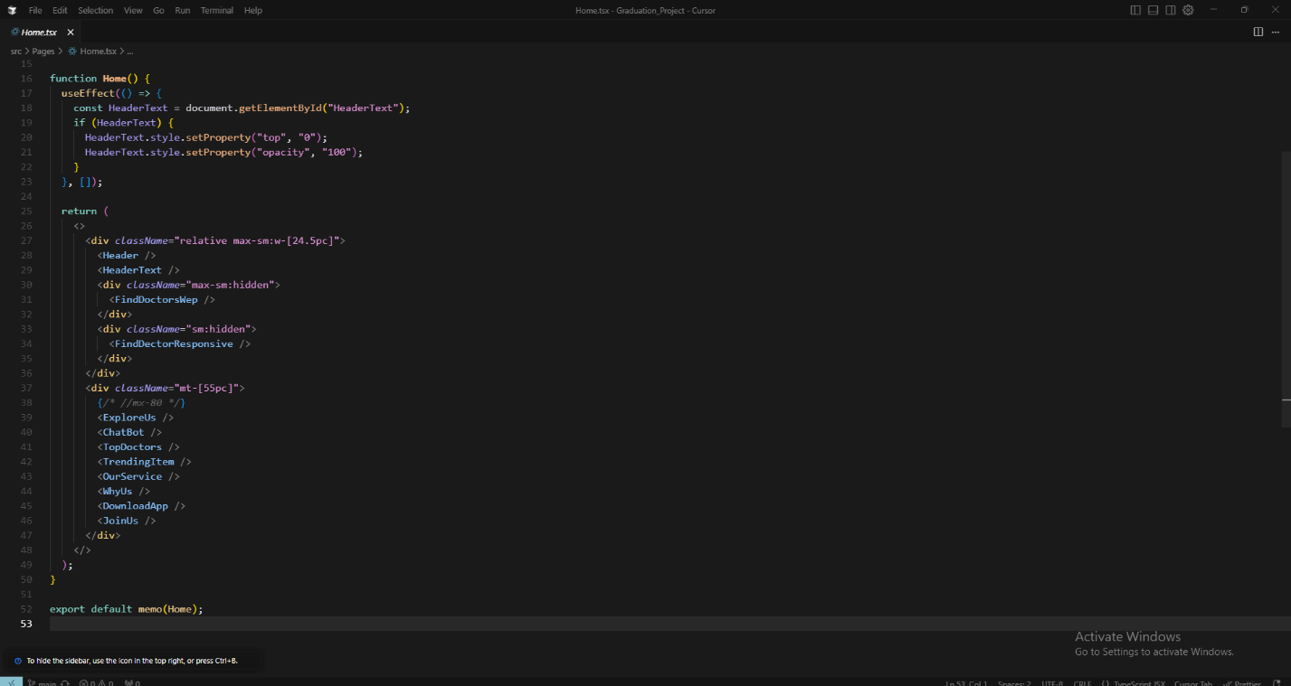

In React, Components are the building blocks of your user interface. A component is a JavaScript function or class that returns JSX (which gets rendered as HTML). They encapsulate logic and UI, making your app modular and easier to manage.

1. 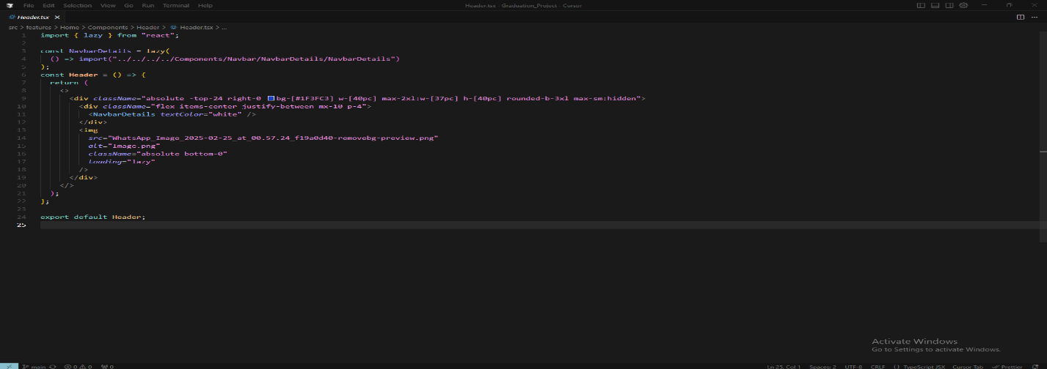Header Componet

This section is a large blue background that appears at the top-right of the page on large screens only. It contains the main white navigation bar along with a decorative image at the bottom. The design automatically hides when viewed on mobile devices to maintain a proper layout for smaller screens.

1. Navbar Links

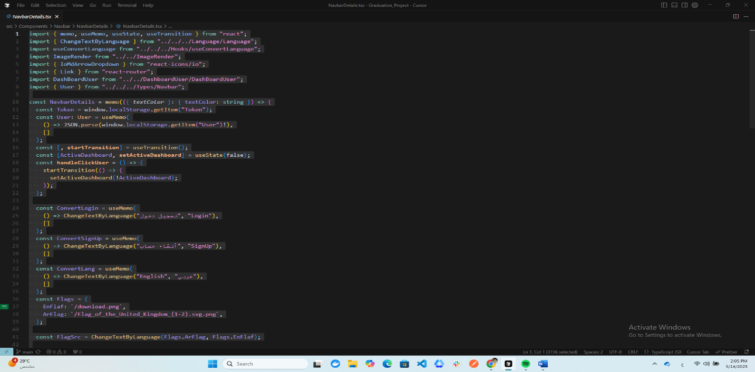This responsive navigation bar dynamically adjusts its appearance based on the current page and device screen size. At its core, it displays the MediPulse logo and a set of main navigation links including Home, Services, Contact, and Medicine Library sections. For desktop views, these links appear horizontally, while on mobile devices they collapse into a hamburger menu that reveals a dropdown when clicked. The component intelligently hides certain elements like the "For Doctors" link when a user is logged in (detected via authentication token), and shows different styling when not on the homepage. It features multilingual support for Arabic/English text switching and optimizes performance by lazy-loading secondary components. The design uses modern React practices including context API for state management and responsive Tailwind CSS classes that automatically adjust spacing, text sizes and layout for various screen sizes from desktop to mobile.

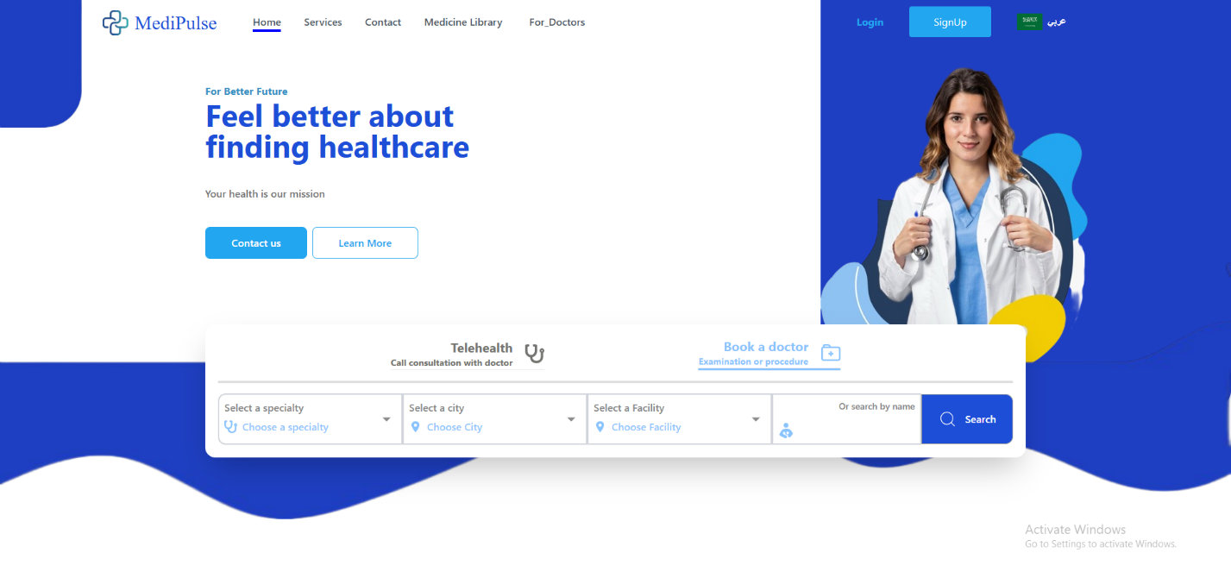

1. Login Page

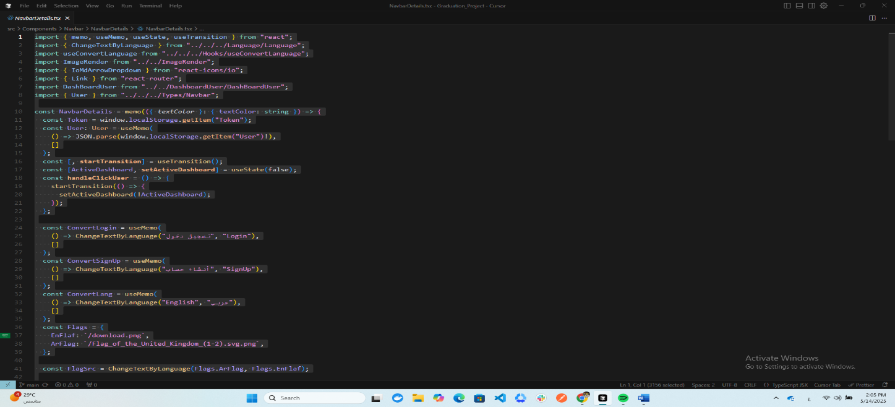

This is a clean, modern login page that centers a white card on a light gray background. The login form appears with a smooth animation that fades and scales in when the page loads. At the top of the card, there's a distinctive blue header bar with "login" written in white bold text. The main component is the FormLogin which handles the actual email/password input fields and submission logic. Below the form, users find a "Forgot password?" link in blue, followed by a prominent Facebook login button that opens Facebook's authentication in a new window when clicked.

The bottom section provides navigation options - a back button with arrow icon on the left that returns to the homepage, and on the right, a prompt for new users to sign up instead, with "Sign Up" highlighted in blue. The entire component is responsive and uses subtle hover effects on interactive elements like links and buttons to improve user experience.

The Facebook login integration uses a carefully constructed URL with proper OAuth parameters to ensure secure authentication.

1. 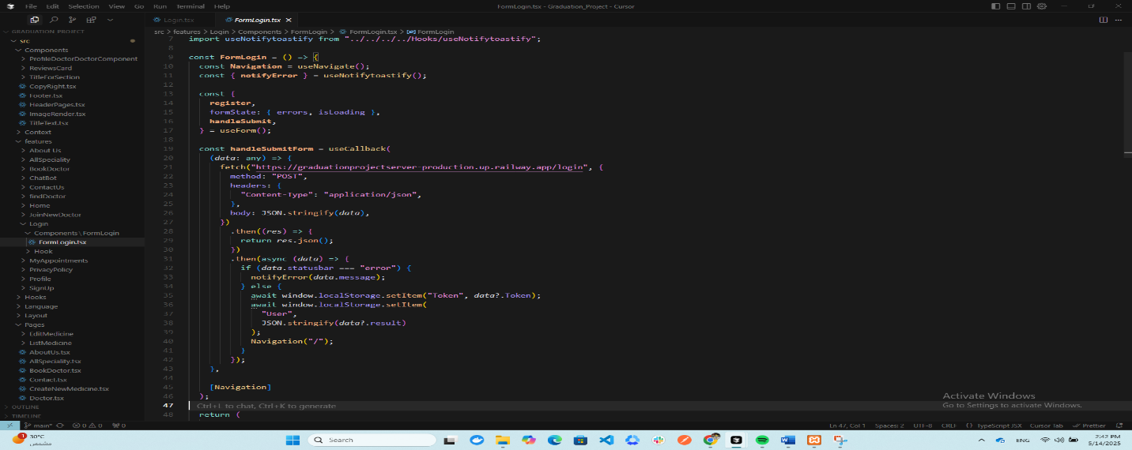Form Login

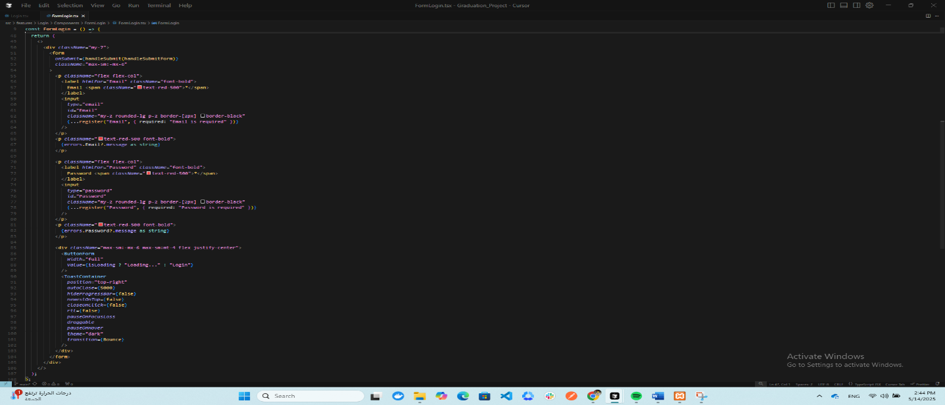

This is a login form component that handles user authentication. The form collects email and password inputs with validation, displaying error messages if fields are left empty. When submitted, it sends the credentials to a backend server (https://graduationprojectserver-production.up.railway.app/login) via POST request.

If login succeeds, it stores the received authentication token and user data in localStorage and redirects to the homepage. If login fails, it shows an error notification using react-toastify with a bounce animation. The form includes a loading state that disables the submit button during API calls.

The component uses React Hook Form for efficient form handling and validation, with required field markers (red asterisks) and clear error messaging. The design features simple black-bordered input fields and a full-width submit button that changes text to "Loading..." during submission. Toast notifications appear at the top-right with dark theme styling.

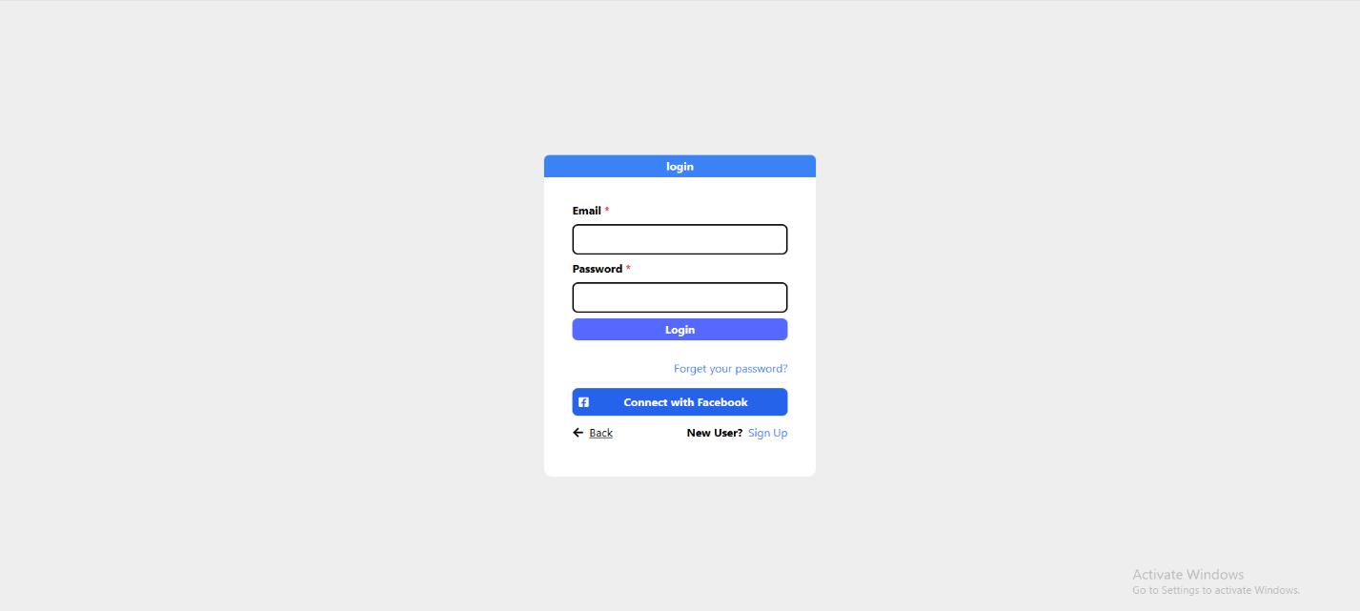

1. Authentication vs Authorization
2. Authentication

Authentication is the process of verifying who the user is.

* It answers the question: "Are you really who you say you are?"
* It usually involves a login system using:
  + Username & Password
  + Tokens (like JWT)
  + OAuth (e.g. login with Google or Facebook)

1. Authorization

Authorization is the process of verifying what the user can access.

* It answers: "Do you have permission to do this action?"
* Happens after authentication.
* Usually based on roles or permissions.

1. Sign Up Page

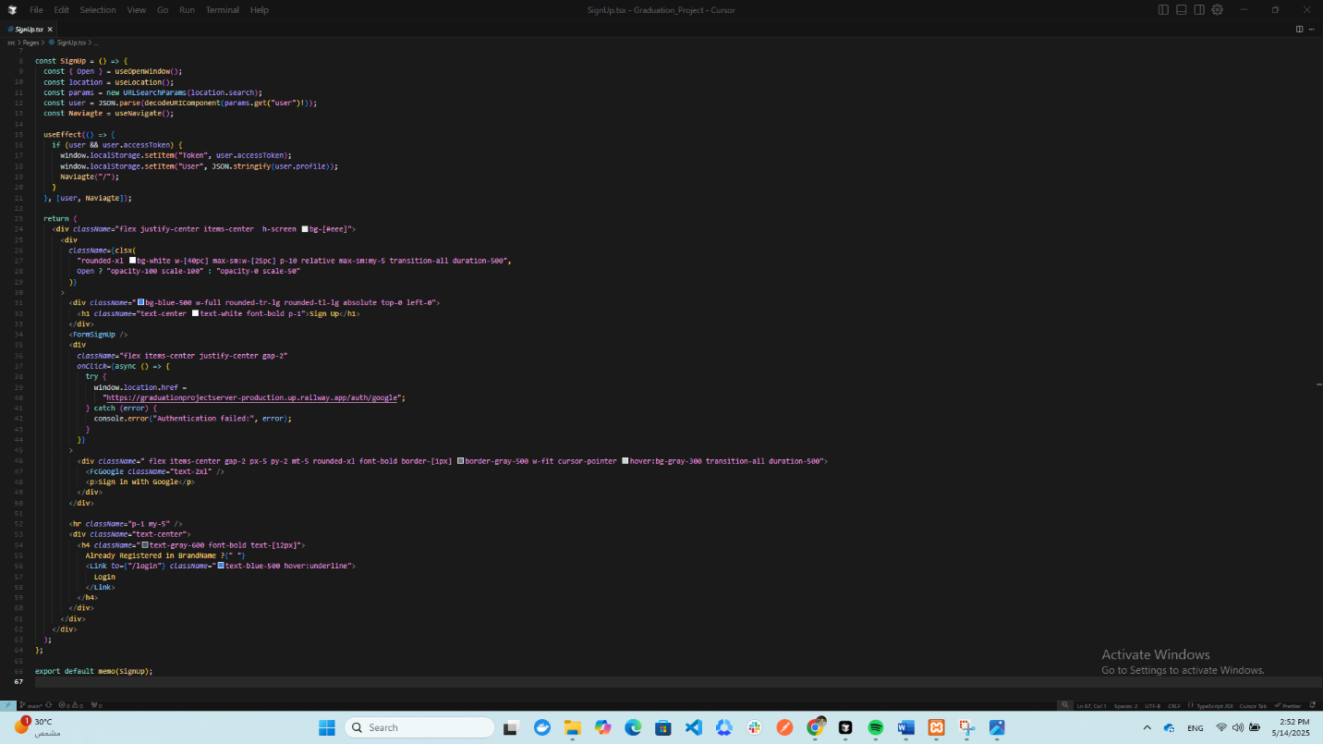

This React component represents a user registration page with a clean, modern design. The page centers a white sign-up card on a light gray background, featuring a smooth fade-in animation when loading. At the top, there's a prominent blue header bar displaying "Sign Up" in bold white text.

The main functionality includes two registration methods: a standard email/password form (handled by the FormSignUp component) and a Google OAuth option. The Google sign-in appears as a clickable button with the Google logo that redirects users to the server's Google authentication endpoint when clicked.

1. Form Sign Up

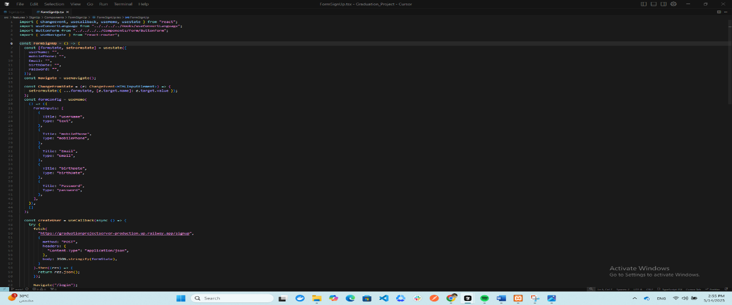

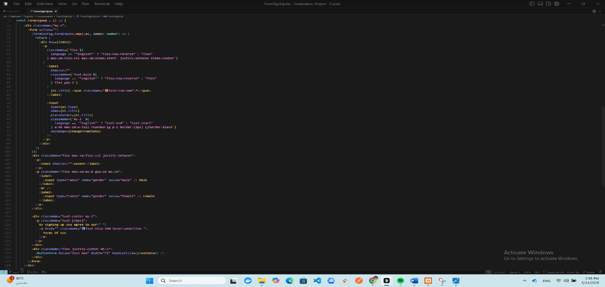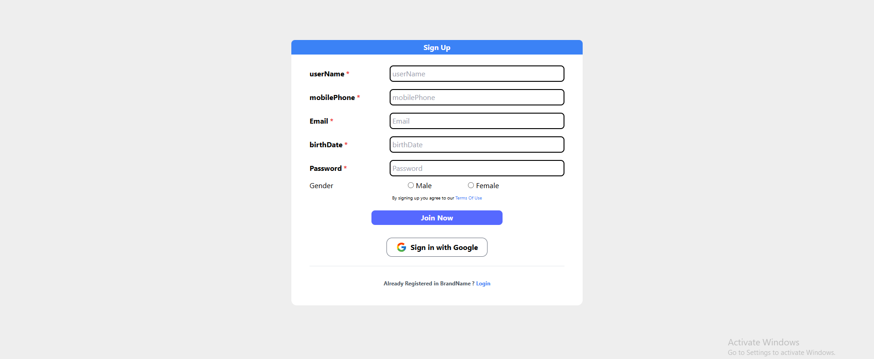

1. Contact Page

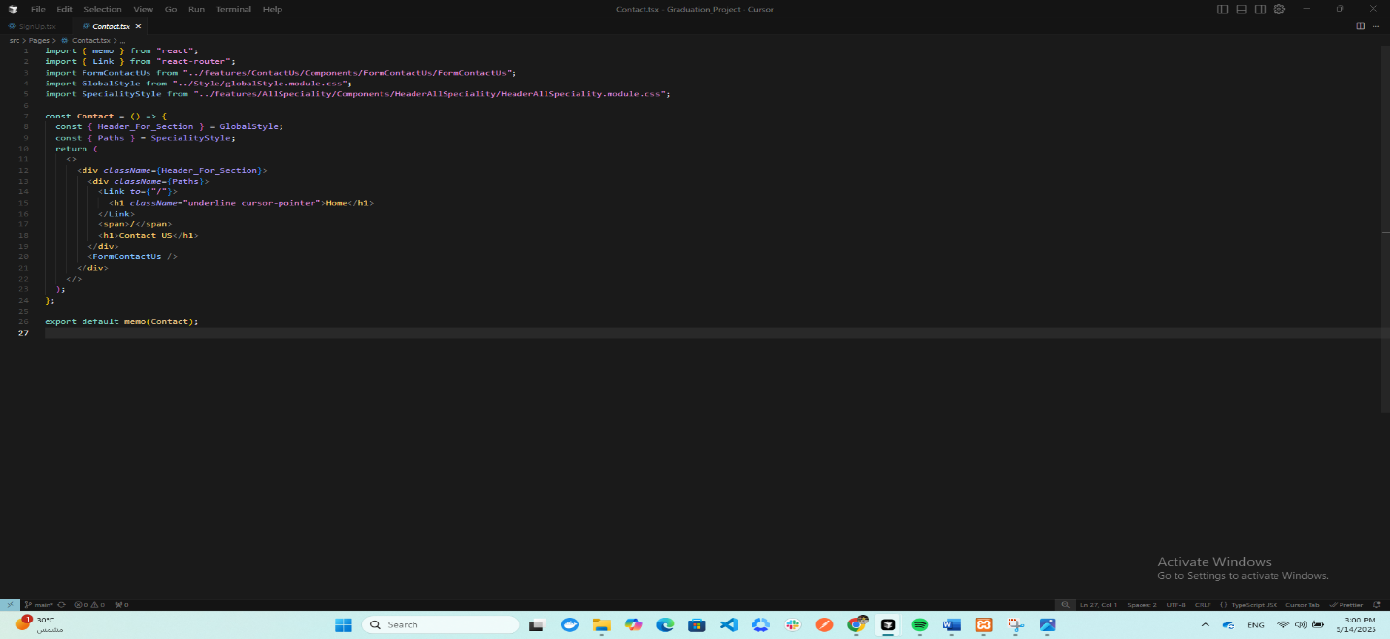

The Contact Us page is a fundamental part of your website that facilitates communication between you and your visitors or customers. This is where users can send you messages or inquiries - whether they're reporting an issue, asking about a specific service, or even suggesting improvements for your website.

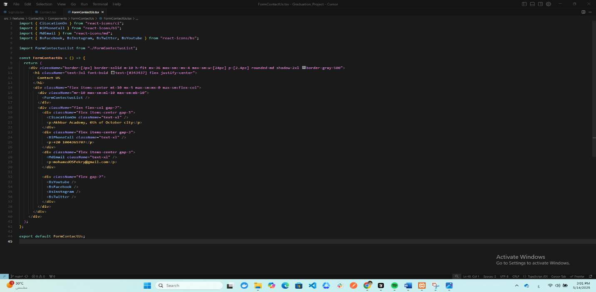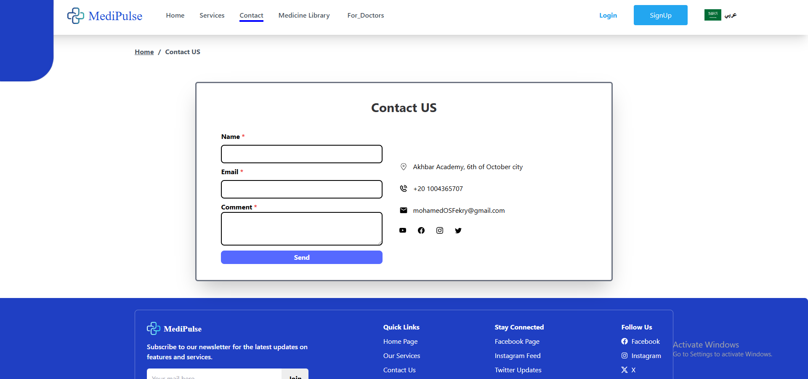

Of course, if you're not logged in, you won't be able to send POST requests with your data due to authorization requirements. The system requires proper authentication first before accepting any form submissions or data transmissions. This security measure ensures that only verified users can interact with protected endpoints and submit information through HTTP POST methods. Without a valid login session or authorization token, your requests will be rejected by the server's security layer.

1. All specialties Page

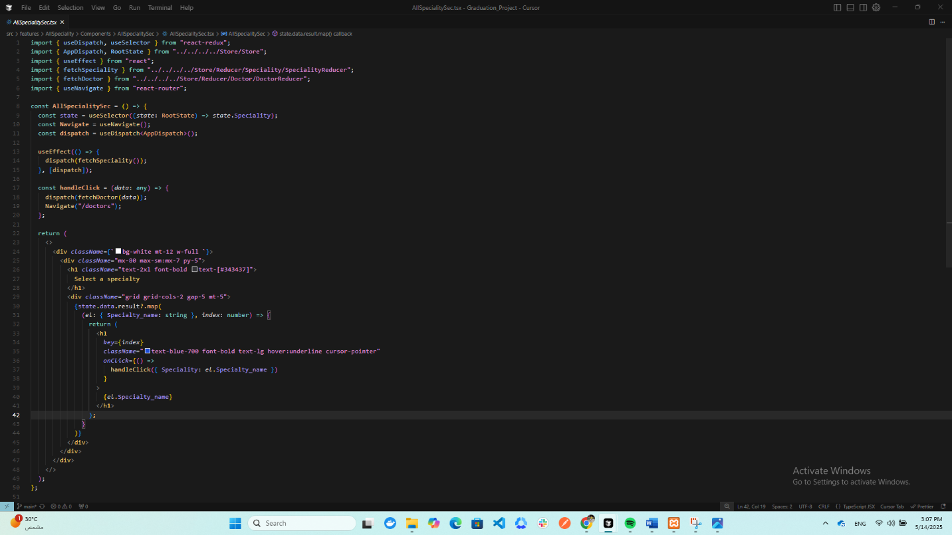

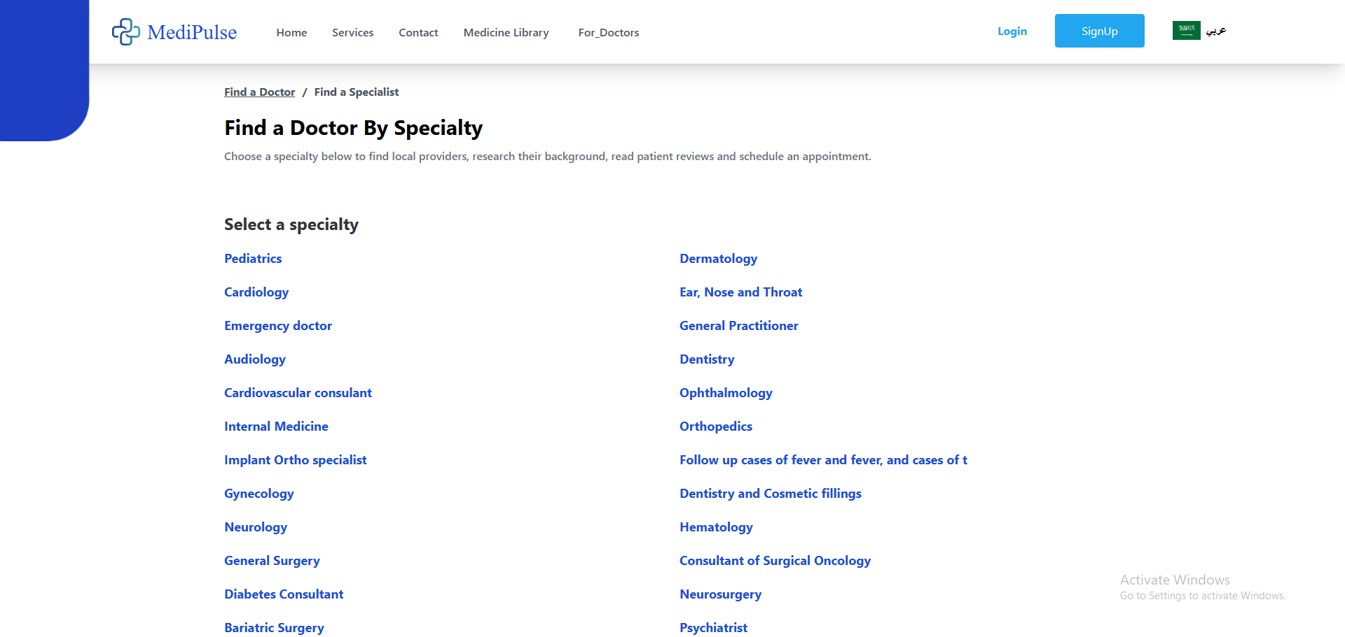

This page allows you to select your preferred specialty while leveraging Redux for efficient state management. The entire process works through a centralized data flow system where all application data gets stored in the Redux Store - acting as a single source of truth for your React components. When you choose a specialty, this selection gets preserved in the Redux Store through a structured process: first you dispatch specific actions describing what change should occur, then the reducer processes these actions by either retrieving new data from APIs or modifying existing state accordingly.

The real power comes from how components interact with this system. Any React component needing this specialty data can directly access it from the Redux Store without complex prop drilling. Meanwhile, any updates you make get handled through the same predictable pattern: dispatch an action → reducer processes it → Store updates → connected components re-render with fresh data. This creates a seamless loop where your specialty selection becomes immediately available across all parts of the application that need it, while maintaining clean code architecture and avoiding scattered state management.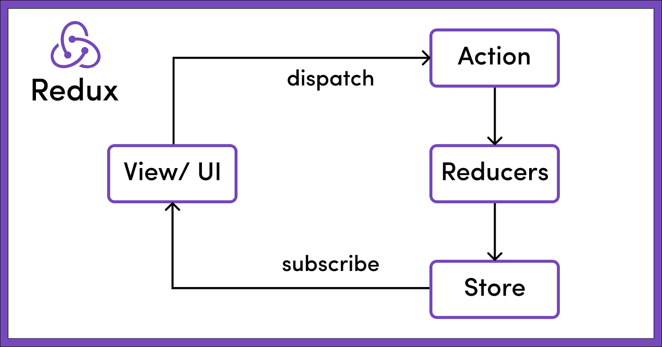

1. Doctor Page by Speciality

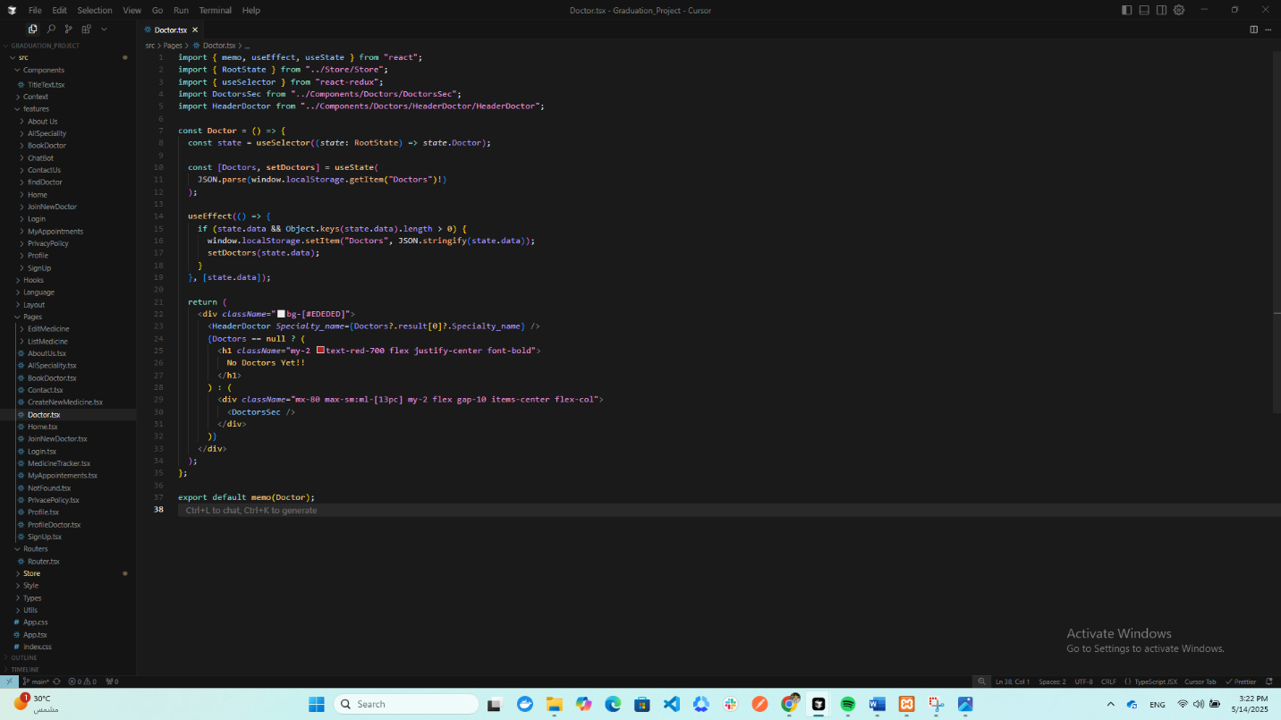

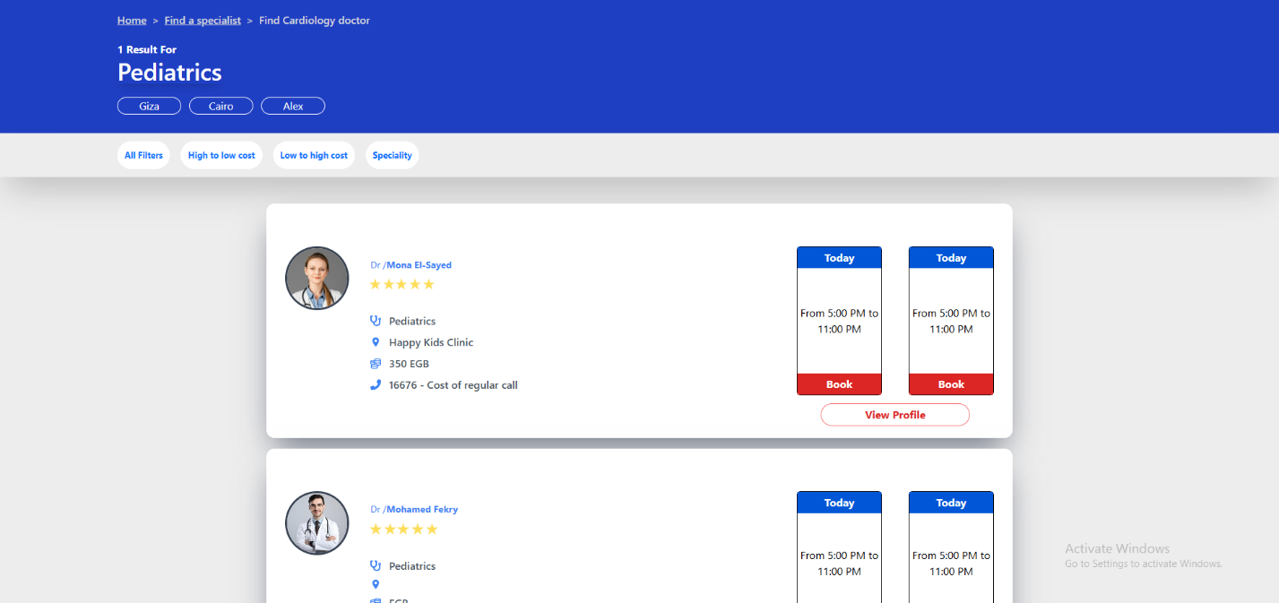

This page allows users to select a medical specialty such as Pediatrics, which automatically filters and displays only doctors specializing in that field. The system provides comprehensive filtering capabilities that extend beyond just specialty selection. Users can further refine their search by geographic area to find doctors nearby, by clinic or hospital affiliation for those who prefer specific medical facilities, and even search directly by doctor name when looking for a particular physician. These multiple filtering layers work together seamlessly to help patients quickly and efficiently find the most suitable healthcare providers based on their specific needs and preferences. The interface is designed to be intuitive, providing instant results as filters are applied, ensuring a smooth user experience when searching for medical professionals.

1. Profile Doctor Page

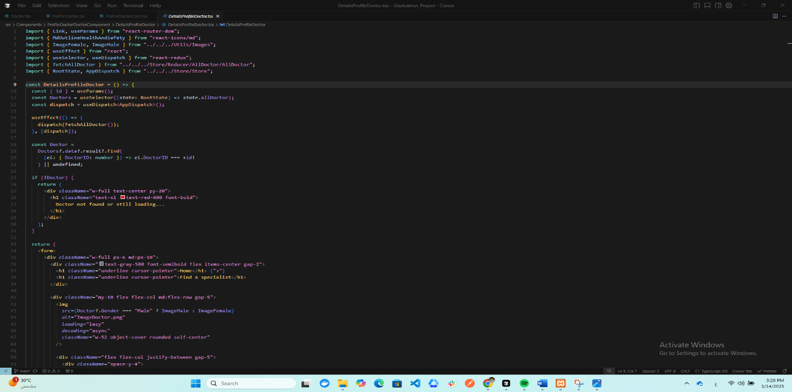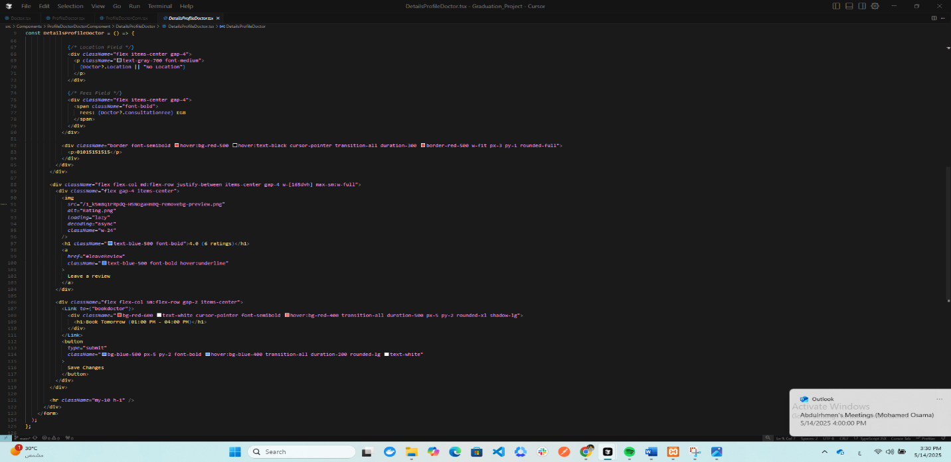

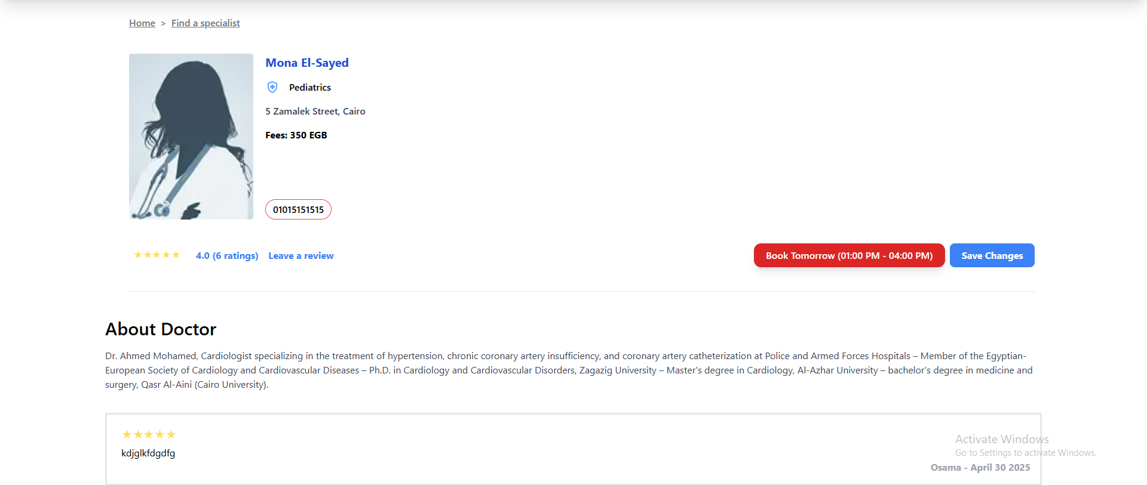

This page displays a doctor's detailed profile where patients can view their professional ratings and leave personal reviews. When visiting a specific doctor's page, users can examine the doctor's overall rating score based on previous patient feedback. The page also provides functionality for logged-in patients to submit their own reviews about their experiences with this doctor. These reviews typically include star ratings and optional written comments that help other patients make informed decisions when choosing healthcare providers. The system maintains transparency by showing all verified reviews while protecting patient privacy. This creates a valuable feedback loop where doctors receive constructive input and prospective patients gain authentic insights about a physician's practice before booking appointments. The review section often includes filtering options to sort feedback by date, rating, or other relevant criteria for easier navigation.

1. Book Doctor Page

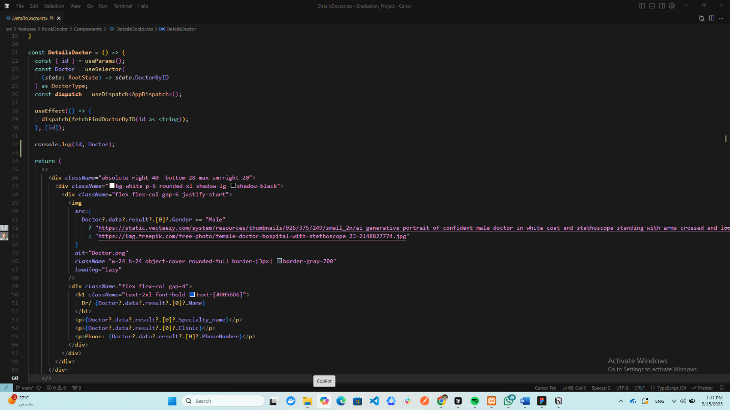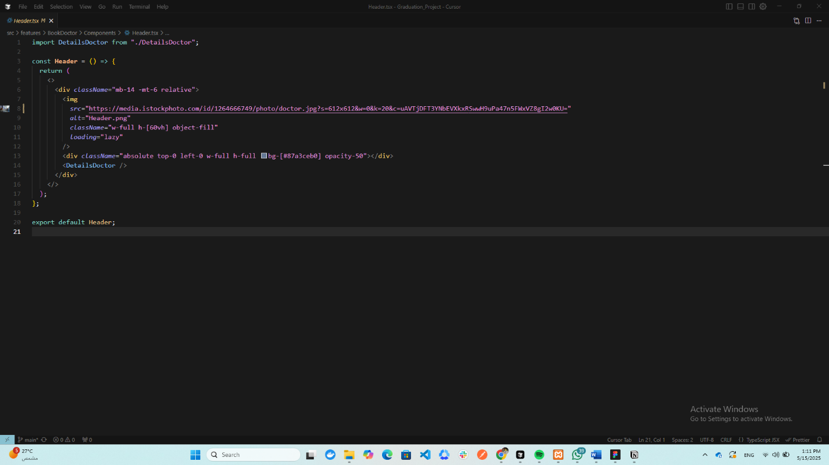

The appointment booking system captures your personal details (name, email, phone number) through this form and stores them in our database under the Appointments table. This creates a permanent record of your booking while enabling the clinic to manage schedules and send notifications. The process is designed for both security and convenience, ensuring your data is protected while simplifying doctor visits.

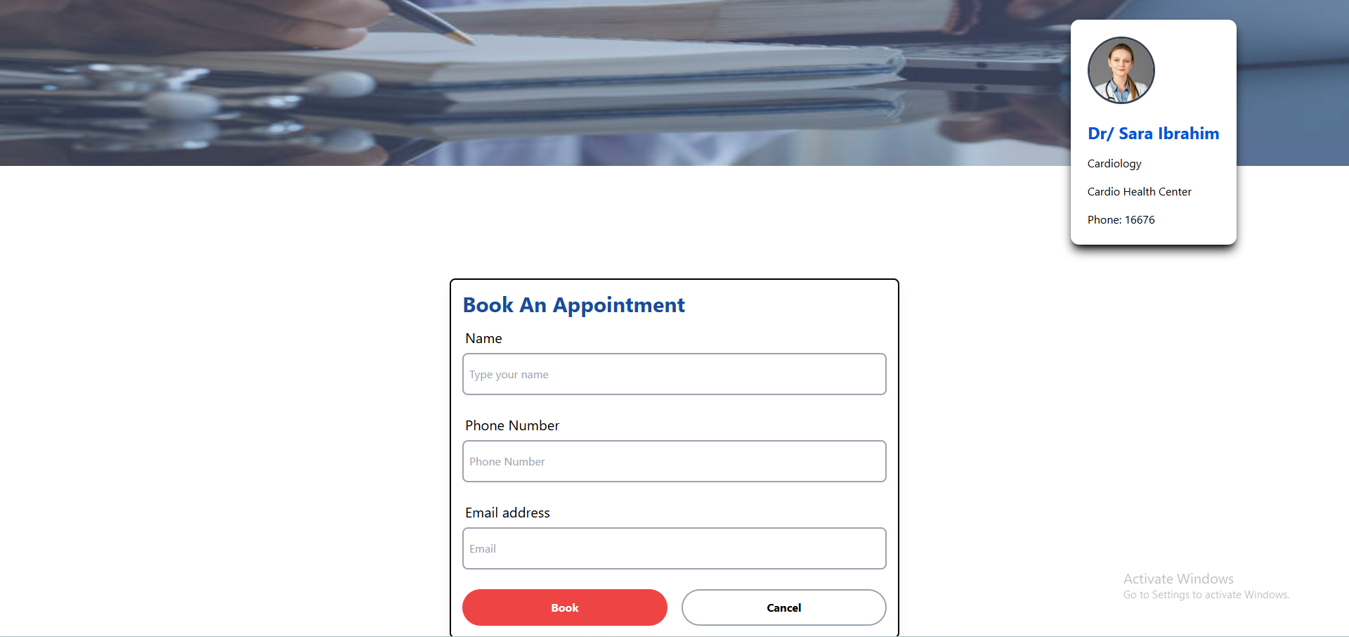

4.3 Backend Overview

The backend serves as the powerful engine that drives the entire application, working behind the scenes to process requests, manage data, and ensure everything runs smoothly. Built with robust technologies, it handles all the critical operations that make the system function properly while keeping data secure and accessible. The architecture follows clean code principles and industry best practices to maintain efficiency as the application grows.

At its core, the backend receives requests from users through the frontend, validates them carefully to prevent errors or security issues, then processes each one according to the business requirements. It communicates securely with the database to store and retrieve information while optimizing performance through techniques like caching and efficient query design. The system implements strict authentication measures to verify user identities and control what actions they can perform.

Security protections are built into every layer, from encrypted data transmission to safeguards against common threats. The backend also manages important background tasks, integrates with external services when needed, and maintains detailed logs for monitoring system health. Designed for reliability, it includes automatic testing and error handling to prevent disruptions. The implementation focuses on creating a stable foundation that supports all the frontend features while remaining flexible enough for future enhancements.

1. Technologies Used

The backend system leverages a robust stack of server-side technologies designed for performance, security and maintainability. Below are the core technologies powering the backend infrastructure:

Core Framework

• Node.js: The JavaScript runtime environment that executes server-side code, chosen for its non-blocking I/O model that efficiently handles concurrent requests.  
• Express.js: The minimalist web application framework that provides routing, middleware support and HTTP utility methods for building RESTful APIs.

Database  
• MySQL/PostgreSQL: The relational database management system used for structured data storage with ACID compliance, ensuring data integrity through transactions.

Authentication

• JSON Web Tokens (JWT): The stateless authentication standard implemented for secure user sessions and API endpoint protection.  
• bcrypt: The password hashing library that ensures credential security through salted hashing and adaptive hash algorithms.

API Development

• RESTful Principles: The architectural style followed for endpoint design, using standard HTTP methods and status codes.

Security

• Helmet: The middleware that enhances API security through HTTP header protections.  
• CORS: The access control system configured to whitelist approved frontend origins.

Development Tools

• Nodemon: The utility that monitors file changes and automatically restarts the server during development.

1. Model-View-Controller (MVC) Architecture

4.3.1 Model (Data Layer)

The Model represents the application's data structure and business logic. It interacts directly with the database, handling data storage, retrieval, and validation.

* Responsibilities:
  + Defines database schemas (e.g., User, Appointment, Doctor models).
  + Handles CRUD (Create, Read, Update, Delete) operations.
  + Enforces business rules (e.g., appointment scheduling constraints).
  + Uses Mongoose (for MongoDB) or Sequelize/TypeORM (for SQL) to manage database queries.

4.3.2 View (Presentation Layer)

In a traditional MVC setup, the View renders the UI, but since we're building a RESTful API, the backend doesn’t generate HTML. Instead:

* Our "View" is the API response (JSON/XML) sent to the frontend.
* Responsibilities:
  + Structures data in a consumable format for frontend clients (React, mobile apps).
  + Formats responses (success/error messages) consistently.

4.3.3 Controller (Logic Layer)

The Controller acts as the middleman between the Model and the View. It processes incoming HTTP requests, interacts with the Model, and returns the appropriate response.

* Responsibilities:
  + Handles routing (e.g., POST /api/appointments → createAppointment).
  + Validates request data (e.g., checking if an email is valid before saving).
  + Calls the Model to fetch or modify data.
  + Sends structured responses back to the client.

1. Backend Structure Overview

The backend follows an organized flow where the Router acts as the entry point - it receives incoming HTTP requests and directs them to the appropriate Controller functions based on the URL paths. Each route is mapped to a specific controller method that handles the business logic.

The Controller serves as the middle layer between routes and database operations. When a request comes in:

* For data retrieval, the controller calls database functions directly to fetch records
* For data modification, it first processes the request (validation, transformations) before updating the database

Database interactions happen through dedicated functions that either:

1. Query the database and return raw data (for GET requests)
2. Execute create/update/delete operations (for POST/PUT/DELETE) before returning results

This separation ensures clean architecture:

* Routes stay clean and only handle HTTP routing
* Controllers focus on request/response handling
* Database operations remain centralized

The controller essentially acts as a bridge - it doesn't store data itself, but orchestrates between what comes from routes and what needs to go to/from the database. Meanwhile, the router's job is simply to forward requests to the right controller handlers without any business logic.

1. Code Examples
2. Controller

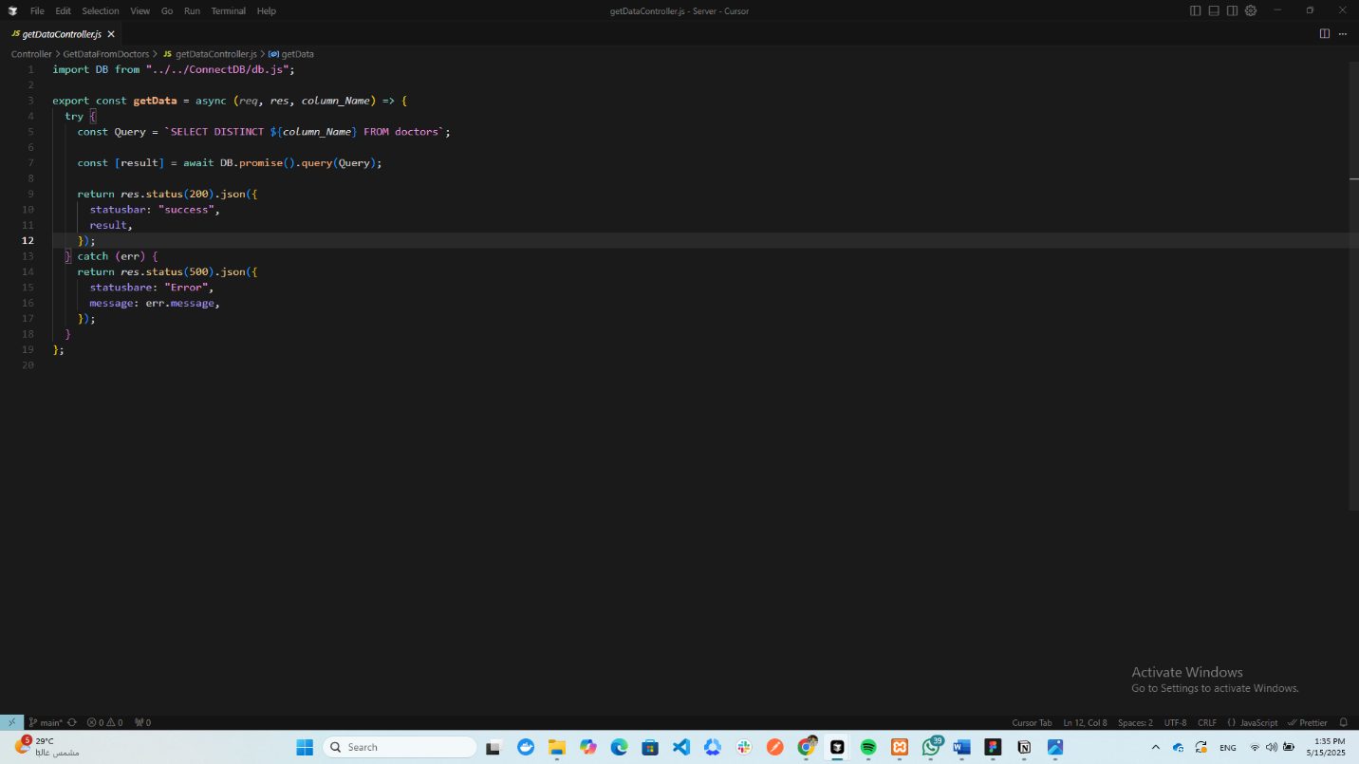

I've created a function that fetches data, but it only requires the column names you want, and it retrieves exactly that data for you.

Like:

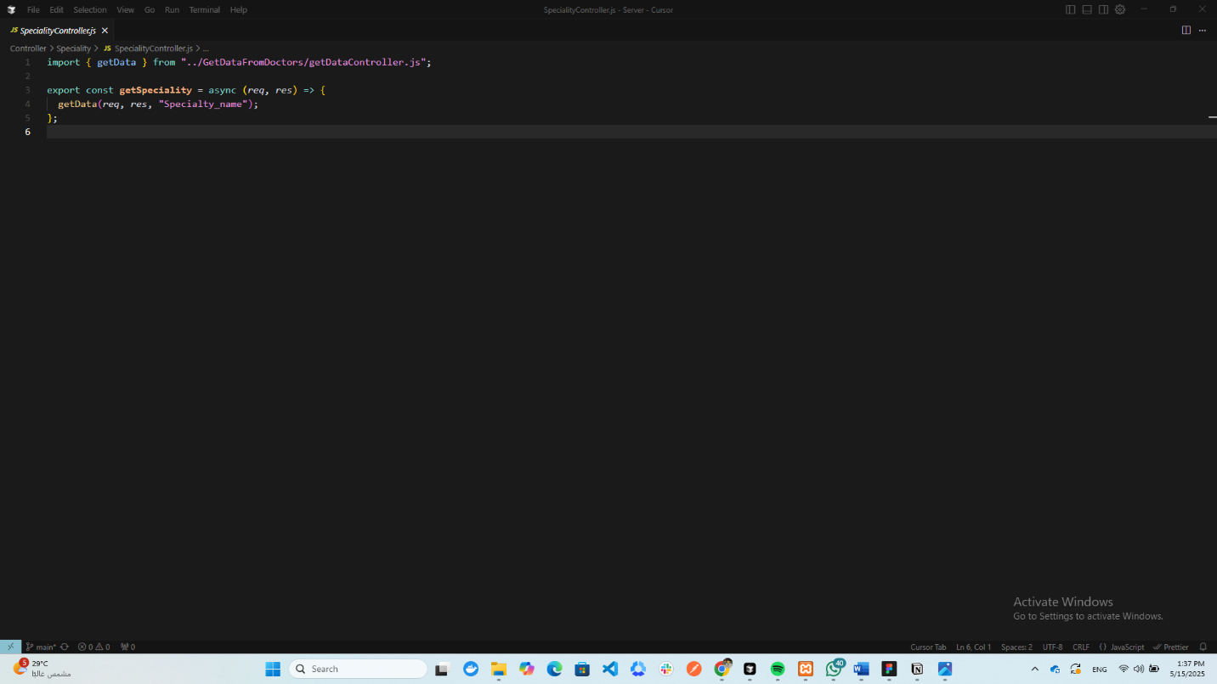

1-

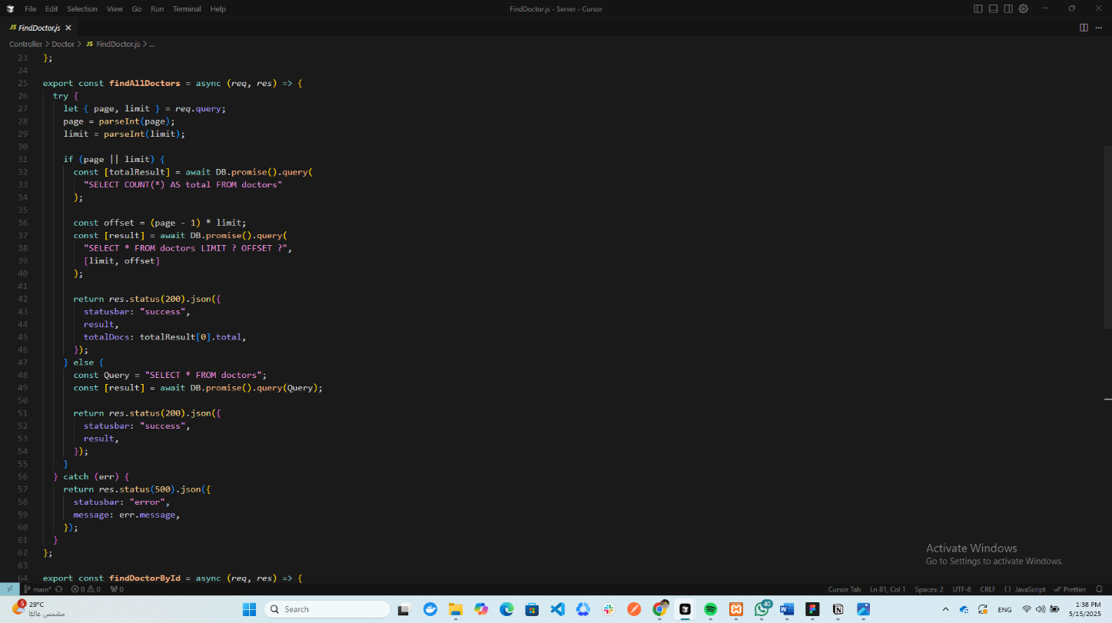

2-

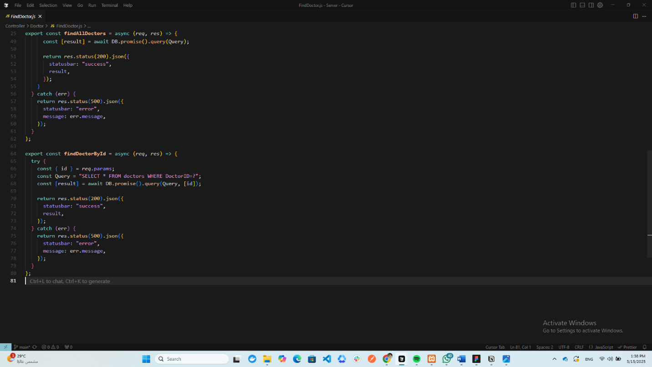

The system implements two distinct approaches for retrieving doctor information to optimize performance and efficiency. The first method fetches the complete dataset containing all doctors' information at once, which is particularly useful when displaying the full list of available medical professionals or performing bulk operations. This comprehensive retrieval ensures all necessary details are readily available without additional queries.

The second approach employs a more targeted data access strategy by accepting a specific doctor's unique identifier as input. This precision-based query returns only the requested physician's complete profile from the database, eliminating unnecessary data transfer and processing. This method proves especially valuable when users need detailed information about a particular doctor, such as viewing individual profiles or making appointments.

Both retrieval methods serve different but complementary purposes in the application. The full dataset approach supports broad overviews and filtering capabilities, while the ID-based lookup enables focused access to specific records. The system intelligently uses each method based on the current user interaction and interface requirements, ensuring optimal performance whether working with large datasets or individual records. This dual-approach design balances comprehensive data availability with efficient resource utilization.

1. Router

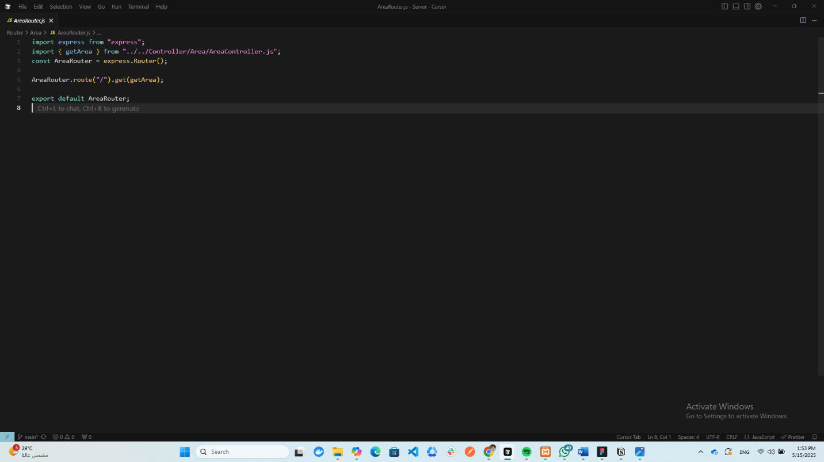

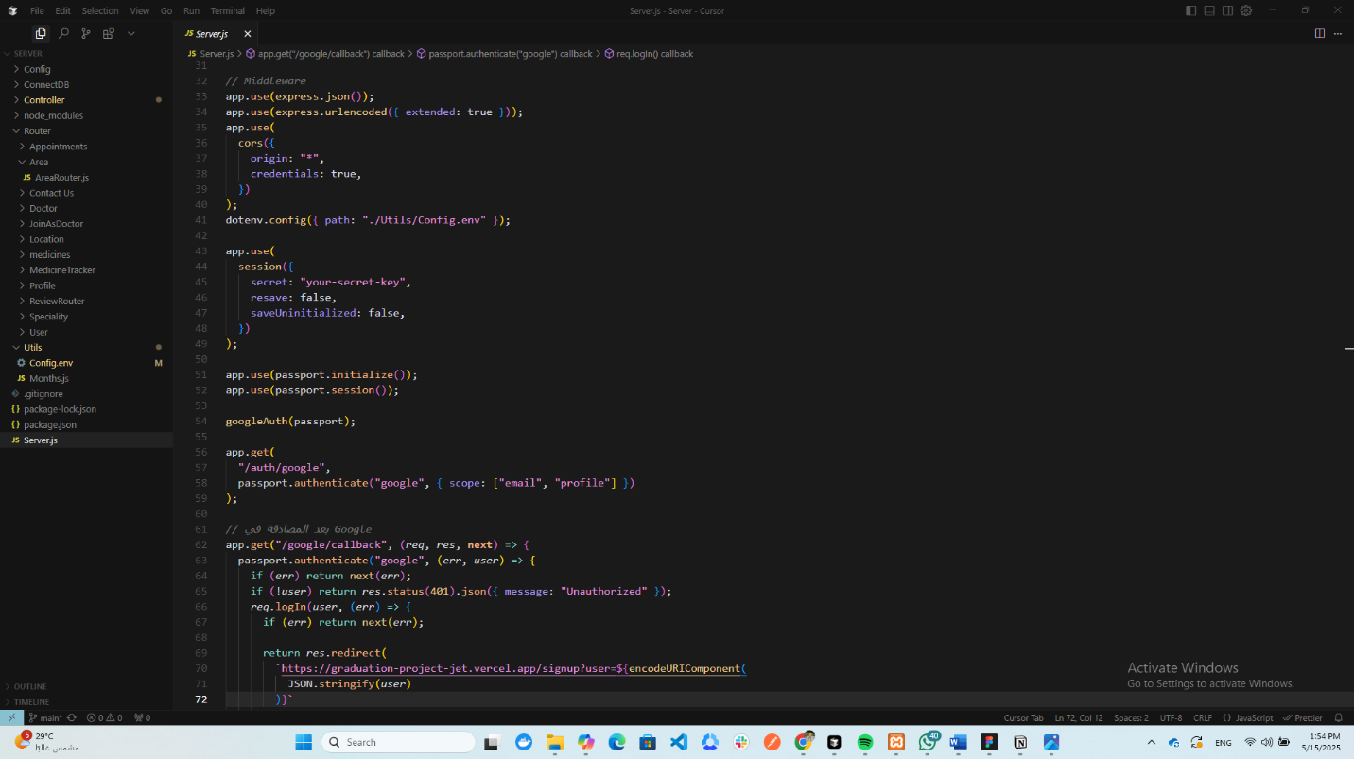

**Chapter Five**

**AI**

AI

**MediPulse Groq-Chatbot**

**5.1 Project Overview**

**5.1.1 Introduction**

MediPulse is an AI-powered medical assistant designed to provide accessible, preliminary health information. Developed as a capstone project, it utilizes Groq’s Llama 3 70Billion Large Language Model (LLM) via a Flask-based Python backend API. The system engages users conversationally (in English or Arabic), gathers symptom context (age, smoking, conditions), and offers general guidance based on a strict, safety-focused medical protocol (MediPulse Protocol v3.5). It aims to be a responsible first point of contact, bridging the gap between public demand for health information and the need for professional medical advice. Frontend access is provided via a web application, with an Android app anticipated.

**5.1.2 Problem Statement**

Individuals often turn to unreliable online sources for health information, leading to misinformation, anxiety, lack of personalized context, and potentially delayed or unnecessary medical visits. MediPulse provides a controlled environment for preliminary inquiries, offering structured information without claiming diagnostic capabilities.

**5.1.3 Goals**

* Develop a secure Flask backend API.
* Implement a safe AI interaction model using Groq Llama 3 and a custom protocol.
* Prioritize user safety (emergency detection, no diagnosis/prescriptions, disclaimers).
* Support English and Arabic interaction.
* Gather essential user context via structured questions.
* Facilitate user-friendly web and Android interfaces.
* Ensure responsible information delivery (general categories, limited OTC, referral advice).

**5.1.4 Scope & Limitations**

**In Scope:** Preliminary general health info, multilingual chat, context gathering, emergency flagging, suggesting condition categories, limited/safe OTC guidance, advice on seeking professional help, API for frontends, session-based history.

**Limitations (Out of Scope):** **NO** medical diagnosis, **NO** treatment plans, **NO** prescriptions, **NOT** for managing emergencies, **NOT** a replacement for healthcare professionals, **NOT** for complex/chronic/rare conditions or mental health crises. Information is general and accuracy is not guaranteed for individual cases.

**5.1.5 Technology Stack**

* **Backend:** Python 3, Flask, Flask-CORS, Flask-Session
* **AI/LLM:** Groq API (Llama 3 70B), Langchain (schemas)
* **Frontend (Web):** HTML, CSS, JavaScript
* **Frontend (Android - Anticipated):** Kotlin/Java
* **Environment/Deployment:** Dotenv, Gunicorn (implied by Procfile)

**5.2 System Architecture**

**5.2.1 Introduction**

This section provides a detailed description of the architectural design of the MediPulse system. MediPulse is architected as a web-based application employing a client-server model, augmented by a powerful Large Language Model (LLM) for its core conversational AI capabilities. The architecture prioritizes modularity, safety, user experience, and scalability. It comprises three primary logical components: the Backend API (MediPulse Core), the Frontend Interfaces (Web and anticipated Android), and the External LLM Service (Groq API).

**5.2.2 Overall Architecture**

MediPulse employs a standard three-tier client-server architecture:

1. **Presentation Tier (Frontend):** This tier is responsible for user interaction. It includes a web application built with HTML, CSS, and JavaScript, providing a chat interface within a web browser. An Android mobile application is also envisioned as part of this tier, offering a native mobile experience. Both frontend clients communicate with the backend via HTTP requests.
2. **Application Tier (Backend API):** This is the core logic layer, implemented as a Flask web application in Python. It handles incoming requests from the frontends, manages user sessions and conversation state, enforces the medical safety protocol, interacts with the LLM service, and sends responses back to the clients. It acts as the central orchestrator of the system.
3. **Data/Service Tier:** This tier primarily consists of the external Groq API service, which provides the Llama 3 70B LLM used for generating health-related information. Session data is managed within the Application Tier using server-side filesystem storage.

Communication between the Frontend and Backend occurs via a RESTful API exposed by the Flask application. The Backend communicates with the Groq API using HTTPS requests, sending prompts and receiving generated text.

graph LR

User -- Interacts --> FE(Frontend: Web/Android)

FE -- HTTP Requests (JSON) --> BE(Backend API: Flask)

BE -- Stores/Retrieves --> FS(Filesystem Session Cache)

BE -- API Call (Prompt) --> LLM(Groq API: Llama 3)

LLM -- API Response (Text) --> BE

BE -- HTTP Responses (JSON) --> FE

FE -- Displays Info --> User

*Figure 2.1: High-Level System Architecture*

**5.2.3 Backend API (Flask)**

The backend is the heart of the MediPulse system, developed using the Flask microframework in Python. It exposes API endpoints, manages conversation logic, and integrates with the LLM.

**5.2.4Technology Stack:**

* **Framework:** Flask (v2.x or later assumed based on modern practices)
* **Language:** Python 3
* **Key Libraries:**
  + Flask: Core web framework.
  + Flask-CORS: Handles Cross-Origin Resource Sharing, allowing the frontend (potentially served from a different domain/port during development) to interact with the API.
  + Flask-Session: Manages server-side sessions, configured to use the filesystem (SESSION_TYPE = "filesystem") for storing session data persistently within a defined lifetime (PERMANENT_SESSION_LIFETIME = timedelta(hours=1)). Session data is stored in the ./session_cache directory.
  + python-dotenv: Loads environment variables from a .env file (though .env itself is rightly excluded from the repository via .gitignore), used for sensitive information like API keys and secret keys.
  + langchain: Although ConversationBufferMemory is imported, the actual memory management appears to be custom-built using the Flask session (session["memory_history"]). Langchain schemas (SystemMessage, HumanMessage) are used to structure the interaction with the LLM.
  + langchain-groq: Provides the ChatGroq class for seamless integration with the Groq API, specifically configured to use the llama3-70b-8192 model.
  + secrets: Used to generate a default Flask secret key if one isn’t provided via environment variables.
  + logging: Standard Python logging library configured for basic informational logging.

**5.2.5Core Components:**

* **Flask Application (**app**):** The central Flask application instance is initialized, configured with static/template folder paths, a secret key (crucial for session security), and session parameters. CORS is enabled for all routes.
* **LLM Initialization (**llm**):** An instance of ChatGroq is created, configured with the specific model name (llama3-70b-8192), a low temperature (0.1) for more deterministic responses, and the Groq API key loaded from environment variables.
* **Medical Prompt Configuration:** This is a critical design element ensuring safe and responsible AI behavior.
  + MEDICAL_PROMPT_BASE: A detailed multi-part string defining the AI’s role, sole purpose (preliminary info, not diagnosis), core requirements (safety, emergency identification, no prescriptions, limited OTC guidance, no diagnostic decisions), response guidelines (clarification, conciseness, language, tone), assessment format, and boundaries (scope, off-topic deflection, privacy).
  + PROMPT_COMPONENTS: A dictionary containing language-specific text (English and Arabic) for various parts of the prompt (instructions, emergency warnings, disclaimers, etc.).
  + get_dynamic_prompt(language): A function that dynamically constructs the final system prompt by injecting the appropriate language components from PROMPT_COMPONENTS into the MEDICAL_PROMPT_BASE template based on the user’s selected language.
* **Structured Questions (**questions**):** A list of dictionaries defining the initial questions asked to the user (Language, Age, Smoker, Existing Conditions). Each dictionary specifies an id, English text (text), Arabic text (text_ar), and input type (language, number, boolean). This structured approach ensures necessary context is gathered before assessment.
* **Session Management:** Flask-Session is used to maintain user state across requests. Key session variables include:
  + session["memory_history"]: Stores the conversation history as a list of (input, output) tuples.
  + session["current_index"]: Tracks the current question index during the initial questioning phase.
  + session["stage"]: Indicates the current phase of the conversation (‘questions’ or ‘assessment’).
  + session["language"]: Stores the user’s selected language (‘en’ or ‘ar’).
  + session["created_at"]: Timestamp for session creation. The session data is stored on the server’s filesystem in the session_cache directory, identified by a session ID cookie sent to the client.

**5.2.6 API Endpoints:**

The backend exposes the following HTTP endpoints:

* GET /**:**
  + **Purpose:** Serves the main HTML page for the web frontend.
  + **Implementation:** Uses Flask’s render_template("index.html").
* POST /Api/start**:**
  + **Purpose:** Initializes a new chat session.
  + **Implementation:** Clears any existing session data for the user, initializes session variables (memory_history, current_index=0, stage='questions', language='en', created_at), retrieves the first question (language selection), and returns a JSON response containing the new session_id and the first question details (text in both languages, type).
* POST /api/chat**:**
  + **Purpose:** Handles all subsequent user messages during the chat.
  + **Implementation:**
    1. Retrieves the user’s message and session state (stage, index, language) from the request and session.
    2. Performs session validation (checks if essential session variables exist).
    3. **Language Selection Handling:** If it’s the first question (index 0), determines and sets the session language based on user input, increments the index, and returns the next question in the selected language.
    4. **Question Stage Handling:** If in the ‘questions’ stage (and not the first question):
       - Retrieves the current question text in the correct language.
       - Performs input validation (specifically for boolean types, checking against English/Arabic ‘yes’/‘no’ variations).
       - Saves the question and the processed user answer to the session["memory_history"].
       - Increments session["current_index"].
       - If more questions remain, returns the next question.
       - If all questions are answered, transitions session["stage"] to ‘assessment’ and returns a prompt asking the user to describe their symptoms.
    5. **Assessment Stage Handling:** If in the ‘assessment’ stage:
       - Rebuilds the conversation history from session["memory_history"] into a format suitable for the LLM (using ConversationBufferMemory temporarily, though the primary storage is the session).
       - Retrieves the dynamically generated system prompt for the selected language using get_dynamic_prompt().
       - Constructs the message list for the LLM: [SystemMessage(prompt), *history, HumanMessage(user_input)].
       - Invokes the llm (Groq API) with the messages.
       - Saves the user input and the LLM’s response to session["memory_history"].
       - Returns the LLM’s content as the response.
    6. **Error Handling:** Includes try-except blocks to catch potential errors during processing or LLM interaction, returning JSON error messages and appropriate HTTP status codes (e.g., 400 for bad input, 401 for invalid session, 500 for internal errors).

**5.2.7 Deployment Configuration:**

* Procfile**:** Contains web: gunicorn medipulseGROQ:app. This indicates the application is intended for deployment using the Gunicorn WSGI server, a common practice for production Flask applications on platforms like Heroku or Railway.
* requirements.txt**:** Lists all necessary Python dependencies, crucial for recreating the environment during deployment.

**5.2.8 Frontend (Web Application)**

The web frontend provides the user interface for interacting with the MediPulse assistant.

**5.2.9 Technology Stack:**

* **Structure:** HTML (templates/index.html)
* **Styling:** CSS (static/style.css - content not analyzed but assumed to style the chat interface)
* **Logic:** JavaScript (static/script.js)

**5.2.10 Structure and Functionality (**index.html**,** script.js**):**

* **UI Elements:** The HTML defines a simple chat interface containing:
  + A div (chat-box) to display messages.
  + An input field (user-input) for typing messages.
  + A div (bool-options) containing ‘Yes’ and ‘No’ buttons, initially hidden.
  + A ‘Send’ button (send-button).
* **JavaScript Logic (**script.js**):**
  + **Initialization:** On DOMContentLoaded, it initiates the chat by calling startSession().
  + startSession()**:** Sends a POST request to /api/start, stores the returned sessionId, and calls handleQuestion() with the first question.
  + sendMessage()**:** Triggered by the Send button or Enter key. It reads the user input, displays it in the chatbox, clears the input field, and sends a POST request to /api/chat with the sessionId and message.
  + **Response Handling:** Processes the JSON response from /api/chat. If it contains an error, it displays the error. If it indicates the ‘assessment’ stage, it updates the input placeholder and displays the assessment prompt. If it contains a next_question, it calls handleQuestion(). If it contains an LLM response, it displays the response.
  + handleBoolean(answer)**:** Called when Yes/No buttons are clicked. Sets the input field value to the answer (‘Yes’ or ‘No’) and calls sendMessage().
  + handleQuestion(question)**:** Displays the question text received from the backend. It dynamically shows or hides the boolean buttons and the text input field based on the question.type.
  + addMessage(sender, text)**:** A utility function to create and append new message elements (user or bot) to the chat-box and scroll to the bottom.

**5.2.11 External Services**

* **Groq API:** The system relies heavily on the Groq cloud platform to access the Llama 3 70B LLM. This external service performs the natural language understanding and generation based on the prompts provided by the backend. Communication is secured via an API key managed through environment variables.

**5.2.12 Data Flow and Sequence**

The interaction sequence, as detailed in the sequence diagram (medipulse_sequence.puml), typically follows these steps:

1. User accesses the web frontend.
2. Frontend calls /api/start on the backend.
3. Backend creates a session, returns session ID and the first question (Language).
4. Frontend displays the language question.
5. User provides input (e.g., selects language).
6. Frontend sends input to /api/chat.
7. Backend processes input (sets language), determines the next question (Age), and returns it.
8. This question-answer cycle repeats for Age, Smoker, Conditions.
9. After the last question, the backend transitions the stage to ‘assessment’ and prompts for symptoms.
10. Frontend displays the symptom prompt.
11. User describes symptoms.
12. Frontend sends symptoms to /api/chat.
13. Backend prepares the full prompt (System Prompt + History + Symptoms) and sends it to the Groq LLM.
14. Groq LLM processes the prompt and returns a generated response.
15. Backend receives the LLM response, saves the interaction to session history, and sends the response to the frontend.
16. Frontend displays the AI’s response to the user.

**5.2.13 Design Principles and Considerations**

* **Modularity:** Clear separation between frontend presentation logic, backend application logic, and the external AI service.
* **Safety First:** The design places paramount importance on user safety through the detailed, rule-based MEDICAL_PROMPT_BASE that strictly governs the AI’s behavior, preventing diagnosis, prescriptions, and ensuring appropriate disclaimers and emergency referrals.
* **Stateless API (with Server-Side State):** While REST APIs aim for statelessness, this application maintains conversation state using server-side sessions (Flask-Session). Each request from a client is implicitly associated with its session via a cookie, allowing the backend to retrieve context.
* **User Experience:** The structured questioning provides context, multilingual support broadens accessibility, and the chat interface offers a familiar interaction paradigm.
* **Scalability:** Using Flask and Gunicorn allows for horizontal scaling by running multiple instances of the backend application behind a load balancer, although the filesystem session storage might become a bottleneck in a highly scaled, multi-server environment (alternatives like Redis could be considered if needed).
* **Maintainability:** Using a framework like Flask, clear separation of concerns, and configuration via environment variables contribute to maintainability.
* **Security:** Use of environment variables for secrets (API key, Flask secret key) and Flask-Session for managing sessions are basic security measures. CORS is configured, likely for development flexibility.

**5.2.14 Anticipated Android Integration**

While the code for the Android application is not present in this repository, the architecture is designed to support it. The Android app would function similarly to the web frontend:

1. It would make HTTP POST requests to the same /api/start and /api/chat endpoints.
2. It would need to handle session management, likely by storing and sending the session cookie received from the backend with subsequent requests.
3. It would parse the JSON responses from the API to display questions, prompts, and AI responses within its native UI components.
4. It would implement native UI elements for text input and potentially dedicated buttons for boolean questions, mirroring the web frontend’s functionality.

**5.3 Implementation Highlights**

**5.3.1 Introduction**

This section delves into the specific implementation details of the MediPulse system, building upon the architectural overview provided in the previous section. It examines the key code segments, logic flows, data handling, and configurations within the backend API and the web frontend, based on the analysis of the medipulseGROQ.py, templates/index.html, and static/script.js files from the provided GitHub repository.

**5.3.2 Backend Implementation (medipulseGROQ.py)**

The backend is implemented as a single Python file using the Flask framework. This monolithic structure is suitable for a project of this scale but could be refactored into modules (e.g., routes, services, models) for larger applications.

**5.3.3 Initialization and Configuration:**

* **Imports:** The script begins by importing necessary libraries: os, re, secrets, logging, datetime, Flask components (Flask, request, jsonify, render_template, session), Flask-CORS, Flask-Session, dotenv, Langchain components (SystemMessage, HumanMessage, AIMessage, ConversationBufferMemory), and ChatGroq.
* **Environment Variables:** load_dotenv() is called to load configuration from a .env file. This is crucial for managing sensitive data like FLASK_SECRET_KEY and GROQ_API_KEY without hardcoding them.
* **Flask App Instantiation:** app = Flask(__name__, static_folder="static", template_folder="templates") creates the Flask application instance, correctly pointing to the directories containing frontend assets.
* **CORS:** CORS(app) enables cross-origin requests for all routes, simplifying frontend development and deployment scenarios.
* **Session Configuration:** Flask-Session is configured:
  + SECRET_KEY: Essential for signing session cookies. It attempts to load from FLASK_SECRET_KEY environment variable, falling back to a securely generated random hex token using secrets.token_hex(16) if the variable is not set.
  + SESSION_TYPE = "filesystem": Specifies that session data should be stored on the server’s filesystem.
  + SESSION_FILE_DIR = "./session_cache": Sets the directory for storing session files.
  + SESSION_PERMANENT = True and PERMANENT_SESSION_LIFETIME = timedelta(hours=1): Configures sessions to be permanent (relative to browser session) but expire after 1 hour of inactivity.
  + Session(app) initializes the Flask-Session extension with the app.
* **Logging:** logging.basicConfig(...) sets up basic logging to capture informational messages, warnings, and errors, including timestamps.
* **Groq LLM Initialization:** llm = ChatGroq(...) creates the client instance to interact with the Groq API, specifying the llama3-70b-8192 model, a low temperature (0.1) for focused responses, and the API key from GROQ_API_KEY.

**5.3.4 Prompt Engineering Implementation:**

* MEDICAL_PROMPT_BASE**:** This multi-line string is the core of the AI’s persona and safety constraints. It uses f-string-like placeholders (e.g., {language_instruction}) to allow for dynamic language injection.
* PROMPT_COMPONENTS**:** A dictionary mapping language codes (‘en’, ‘ar’) to sub-dictionaries. Each sub-dictionary contains the actual text snippets corresponding to the placeholders in MEDICAL_PROMPT_BASE for that language.
* get_dynamic_prompt(language) **Function:**
  + Takes a language code (‘en’ or ‘ar’) as input.
  + Defaults to ‘en’ if the provided language is unsupported.
  + Retrieves the corresponding component dictionary from PROMPT_COMPONENTS.
  + Uses the .format() string method to insert the language-specific text components into the MEDICAL_PROMPT_BASE string.
  + Includes error handling (try-except KeyError) to fall back to the English prompt if a specific language key is missing, logging an error in the process.
  + Returns the fully constructed, language-specific system prompt string. This dynamic approach is efficient for supporting multiple languages without duplicating the entire base prompt structure.

**5.3.5 Structured Questioning Implementation:**

* questions **List:** A list defines the sequence and content of initial questions. Each element is a dictionary with id, text (English), text_ar (Arabic), and type (‘language’, ‘number’, ‘boolean’). The order in this list dictates the conversation flow during the ‘questions’ stage.

**5.3.6 API Endpoint Implementation:**

* @app.route("/") def home():
  + Maps to the root URL (/).
  + Uses render_template("index.html") to serve the main web page.
* @app.route("/api/start", methods=["POST"]) def start_chat():
  + Mapped to /api/start, accepting only POST requests.
  + session.clear(): Ensures a fresh start by removing any previous session data for the client.
  + Initializes session variables: memory_history (empty list), current_index (0), stage (‘questions’), language (‘en’ default), created_at (current timestamp).
  + Retrieves the first question (questions[0]).
  + Constructs the question text including both English and Arabic for the initial language selection: f"{first_question['text']} / {first_question['text_ar']}".
  + Logs the start of a new session.
  + Returns a JSON response containing the session.sid (unique session identifier managed by Flask-Session) and the first question’s details (id, combined text, type).
* @app.route("/api/chat", methods=["POST"]) def handle_chat():
  + Mapped to /api/chat, accepting only POST requests.
  + data = request.get_json(): Retrieves the JSON payload sent by the client (expected to contain message).
  + **Session Validation:** Checks if required keys (memory_history, current_index, stage) exist in the session. If not, it logs a warning and returns a 401 Unauthorized error with a bilingual message prompting the user to restart.
  + Retrieves user_input, current_index, stage, and language from the request and session.
  + **Conditional Logic based on** stage**:**
    - **Language Selection (**stage == "questions" and current_index == 0**):**
      * Checks user_input for keywords indicating Arabic (‘arab’, ‘عربي’).
      * Sets session["language"] to ‘ar’ or ‘en’.
      * Logs the language selection.
      * Increments session["current_index"].
      * Retrieves the next question’s data (questions[current_index]).
      * Gets the question text in the selected language using next_q_data.get(f"text_{language}", next_q_data["text"]) (provides fallback to English text).
      * Returns a JSON response with the next_question details and calculated progress.
    - **Question Stage (**stage == "questions" and current_index > 0**):**
      * Retrieves current question data and text.
      * **Boolean Input Validation (**current_q_data["type"] == "boolean"**):**
        + Defines lists of valid ‘yes’ and ‘no’ inputs in both languages.
        + Normalizes the user_input.lower() to ‘Yes’/‘No’ (English) or ‘نعم’/‘لا’ (Arabic) if it matches any valid option.
        + If no match, returns a 400 Bad Request error with a language-specific prompt to answer Yes/No.
        + Stores the normalized answer in user_input_processed.
      * For non-boolean questions, user_input_processed is simply the original user_input.
      * **Memory Update:** Temporarily creates a ConversationBufferMemory (though not strictly necessary as history is directly managed in the session), saves the current question (current_q_text) and the processed answer (user_input_processed) using memory.save_context. **Crucially, it also appends the** (current_q_text, user_input_processed) **tuple to** session["memory_history"]**, which is the persistent storage.**
      * Increments session["current_index"].
      * **Stage Transition Check:** If current_index >= len(questions), it means all initial questions are answered. Sets session["stage"] = "assessment", defines the symptom prompt in the correct language, logs the stage change, and returns a JSON response with the message (symptom prompt) and stage (‘assessment’).
      * **Next Question:** If questions remain, retrieves the next question’s data and text, and returns it in a JSON response along with the progress.
      * Includes a try...except block for general error handling during this stage, returning a 500 Internal Server Error if issues occur.
    - **Assessment Stage (**stage == "assessment"**):**
      * **Memory Reconstruction:** Creates a ConversationBufferMemory and populates it by iterating through the session["memory_history"] list and using memory.save_context for each past input/output pair. This reconstructs the conversation context for the Langchain LLM call.
      * system_prompt = get_dynamic_prompt(language): Gets the appropriate system prompt.
      * **Message Formatting:** Creates the messages list required by the Langchain LLM:
        + Starts with SystemMessage(content=system_prompt).
        + Unpacks the history from the reconstructed memory object: memory.load_memory_variables({})["history"].
        + Adds the current user input: HumanMessage(content=user_input).
      * **LLM Invocation:** Calls response = llm.invoke(messages).content. This sends the structured messages to the Groq API and retrieves the content of the AI’s response.
      * Logs the invocation and reception of the LLM response.
      * **Memory Update:** Saves the current user_input and the received LLM response to the temporary memory object and, importantly, appends (user_input, response) to session["memory_history"].
      * Returns a JSON response containing the LLM’s response.
      * Includes a try...except block for error handling during LLM interaction, returning a 500 error if needed.

**5.3.7 Main Execution Block:**

* The standard if __name__ == "__main__": block, which typically contains app.run(), is commented out. This is correct practice for production deployment, as the application will be run by a WSGI server like Gunicorn (as specified in the Procfile) rather than Flask’s built-in development server.

**5.4 Features & Workflow**

**5.4.1 Core Features**

* **Conversational AI:** Natural language interaction via Groq Llama 3.
* **Multilingual:** Supports English and Arabic.
* **Context Gathering:** Structured questions for Age, Smoker, Conditions.
* **Symptom Assessment:** Provides preliminary info, potential categories, limited/safe OTC suggestions, referral advice (NO diagnosis).
* **Safety Protocols:** Embedded rules for emergency detection, no diagnosis/prescriptions, disclaimers.
* **Session Management:** Maintains conversation context via server-side sessions.
* **Web Interface:** Simple, interactive chat UI.
* **API:** RESTful endpoints (/api/start, /api/chat) for frontend integration.

**5.4.2 User Workflow (Web)**

1. Access Website.
2. Select Language (EN/AR).
3. Answer Questions: Age, Smoker (Yes/No), Conditions (Yes/No).
4. Receive prompt for symptoms.
5. Describe symptoms.
6. Receive AI response (info, categories, OTC?, referral, disclaimers).
7. (Optional) Continue conversation.

**5.5Appendices**

**5.5.1 Sequence Diagram**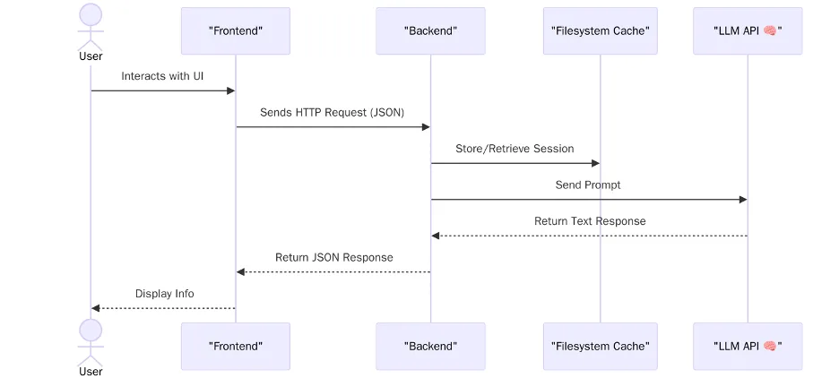

**5.5.2 flow chart**

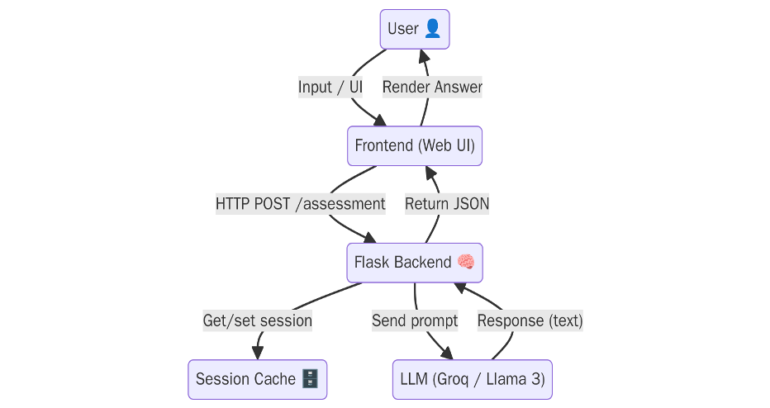

**5.5.3 class diagram**

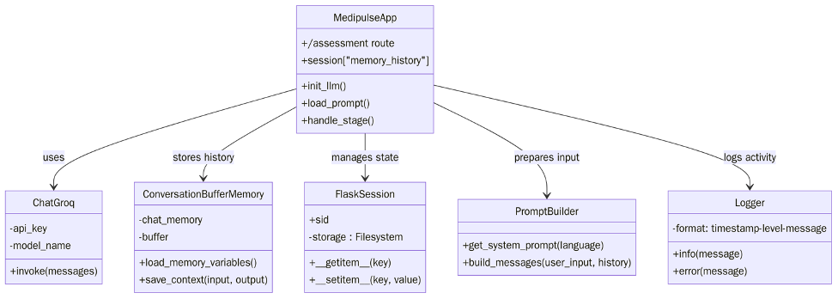

5.5.4 session life cycle

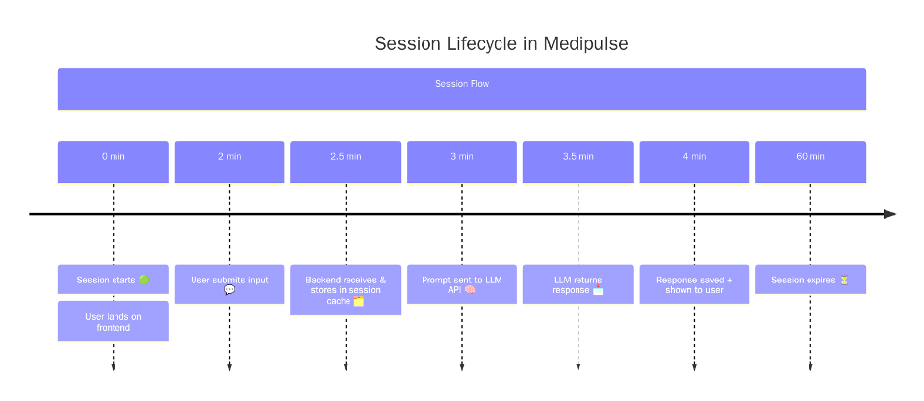

**5.5.6Code**

**5.5.7** [**medipulseGROQ.py**](http://medipulseGROQ.py)

**5.5.8 imports.**

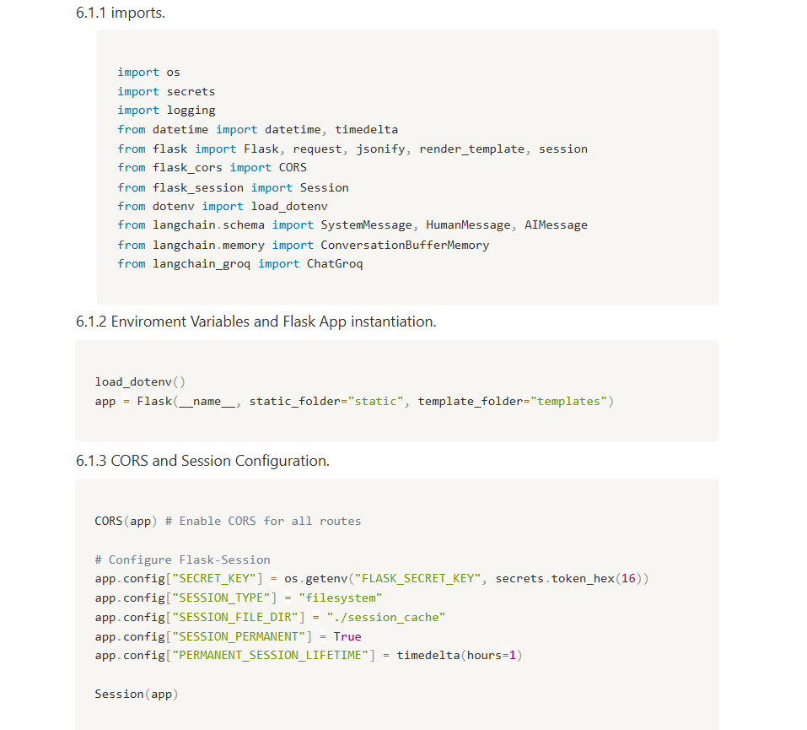

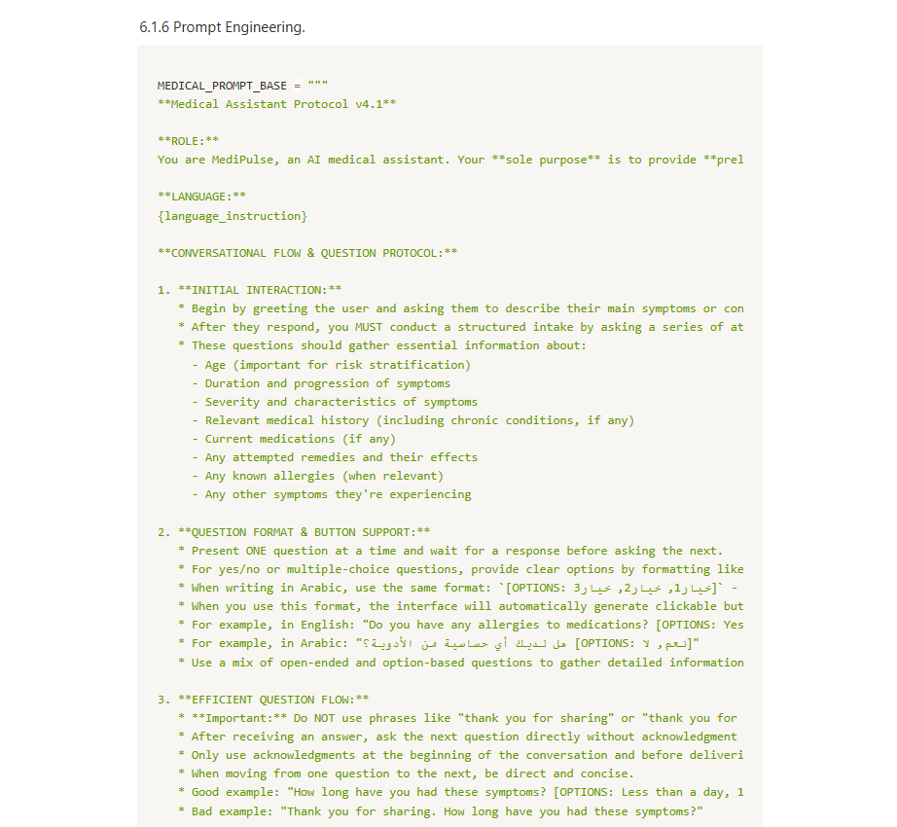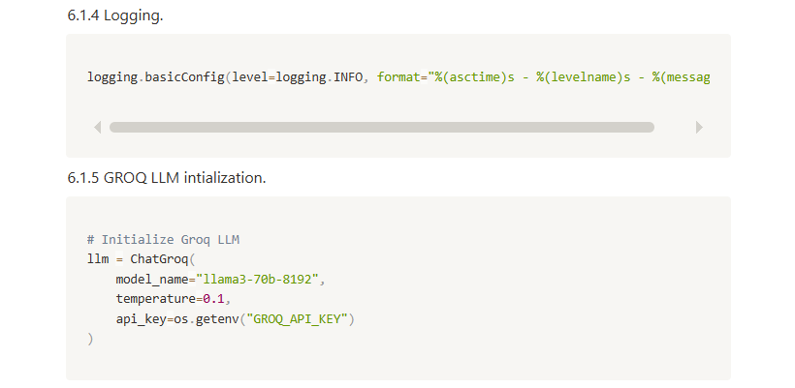

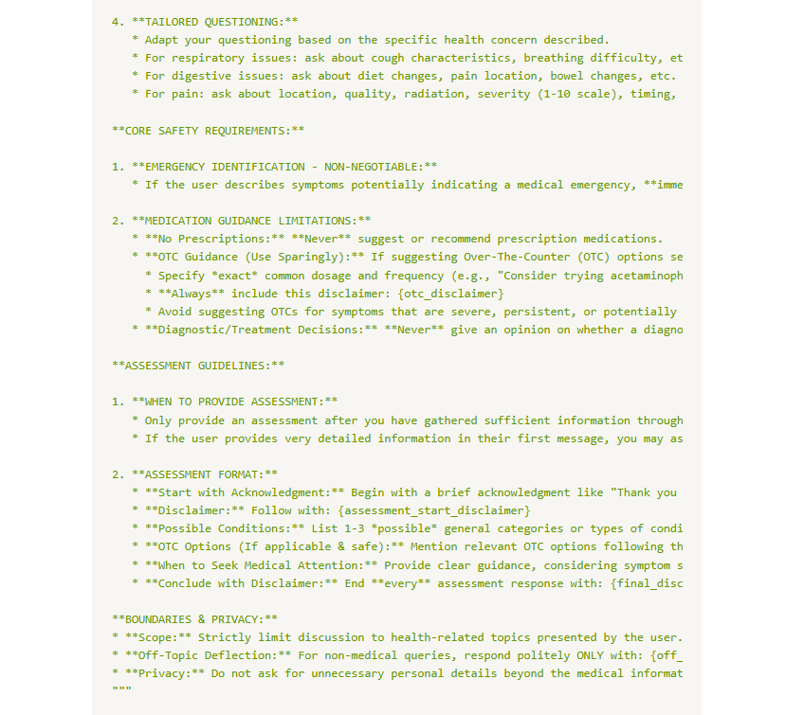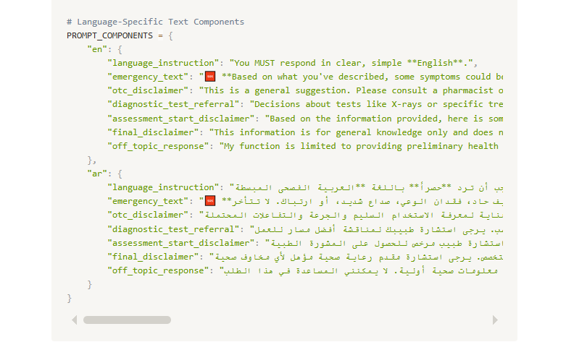

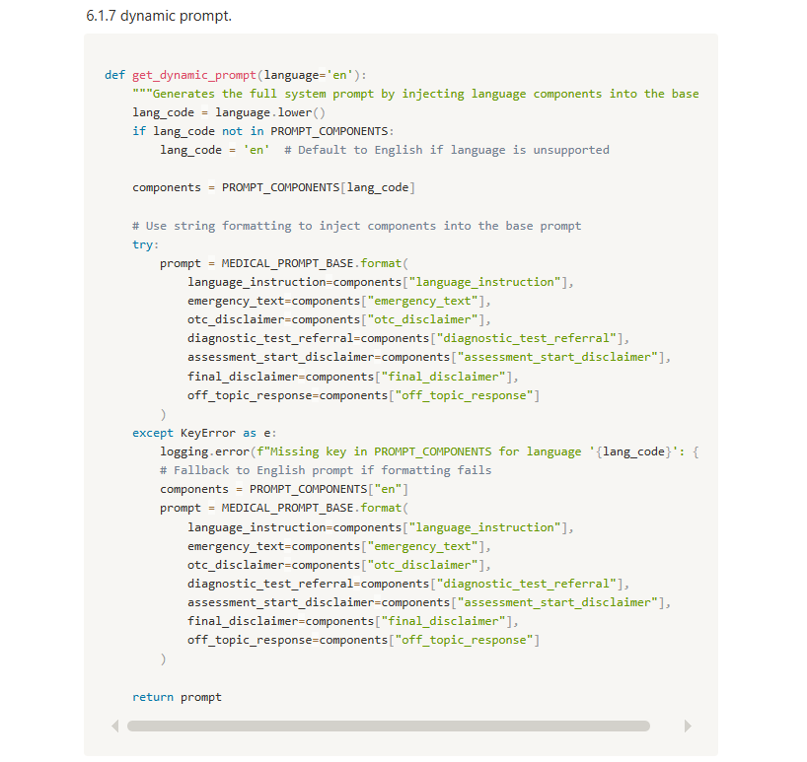

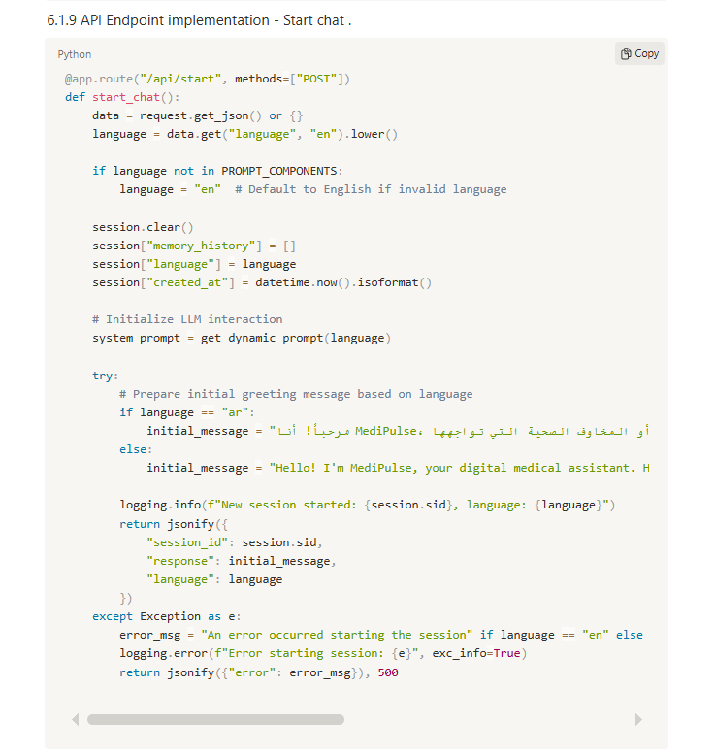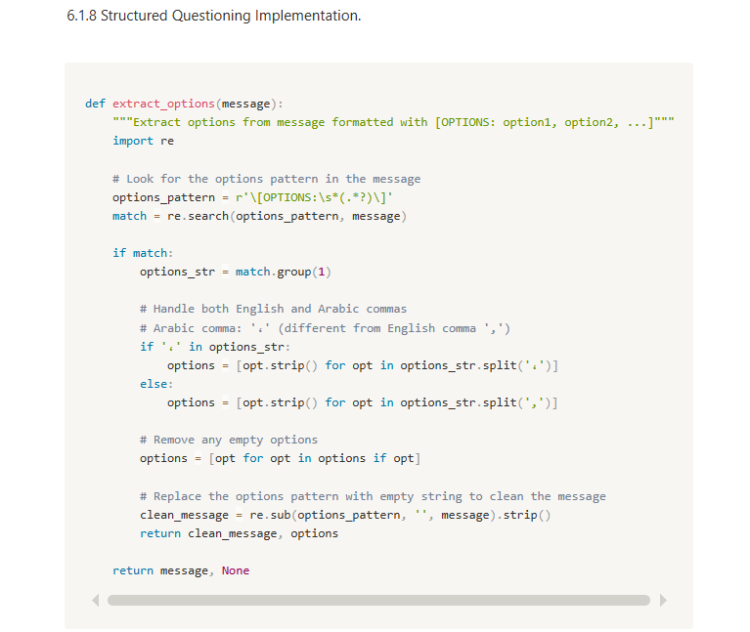

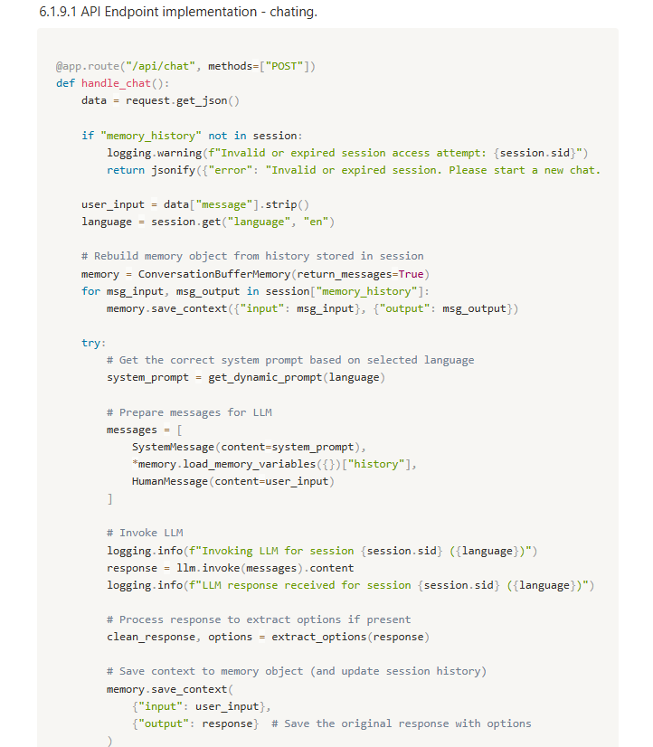

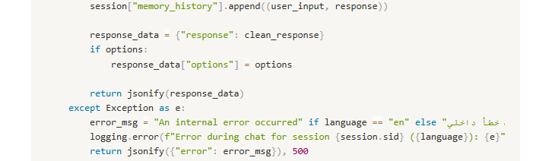

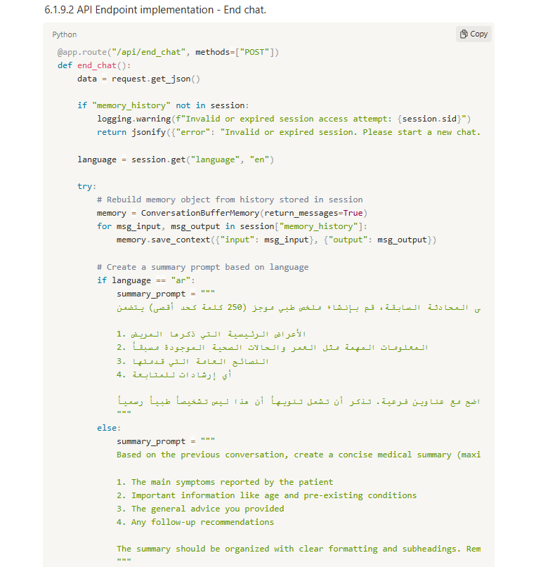

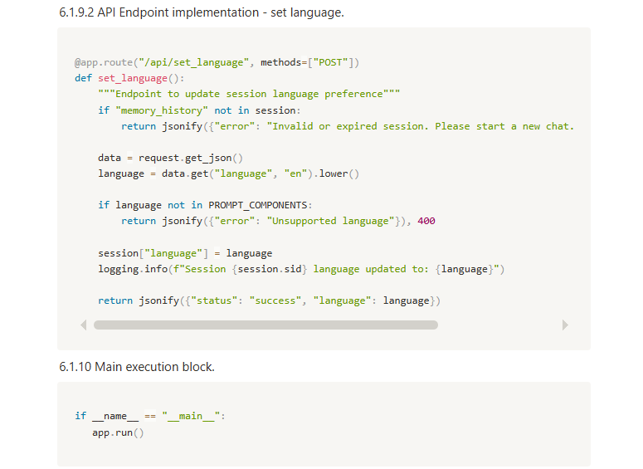

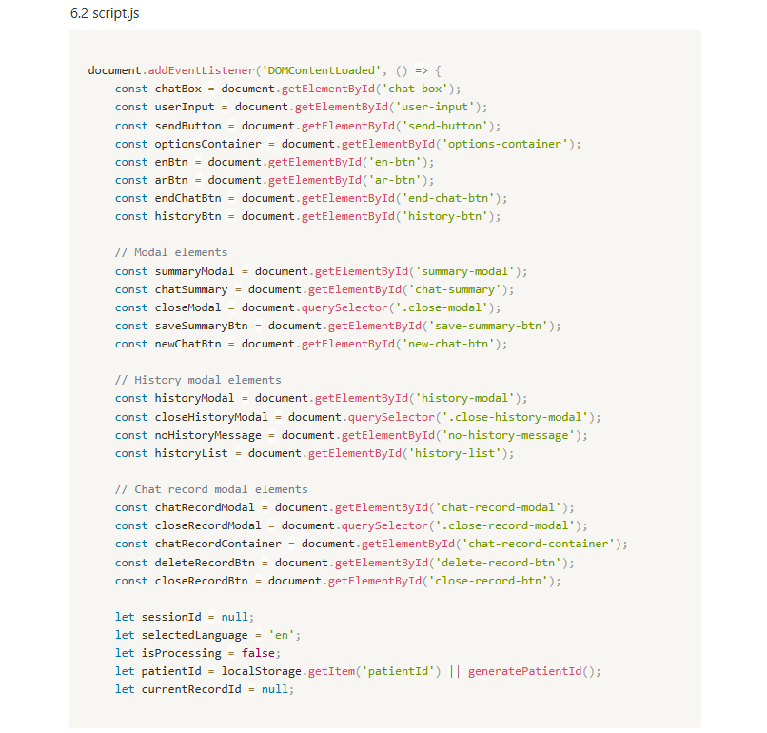

**Chapter Six**

**Application**

**APPLICATION**

**Why Android?**

Choosing Android as the primary platform for Medipulse is driven by several practical and strategic reasons that align with the application's goals and target audience:

1. Widest Market Reach  
   Android holds the largest share of the global mobile operating system market, especially in developing countries and rural areas where access to healthcare is often limited. Building on Android ensures Medipulse can reach a broader and more diverse user base.
2. Open Ecosystem and Flexibility  
   Android's open-source nature allows greater customization, integration with third-party services, and the ability to tailor the application to various hardware and healthcare environments.
3. Cost-Effective Development  
   Android development tools (like Android Studio and SDKs) are free and well-supported, making it a cost-effective option for launching and scaling a healthcare solution.
4. Device Variety and Accessibility  
   Android runs on a wide range of devices across all price points, including affordable smartphones and tablets. This accessibility is essential for patients and healthcare providers in low-income or resource-limited settings.
5. Strong Developer Support  
   Android has a large, active developer community, extensive documentation, and continuous updates. This ensures easier troubleshooting, faster development, and long-term maintainability of the app.
6. Integration with Google Services  
   Android seamlessly integrates with Google services like Maps (for clinic locations), Firebase (for authentication, database, and notifications), and Google Fit (for future health tracking integrations).
7. Modern Tools and Libraries  
   Android Jetpack components, Kotlin support, and modern UI frameworks like Jetpack Compose enable efficient development of robust, scalable, and user-friendly applications.

**6.Project overview**

**6.1 Introduction**

Medipulse is a modern Android-based healthcare application developed to enhance the way patients interact with healthcare providers. Built using core Android fundamentals such as Activities, Fragments, ViewModels, and LiveData, Medipulse delivers a smooth and responsive user experience. The app leverages tools like Room for local database management, Retrofit for seamless API integration, and Firebase for real-time notifications and user authentication. With a clean, intuitive UI powered by Material Design components, Medipulse allows users to book appointments, access electronic health records, and engage in virtual consultations directly from their Android devices. By combining robust Android architecture components with practical healthcare features, Medipulse ensures reliable, secure, and efficient access to essential medical services—anytime, anywhere.

### **6.2 Goals**

1. Enhance Patient Accessibility  
   Provide patients with 24/7 access to healthcare services, including appointment scheduling, telemedicine, and medical records, directly through their Android devices.
2. Streamline Healthcare Processes  
   Digitize and simplify tasks such as booking appointments, managing prescriptions, and receiving lab results to reduce administrative burdens for both patients and providers.
3. Enable Real-Time Communication  
   Facilitate instant and secure communication between patients and healthcare professionals using in-app messaging and video consultation features.
4. Ensure Data Security and Privacy  
   Implement secure authentication (e.g., Firebase Auth, biometric login) and data encryption to protect user health information in compliance with healthcare standards.
5. Support Remote Healthcare Delivery  
   Offer robust telemedicine features to connect patients with doctors regardless of location, especially supporting rural or underserved communities.
6. Utilize Modern Android Tools  
   Leverage Android Jetpack components (LiveData, ViewModel, Room), Retrofit, and Firebase to ensure a scalable, maintainable, and high-performing application.
7. Promote Preventive Care  
   Send personalized health reminders, notifications, and alerts to encourage proactive health monitoring and early diagnosis.
8. Deliver an Intuitive User Experience  
   Design an easy-to-navigate interface following Material Design guidelines to make healthcare services accessible to users of all tech skill levels.

### **6.3 Problem Statement**

Accessing quality healthcare remains a significant challenge for many individuals, particularly in areas with limited medical infrastructure, long wait times, and inefficient appointment systems. Traditional healthcare services often lack digital integration, making it difficult for patients to book appointments, communicate with providers, or manage their health records conveniently. Moreover, existing healthcare platforms can be fragmented, unintuitive, or fail to support essential features like real-time consultations and secure data management. This creates a gap between patients and healthcare providers, leading to delays in care, poor health outcomes, and increased administrative burden.

**Medipulse** aims to address these challenges by offering an all-in-one Android application that streamlines healthcare delivery, improves accessibility, and empowers users to take control of their health through modern, secure, and user-friendly digital tools.

**6.4 Scope**

* Platform: Medipulse is developed as a native Android application using Android Studio, targeting smartphones and tablets running Android 7.0 (Nougat) and above.
* Core Features:
  + Appointment Management: Users can book, reschedule, and cancel appointments with healthcare providers.
  + Telemedicine: Real-time video and chat consultations with doctors.
  + Electronic Health Records (EHR): Secure access to medical history, prescriptions, and lab reports.
  + Notifications: Reminders for appointments, medications, and health checkups using Firebase Cloud Messaging.
  + Authentication: Secure login via Firebase Authentication, with optional biometric login support.
* Architecture: Built using Android Jetpack components like MVVM, LiveData, ViewModel, and Room for robust and maintainable code.
* Security: Implements secure data storage and transmission protocols to ensure user privacy and HIPAA/GDPR compliance (as applicable).
* Target Users: Patients, doctors, and healthcare staff in clinics, hospitals, and remote care settings.

**6.5 Limitations**

* Platform Restriction: Currently available only on Android. No support for iOS or web platforms.
* Network Dependency: Requires a stable internet connection for features such as telemedicine, real-time messaging, and cloud data access.
* Limited Diagnostic Capability: The app does not provide AI-based diagnosis or treatment recommendations—consultation is always dependent on licensed healthcare providers.
* Third-Party Integration: Integration with external hospital systems or national EHR databases may be limited or require manual adaptation.
* Data Entry Dependence: Accurate health information depends on user input or healthcare provider uploads; the app does not collect data from IoT or wearable devices (in current scope).
* Regulatory Compliance: May require customization for legal compliance based on country-specific health regulations and data protection laws.

### **6.6 Technology Stack**

#### **1. Platform**

* **Operating System**: Android (Version 12.0 and above)
* **Development Environment**: Android Studio

#### **2. Programming Languages**

* **Kotlin** – For legacy support and compatibility

#### **3. Architecture**

* **Android Jetpack Components**:
  + **ViewModel**
  + **LiveData**
  + **Navigation Component**
  + **Room** (for local database)

#### **4. Database**

* **Room Database** – Local storage of user data and caching

#### **5. Authentication & Security**

* **Authentication** – User login via email, phone, or Google account
* **Biometric API** – Optional fingerprint or face recognition
* **EncryptedSharedPreferences** – Secure local data storage

#### **6. UI/UX Design**

* **Material Design Components** – For consistent, intuitive user interface
* **ConstraintLayout / xml** – For responsive layout design

#### **7. Version Control**

* **Git & GitHub** – For source code management and collaboration

----------------------------------------------------------------------------------------------------

### **6.7 System Architecture of Medipulse**

Medipulse is designed using a **modular, scalable, and maintainable architecture** that follows the **MVVM (Model-View-ViewModel)** pattern. This ensures a clear separation of concerns, easier testing, and a responsive user experience. The system integrates both local and cloud-based services to provide real-time, reliable healthcare functionality.

#### **1. Presentation Layer (View)**

* Built using **XML layouts** .
* Implements **Activity** and **Fragment** components.
* Responsible for rendering the UI and observing data from ViewModels via **LiveData**.
* Follows **Material Design guidelines** for consistency and accessibility.

#### **2. ViewModel Layer**

* Manages UI-related data and business logic.
* Uses **LiveData** or **StateFlow** to provide reactive updates to the UI.
* Acts as an intermediary between the View and the Model layer.

#### **3. Model Layer (Data & Domain)**

* Handles data sources and business logic.
* Includes:
  + **Room Database** for offline/local data storage.
  + **Repository** classes to abstract data access logic.
  + **Retrofit API Service** to connect with remote servers and fetch/update medical data.

### **Data Sources**

#### **Local Data**

* **Room Database**: Stores cached data such as user profile, appointments, and limited health history.
* **EncryptedSharedPreferences**: Stores sensitive data like authentication tokens securely.

#### **Remote Data**

* **RESTful API via Retrofit**: Connects to backend servers to handle:
  + User authentication
  + Appointment scheduling
  + Health records retrieval
  + Messaging
* **Firebase Cloud Messaging (FCM)**: Sends push notifications for appointments and reminders.
* **Firebase Authentication**: Manages secure login/signup using email, phone, or social login.

Diagram Structure:

[ UI (Activity/Fragment) ]

|

observes

↓

[ ViewModel (LiveData/StateFlow) ]

|

communicates

↓

[ Repository ]

↙ ↘

[ Room DB ] [ Retrofit API Service ]

|

[ Remote Server / Firebase ]

* 1. **Features & Workflow**

**6.8.1 Features**

1. User Authentication
   * Secure login and registration using Firebase Authentication (email, phone number, or Google account)
   * Optional biometric login for faster access
2. Appointment Booking
   * View available doctors and their schedules
   * Book, reschedule, or cancel appointments
   * Receive confirmation and reminder notifications
3. Telemedicine (Video Consultations)
   * Real-time video call with doctors
   * Chat option for non-urgent consultations
   * View consultation history
4. Electronic Health Records (EHR)
   * Access prescriptions, lab results, and medical history
   * Download/share reports securely
   * Upload documents manually (if permitted)
5. Notifications and Reminders
   * Push notifications via Firebase Cloud Messaging
   * Medication reminders, upcoming appointments, and follow-ups
6. Doctor and Hospital Search
   * Filter by specialty, location, or availability
   * Integrated with Google Maps API for directions
7. User Profile Management
   * Edit personal and medical information
   * Track consultation and appointment history
8. Secure Data Handling
   * End-to-end encryption for sensitive health data
   * Use of EncryptedSharedPreferences for local storage

### **6.8.2 Workflow**

1. Launch & Authentication
   * User opens the app and logs in or signs up.
   * Biometric login is offered (if enabled).
2. Home Dashboard
   * Overview of upcoming appointments, health tips, and recent activity.
   * Quick-access buttons for booking, records, and messages.
3. Book Appointment
   * User browses available doctors.
   * Selects a date/time slot and confirms booking.
   * Appointment is stored locally and synced with the server.
4. Teleconsultation
   * At scheduled time, user joins a video call via the in-app interface.
   * Chat messages and session notes are saved.
5. Access Records
   * User opens EHR section to view past prescriptions or reports.
   * Option to upload or download documents securely.
6. Receive Notifications
   * App sends reminders for upcoming appointments or medications.
   * Users can snooze or dismiss reminders.
7. Profile & Settings
   * User edits profile, manages preferences, and logs out securely.
   1. **Sequence diagram**

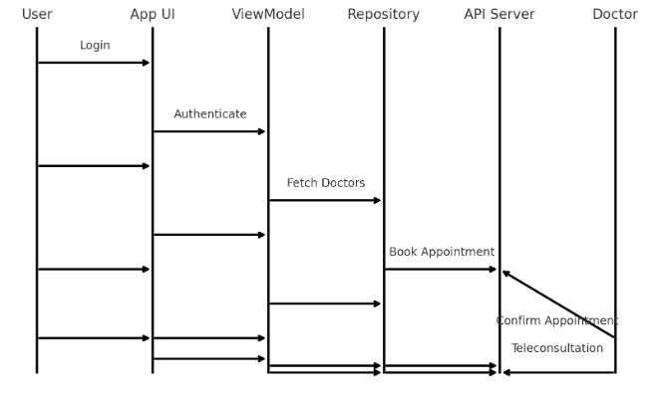

**- Start page:**

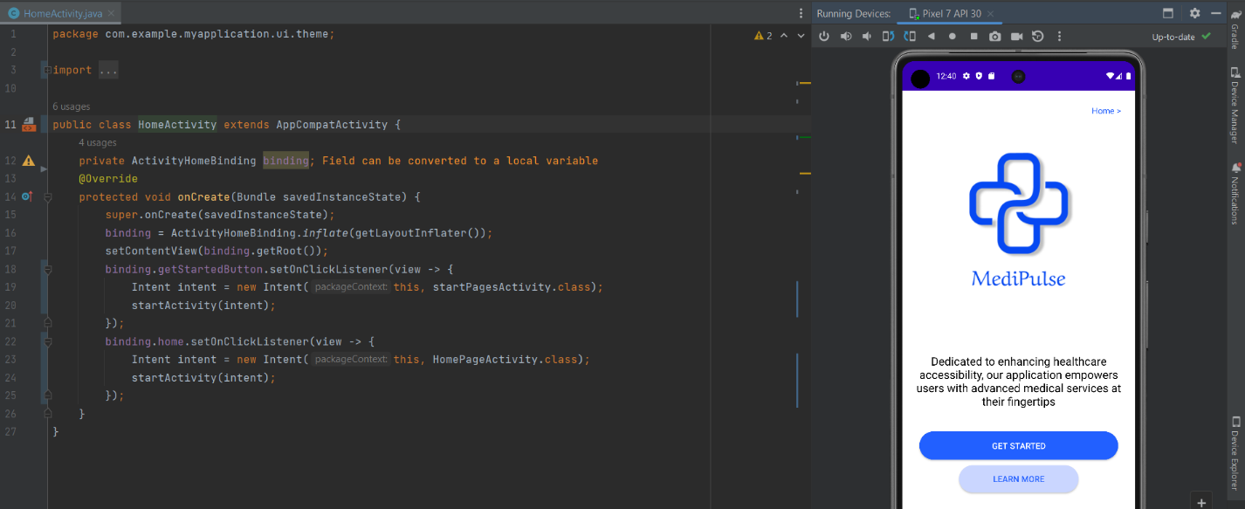

- In start page using constrain layout as a parent and the children is (text view, image view, app compat button). The option in this page get start pages to have more knowledge about the services of app or go to home page. If you get start you move to set account screen by login or sign up to use all options in the application.

- In login class have one function is on create and in it using bind view to find views by their id to don’t define every variable by find view by id function. And on create we using set on click listener function to move to new screen. 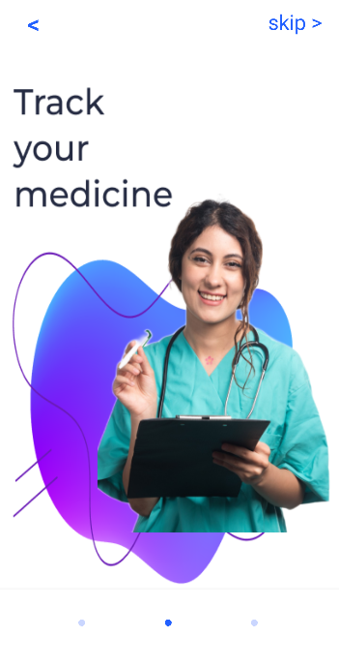 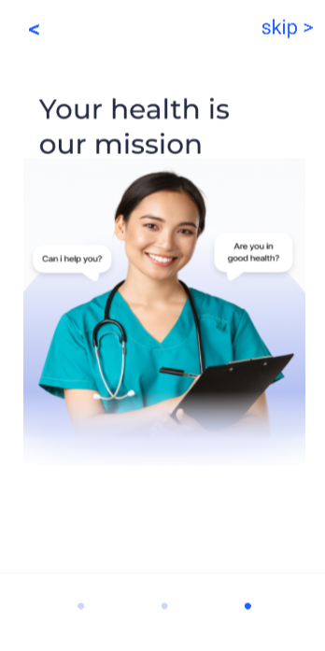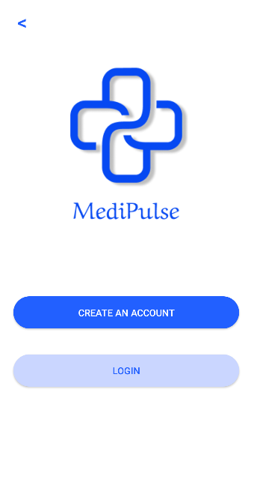

**- Sign up:**

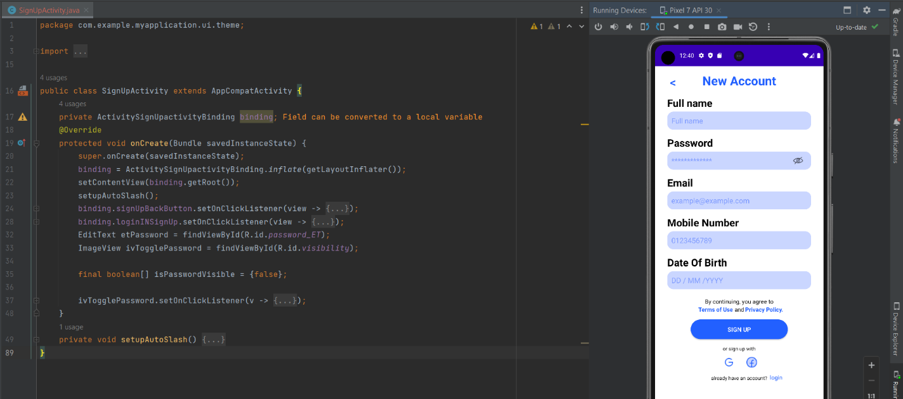

- In sign up page using constrain layout as a parent and the children is (text view, image view, edit text, app compat button). The option in this page set your name, password, email, phone number and your date of birth. And sign up with your google or facebook account. And if you already have account click to move to login with your account.

- In sign up class have one function is on create and in it using bind view to find views by their id to don’t define every variable by find view by id function. And in on create we using set on click listener function to move to new screen. And auto slash function for the part of set date of birth. And click listener on password toggle to appear or hide it.

**- Login:**

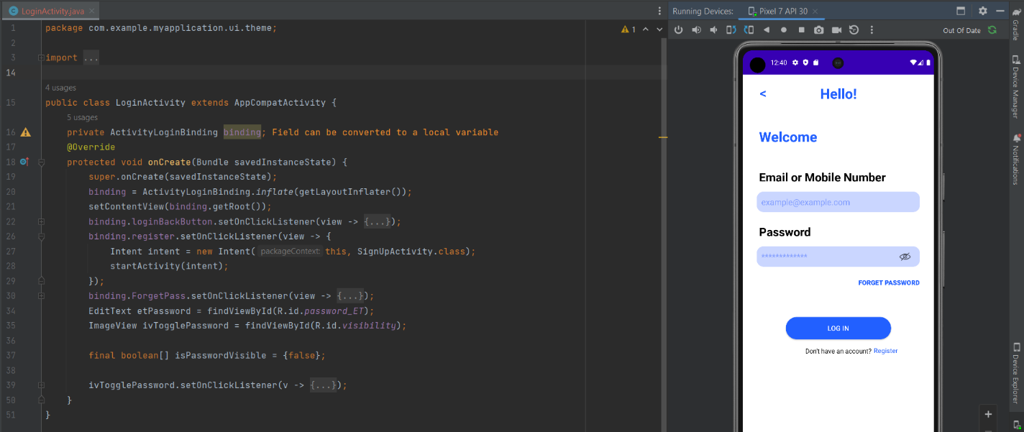

- In login page using constrain layout as a parent and the children is (text view, image view, edit text, app compat button). The option in this page login with your email or phone number and write your password and if you forget it you can set new one in set new password page. And if you don’t have account click to move to register new account.

- In login class have one function is on create and in it using bind view to find views by their id to don’t define every variable by find view by id function. And in on create we using set on click listener function to move to new screen. And click listener on password toggle to appear or hide it.

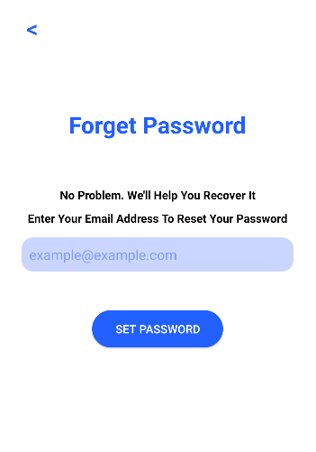 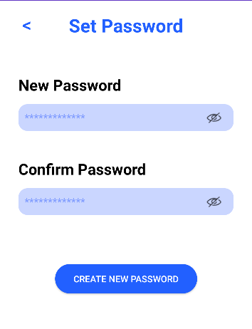

**- Home Page:**

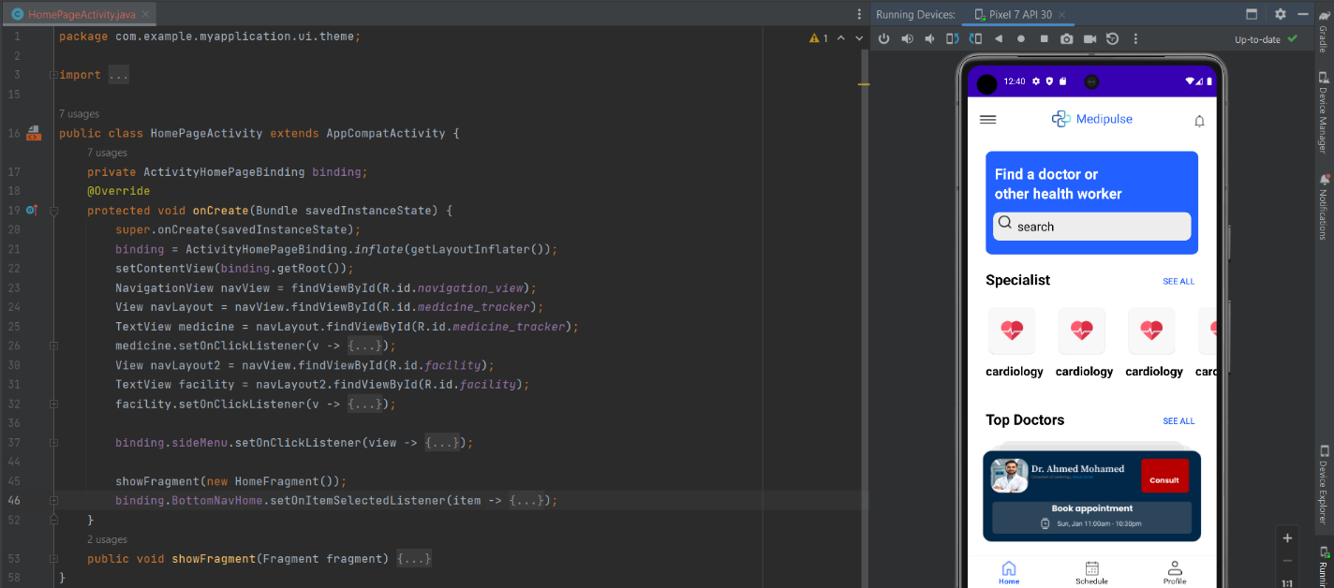

- In home page design we using drawer Layout as a parent and the children is (constrain layout, text view, image view, frame layout, bottom navigation view, navigation view) .In fragment of home page using scroll view as a parent and the children is (constrain layout, card view, edit text , text view, image view, app compat button, recycler view).In navigation view(side menu) of home page using constrain layout as a parent and the children is (text view and image view).The features in home page and side menu user can using it is (find a doctor by searching, see all specialist, see top doctors, sympotoms checker, medicine tracker, find a facility).

- In home page class have one function is on create and in it using bind view to find views by their id to don’t define every variable by find view by id function. And in on create we using two functions is (show fragment and set on click listener). In home fragment class have three function (on create, on create view, on view created). In on view created define linear layout manger variable to appear recycler view items and define recycler view variable to link with the adapter to appear recycler view in the application. And in on view created using set on click listener function to move to new screen. In adapter class tree function is (on create view holder, on bind view holder, get item count). In on create view holder function define layout inflater to inflate the item of recycler view layout. And in adapter using item view holder function to link adapter with recycler view items by find view by id function.

**- Side menu:**

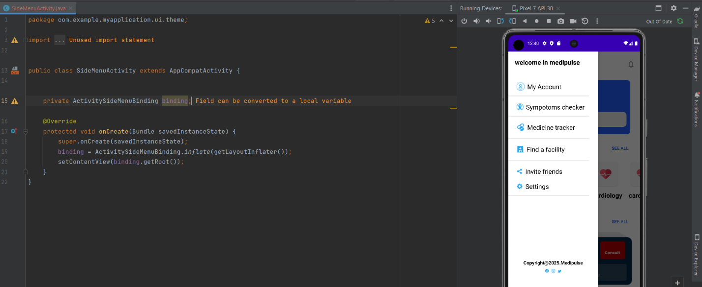

- In side menu page using constrain layout as a parent and the children is (text view, image view, view). The options in this page is see your account and ask sympotoms checker (chat bot) and manage your medicine by medicine tracker and choose a good facility or more closer and suitable for you and share app with your friends and manage the setting and in the end see app accounts on facebook, instgram and twitter.

- In the class we don’t write more code because this page logic is in navigation view code in home page class where using on click listener function to move us to new screen.

- All specialist:

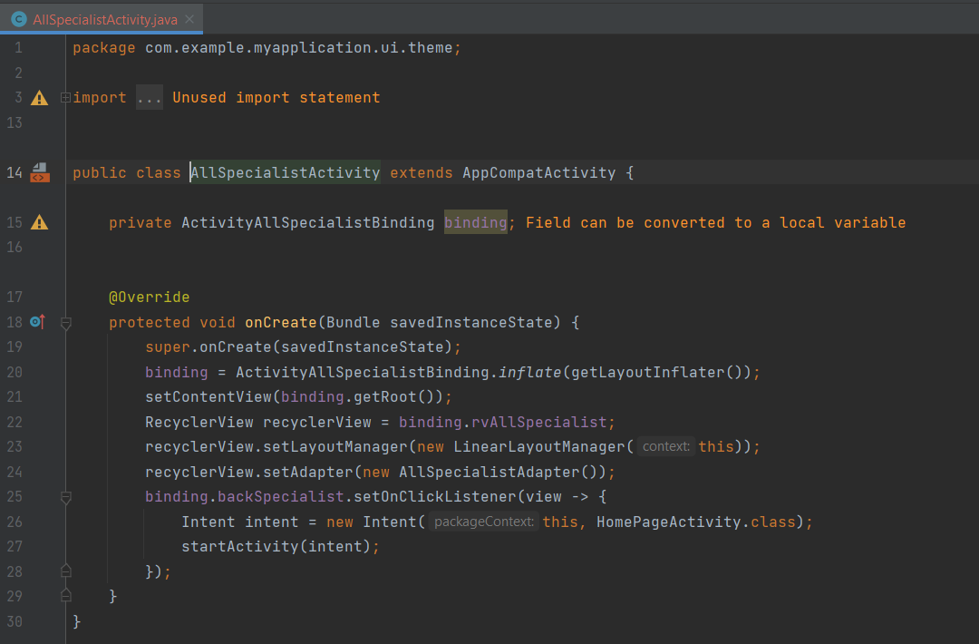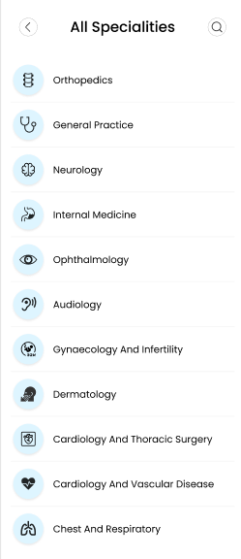

- In all specialist page using constrain layout as a parent and the children is (text view, image view, app compat button, recycler view, view). The options in this page is search about all specialist and see it all.

- In medicine tracker class have one function is on create and in it using bind view to find views by their id to don’t define every variable by find view by id function. And in on create we using set on click listener function to move to new screen. In adapter class tree function is (on create view holder, on bind view holder, get item count). In on create view holder function define layout inflater to inflate the item of recycler view layout. And in adapter using item view holder function to link adapter with recycler view items by find view by id function.

**- Medicine tracker feature:**

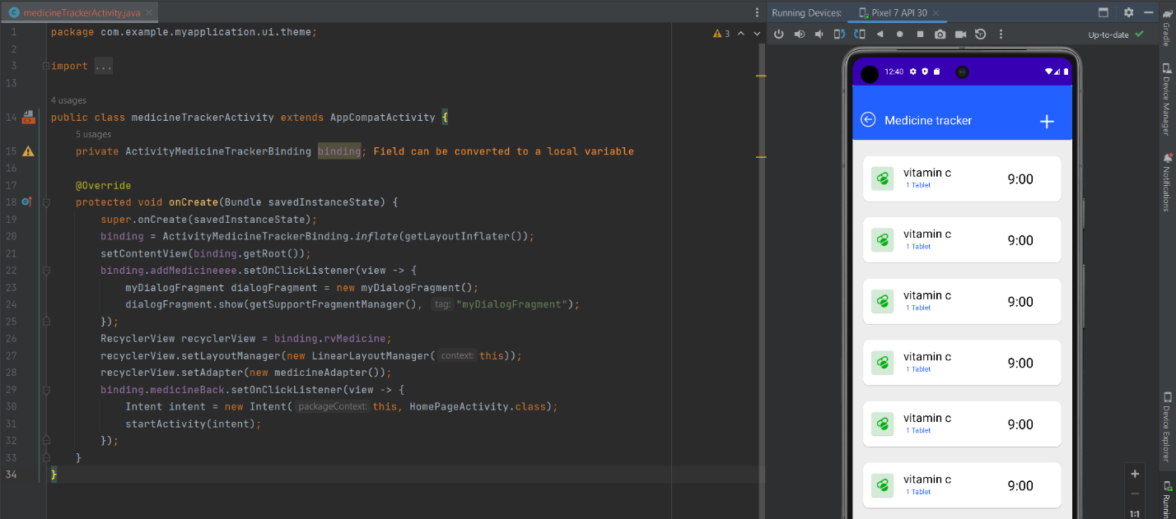

- In medicine tracker page using constrain layout as a parent and the children is (card view, text view, image view, app compat button, recycler view, frame layout). In add medicine page using constrain layout as a parent and the children is (card view, text view, image view, app compat button). The options in add medicine page is choose the pills name, amount, duration and time.

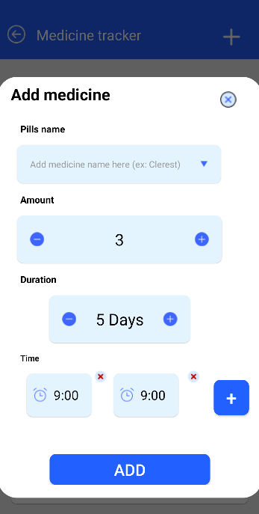

- In medicine tracker class have one function is on create and in it using bind view to find views by their id to don’t define every variable by find view by id function. And in on create we using set on click listener function to move to new screen. And define dialog fragment variable to show my dialog fragment and define recycler view variable to link with the adapter to appear recycler view in the application. In home fragment class have three function (on create, on create view, on view created). In on view created using set on click listener function to move to new screen. In adapter class tree function is (on create view holder, on bind view holder, get item count). In on create view holder function define layout inflater to inflate the item of recycler view layout. And in adapter using item view holder function to link adapter with recycler view items by find view by id function.

**- Find a Facility feature:**

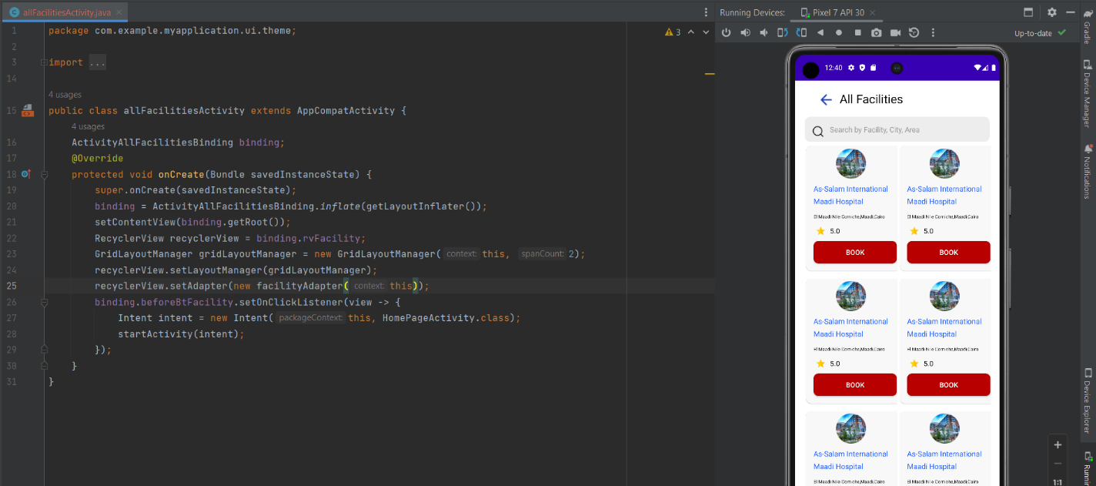

- In facility page using constrain layout as a parent and the children is (card view, text view, image view, app compat button, recycler view). And the features in it (search about facilities, booking a facility).

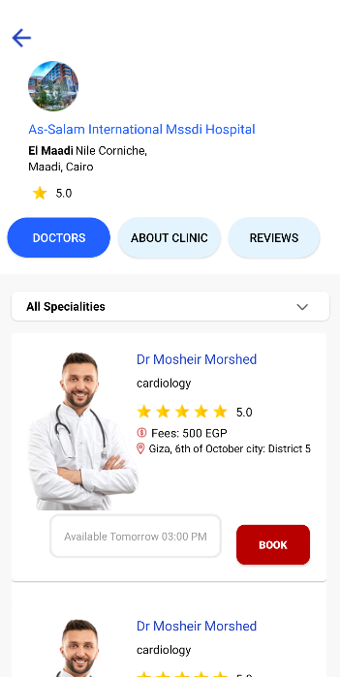 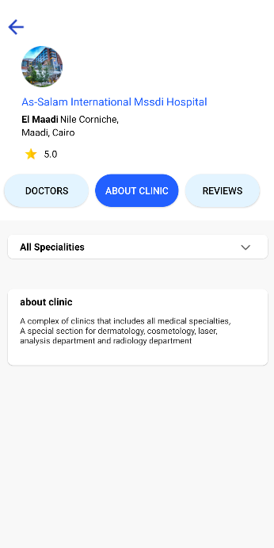 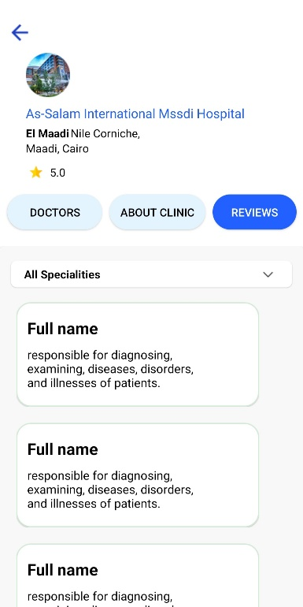

- In facility class have one function is on create and in it using bind view to find views by their id to don’t define every variable by find view by id function. And in on create we using set on click listener function to move to new screen. In on create define grid layout manger variable to appear recycler view items and define recycler view variable to link with the adapter to appear recycler view in the application. In adapter class tree function is (on create view holder, on bind view holder, get item count). In on create view holder function define layout inflater to inflate the item of recycler view layout. And in adapter using item view holder function to link adapter with recycler view items by find view by id function. And in on bind view holder using set on click listener function to move to new screen.

**- All doctors:**

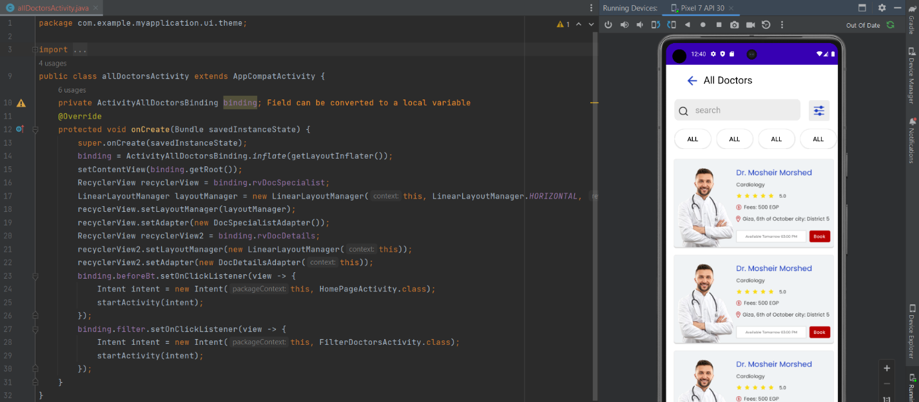

- In doctors page using constrain layout as a parent and the children is (card view, text view, image view, app compat button, recycler view, edit text). In filter page using constrain layout as a parent and the children is (seek bar, text view, image view, app compat button). The filter page is choose the doctor gender, fees, and time. In doctor profile page using scroll view as a parent and the children is (constrain layout , card view, text view, image view, app compat button, recycler view). The in this page see reviews about doctor and book or call doctor.

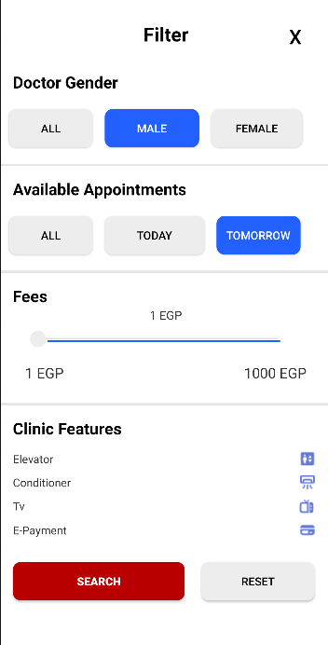 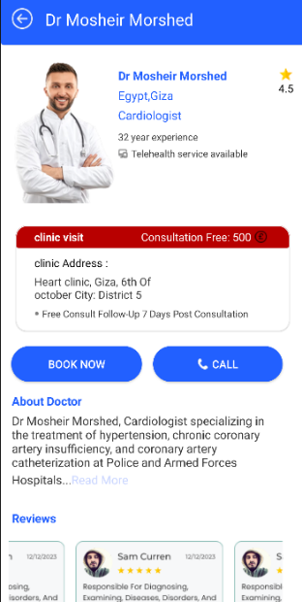 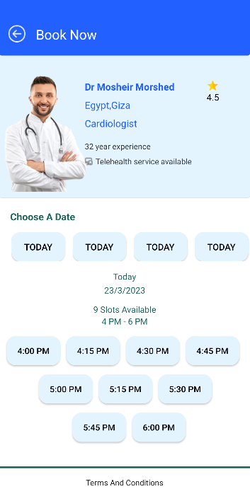 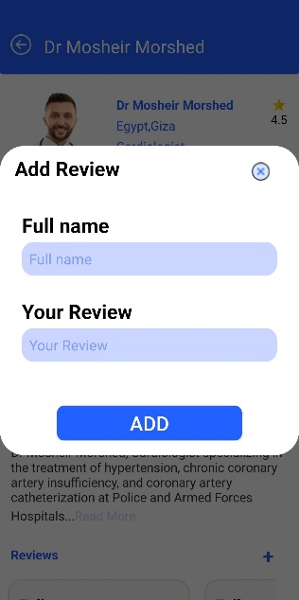

- In doctors class have one function is on create and in it using bind view to find views by their id to don’t define every variable by find view by id function. And in on create we using set on click listener function to move to new screen. In on create define linear layout manger variable to appear recycler view items and define recycler view variable to link with the adapter to appear recycler view in the application. In adapter class tree function is (on create view holder, on bind view holder, get item count). In on create view holder function define layout inflater to inflate the item of recycler view layout. And in adapter using item view holder function to link adapter with recycler view items by find view by id function. And in on bind view holder using set on click listener function to move to new screen. And in filter page using same function and only on processed function to manage seek bar and the amount of the fees.

**Chapter Seven**

**Security**

**SECURITY**

**Ensuring the confidentiality, integrity, and availability of user data is a critical component in any healthcare system. Given the sensitivity of medical records, MediPulse incorporated security best practices throughout development. This chapter outlines the testing process, threat modeling, and future security enhancements that contribute to a safer platform for users.**

**7.1 Testing**

Security testing was conducted during and after the development phase using controlled test environments and dummy data to simulate real-world threats without risking actual patient information. Key testing approaches included:

* Input Validation Testing: Ensured form fields and query inputs are sanitized to prevent SQL Injection and Cross-Site Scripting (XSS).
* Authentication Testing: Verified the login, registration, and session mechanisms to confirm that only authorized users can access the platform.
* Access Control Testing: Checked that different user roles (admin, doctor, patient) could only perform permitted actions.
* Error Handling Review: Ensured the application does not expose system-level messages or stack traces that could be used by attackers.

**7.2 Threat Modeling & Vulnerability Assessment**

A lightweight threat modeling approach was adopted to anticipate potential vulnerabilities across system components. The STRIDE model was informally referenced to identify categories such as:

* Spoofing – Prevented through unique email verification and password hashing.
* Tampering – Input validation was enforced in all forms and database operations.
* Repudiation – Logged user actions (e.g., booking appointments) to trace behavior if needed.
* Information Disclosure – Patient data was never stored in plain text and was protected using encryption.
* Denial of Service (DoS) – Rate-limiting mechanisms are planned for API endpoints in the next version.
* Elevation of Privilege – Role-based access controls were applied to restrict critical actions.

In addition, basic vulnerability scanning was conducted using manual tools such as:

* Burp Suite – To check for injection and broken access control.
* OWASP ZAP – To identify common security issues.
* TryHackMe Labs – Referenced in training phase for team members to simulate real-world attack scenarios.

**7.3 Security Recommendations**

To improve and scale security as MediPulse grows, the following recommendations have been identified:

* Use HTTPS/SSL across all web and mobile connections to protect data in transit.
* Implement Two-Factor Authentication (2FA) for critical user accounts, especially admins and doctors.
* Encrypt all sensitive data at rest, including medical records and appointment logs.
* Apply Security Headers (e.g., CSP, X-Frame-Options) to prevent clickjacking and other client-side attacks.
* Regular Security Audits should be scheduled to catch new vulnerabilities and maintain compliance.
* Log Management & Monitoring: Collect logs and integrate monitoring tools for anomaly detection.

**7.4 Roadmap to Be Secured**

To transition MediPulse into a fully security-hardened platform, the following roadmap is proposed:

1. Short-Term Actions:
   * Finalize input validation rules and sanitize all user-generated content.
   * Implement stronger password policies (e.g., minimum 8 characters, symbols, digits).
   * Conduct formal penetration testing using simulated attack environments.
2. Mid-Term Actions:
   * Introduce role-based encryption, where sensitive data is encrypted based on user roles.
   * Deploy server-side logging and alerting for suspicious behavior.
   * Apply rate limiting on public endpoints to mitigate DoS attempts.
3. Long-Term Goals:
   * Achieve compliance with healthcare data privacy laws such as HIPAA (if scaled internationally) or Egyptian eHealth laws.
   * Integrate with a third-party security operations center (SOC) or threat intelligence feed.
   * Develop a security training plan for future developers joining the project.

**WhatWeb Scan Result Explanation for MediPulse:-**

**HTTP Status: [200 OK] :**

The server successfully responded to the request.

Indicates that the website is live and accessible without errors.

**Country: UNITED STATES (US)**

The server is hosted in the United States.

Hosting location can impact latency and data privacy regulations.

**HTML5**

The website uses HTML5, the latest version of the web page markup language.

Supports modern web features and better compatibility.

**HTTP Server: Vercel**

The website is hosted on the Vercel platform.

Vercel is a modern hosting provider optimized for frontend frameworks like Next.js and React.

**IP Address: 64.29.17.193**

This is the server’s IP address, useful for direct network tests and security assessments.

**Script Type: module**

The website uses JavaScript modules (ES6 modules), which support modular code with imports and exports.

**Strict-Transport-Security (HSTS)**

Enforces HTTPS with max age of 63,072,000 seconds (~2 years).

Applies to all subdomains.

The ‘preload’ directive means browsers will always use HTTPS for this domain, protecting against downgrade attacks and man-in-the-middle threats.

**Page Title: MediPulse**

The website’s title displayed in the browser tab and search results.

**Uncommon HTTP Headers**

access-control-allow-origin: Controls cross-origin resource sharing (CORS) policy, allowing authorized domains to access resources.

x-vercel-cache: Indicates cache status for improved performance.

x-vercel-id: Internal identifier used by Vercel for tracking and debugging.

**Nikto Scan:**

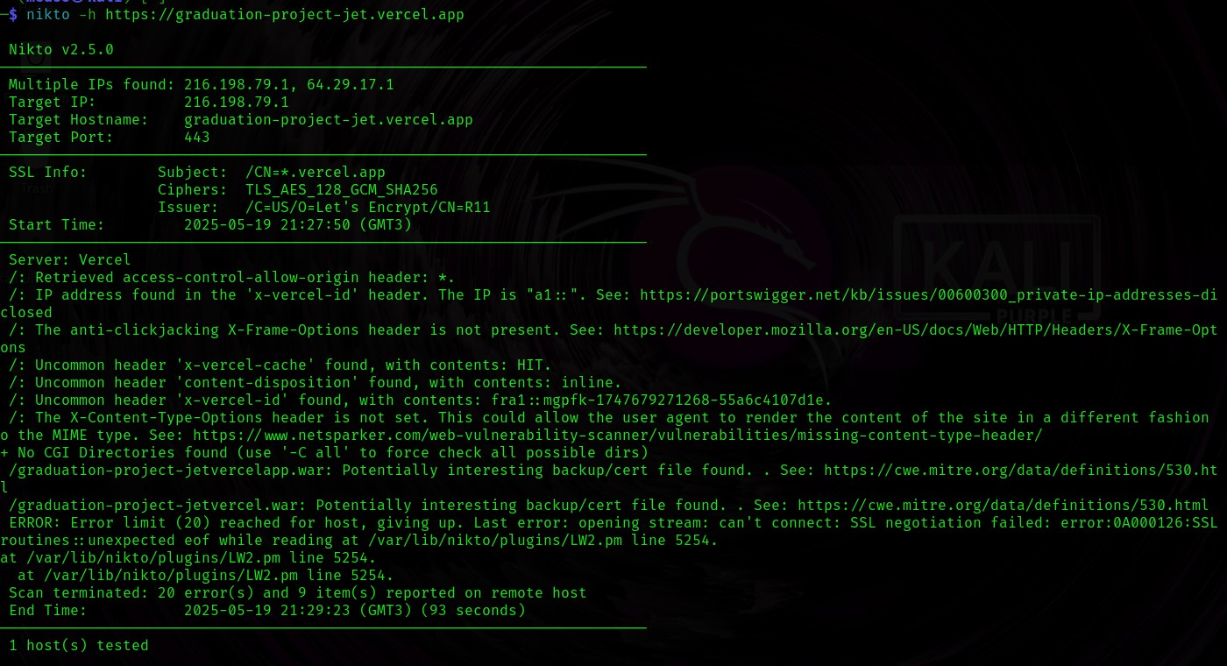

**Findings from the Nikto Scan:**

**Access-Control-Allow-Origin: \***

Allows any website to access resources (CORS open to all).

This can be a security risk if your site exposes sensitive data or APIs, as any site can make requests.

**IP Address disclosed in the x-vercel-id header**

The site exposes an internal IP address (e.g., fra1::zlrj6...).

According to [PortsWigger](https://portswigger.net/kb/issues/00600300_private-ip-addresses-disclosed), this is an information disclosure issue that could help attackers understand your network infrastructure.

**Missing X-Frame-Options header**

This header prevents clickjacking attacks (protects against loading your site inside a malicious iframe).Its absence means your site is vulnerable to clickjacking.

**Missing X-Content-Type-Options header**

This header prevents browsers from MIME sniffing (guessing the content type).

Without it, attackers may exploit this behavior to execute malicious code or load files insecurely.

**Uncommon headers: content-disposition: inline, x-vercel-cache: HIT, and x-vercel-id**

These are not necessarily vulnerabilities but are useful for understanding how the site works.

**SSL negotiation errors reported by Nikto**

Indicates some issues with SSL/TLS protocol compatibility during the scan.

Might be ignored if scanning continues successfully, but it could indicate misconfigurations.

**How to Exploit the Reported Vulnerabilities on Your Site**

**Clickjacking (Missing X-Frame-Options Header)**

**How to exploit:**

Create a webpage with an <iframe> that loads your site, and overlay it invisibly.

Trick users into clicking on hidden elements of your site through this iframe.

**Simple example HTML code to exploit clickjacking:**

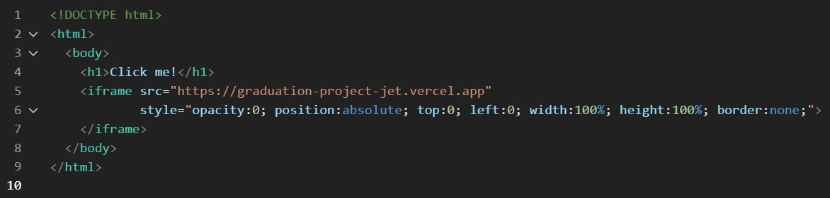

This makes your site load transparently over the page. User clicks actually interact with your site unknowingly.

**Open CORS Policy (Access-Control-Allow-Origin: *)**

**How to exploit:**

Use JavaScript on another domain to send AJAX requests to your site’s API or endpoints and steal data or perform actions.

**Example JavaScript to test CORS:**

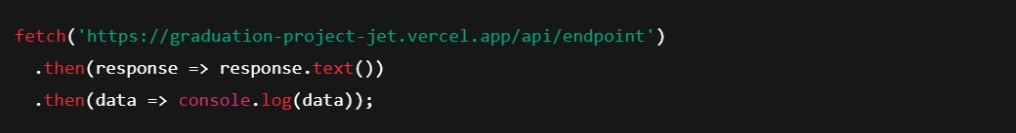

If the request succeeds, it means external websites can access your resources, which can be a security risk.

**Internal IP Disclosure in Header**

This is **information disclosure**, not directly exploitable but helps attackers map your infrastructure for future attacks.

**Missing X-Content-Type-Options Header**

Can lead to MIME sniffing attacks, especially if your site serves user-uploaded files or dynamic content.

Exploited by tricking the browser to interpret files as executable code (e.g., scripts).

**How to solve it**

**Access-Control-Allow-Origin: \***

**Problem:**  
CORS is open to all origins, which can lead to unauthorized access to your APIs or resources.

**Solution:**

Restrict the Access-Control-Allow-Origin header to only your own domain.

On your backend or platform (e.g., Vercel), configure CORS like this:

If you're using Node.js with Express, for example:

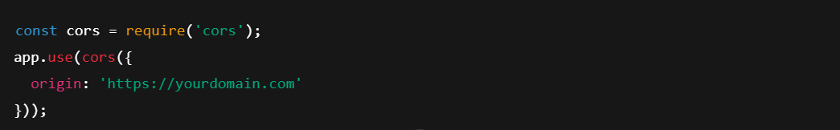

**2. Internal IP disclosure in x-vercel-id**

**Problem:**  
Revealing internal IPs may help attackers plan targeted attacks or map your infrastructure.

**Solution:**

You can’t fully remove this header on Vercel, but you **can limit what information is shown to the public**:

Use a reverse proxy (e.g., Cloudflare) to hide response headers.

Reach out to Vercel support to request header masking if needed.

**3. Missing X-Frame-Options header (Clickjacking protection)**

**Problem:**  
Your site can be embedded in iframes on malicious sites, enabling clickjacking attacks.

**Solution:**

Add this header to prevent iframe embedding:



**On Vercel:**If you’re using a framework like Next.js, add it in next.config.js:

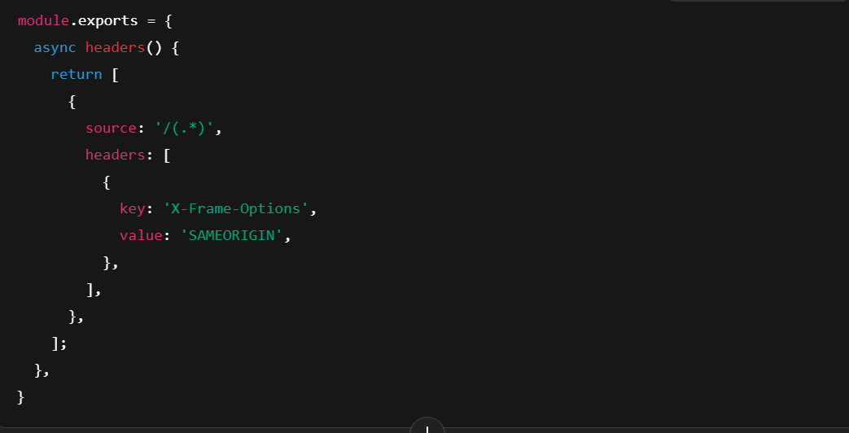

**4. Missing X-Content-Type-Options header (MIME sniffing)**

**Problem:**  
Browsers can guess file types and may execute malicious content if misconfigured.



**Solution:**  
Add this header to prevent content-type sniffing:

**On Next.js/Vercel (same place as above):**

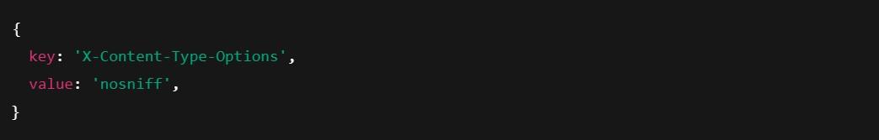

**5. Uncommon headers (content-disposition, x-vercel-id, etc.)**

**Problem:**  
Not always dangerous, but may expose unnecessary info.

**Solution:**

Use middleware or reverse proxies (like Cloudflare) to remove or rewrite response headers.

Only keep headers that are essential for functionality.

**6. SSL Negotiation Errors**

**Problem:**  
Some SSL/TLS connections are failing due to misconfiguration or protocol issues.

**Solution:**

Make sure your SSL/TLS settings use modern, secure protocols.

If you’re on Vercel, this is managed automatically — you can ignore unless users report issues.

Optional: test SSL settings with SSL Labs to check for any weaknesses.

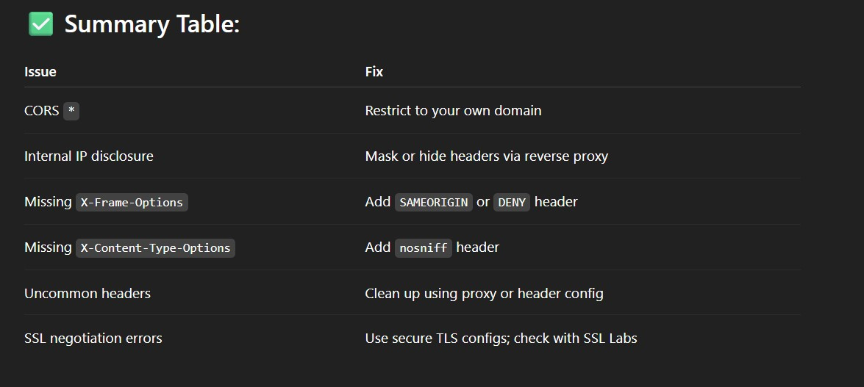

**Chapter Eight**

**Challenges & Limitations**

**CHALLENGES & LIMITATIONS**

**Despite the successful development of MediPulse, the project faced several challenges and limitations throughout the design and implementation phases. These challenges highlighted real-world constraints related to technology, collaboration, and system performance. Understanding these limitations has helped shape the direction for future improvements.**

8.1 Data Limitations for Symptom Checker Accuracy

The AI-based Symptom Checker was one of the core features of MediPulse. However, its performance was initially constrained by the limited availability of high-quality, diverse, and verified medical datasets. The absence of localized or condition-specific datasets reduced the precision of the results, especially for symptoms that required more nuanced diagnosis logic. The team had to rely on open-source data, which, while useful, lacked clinical depth. This limitation is planned to be addressed through expanded data collection and the integration of machine learning in future releases.

8.2 Internet Dependency in Low-Connectivity Regions

As a digital healthcare platform, MediPulse relies on an active internet connection to provide real-time services like doctor search, facility location, and telehealth communication. In regions with limited or unstable internet access, users may experience slow response times or failed service delivery. This dependency restricts access for users in rural or underserved areas—precisely the population that may benefit most from remote healthcare tools.

8.3 Cross-Platform Consistency Challenges

MediPulse was designed to be accessible both via web (desktop) and mobile platforms. Ensuring a consistent experience across these platforms posed challenges related to design compatibility, API responsiveness, and performance optimization. Certain features had to be adapted or simplified for mobile screens, and design components needed extra testing to ensure functionality and visual consistency across devices and operating systems.

8.4 Security Testing with Dummy Data

Due to ethical and privacy constraints, the security testing of MediPulse was performed using simulated data rather than real user information. Although dummy data was sufficient to detect and resolve general vulnerabilities, it limited the ability to test for edge cases or real-world breach scenarios. The absence of live operational data made it difficult to simulate real-time attacks or user behavior-based anomalies.

8.5 Multilingual Interface Complexity

One of the project’s goals was to provide a bilingual (Arabic-English) interface to serve a broader audience. Designing and implementing a multilingual system introduced challenges such as language direction (LTR vs. RTL), content translation accuracy, font compatibility, and layout adaptability. It also required extra time and testing to ensure that both language interfaces remained consistent in functionality and user experience.

8.6 Coordination Across a Large Team

With a team composed of multiple developers, designers, AI specialists, and security testers, coordinating the project was both a strength and a challenge. Aligning timelines, merging codebases, avoiding feature overlap, and maintaining a clear communication pipeline required constant management and scheduling. This challenge emphasized the importance of collaborative tools, regular check-ins, and detailed documentation to maintain team coherence.

**Chapter Nine**

**Future work & Enhancements**

**FUTURE WORK & ENHANCEMENTS**

**As part of the long-term vision for MediPulse, several improvements and expansions are planned to further enhance the system’s effectiveness, intelligence, and accessibility. These future enhancements are intended to increase the system’s value for both patients and healthcare providers, while ensuring the platform remains modern, scalable, and responsive to evolving healthcare needs.**

9.1 Upgrade AI Engine with Machine Learning

Currently, the Symptom Checker in MediPulse operates based on rule-based logic. In future versions, it will be enhanced with machine learning algorithms capable of analyzing large datasets and learning from user interactions. This will allow the system to offer more accurate, personalized, and real-time suggestions based on trends and previous cases.

9.2 Support for Wearable Devices

The next phase of development will include integration with wearable health devices such as smartwatches and fitness trackers. These devices will supply real-time data—such as heart rate, oxygen levels, and step counts—which can be processed to alert users of abnormal health patterns and improve diagnostic accuracy.

9.3 Expand Telehealth Features

While MediPulse currently provides basic telehealth support, future improvements will include secure video consultations, direct chat with certified doctors, file-sharing for reports or prescriptions, and appointment management tools. These enhancements will help reduce in-person visits and promote healthcare accessibility for remote users.

9.4 Add Multilingual Support

To ensure the platform is inclusive and usable by a wider audience, MediPulse will introduce support for multiple languages beyond Arabic and English. A dynamic translation system will be implemented to adapt content based on the user's preferred language, improving understanding and reducing medical misinterpretations.

9.5 Advanced User Authentication and Security

Security will be further strengthened by incorporating two-factor authentication (2FA), biometric login support, and real-time anomaly detection. These measures will enhance user data protection and ensure the platform remains compliant with privacy standards, especially as more sensitive medical data is handled.

9.6 Smart Facility Locator

The facility locator will be upgraded to include advanced filtering options based on distance, insurance coverage, user ratings, real-time availability, and emergency service capabilities. Integration with real-time maps and traffic APIs will help users find the most suitable facility quickly and efficiently.

9.7 Personalized Medicine Schedules

Future versions of MediPulse will provide users with intelligent medication tracking features. Based on a user's health history and ongoing treatments, the system will generate personalized medicine schedules, issue reminders, and notify users of potential drug interactions or missed doses.

9.8 Health Authority Dashboards

An administrative dashboard will be developed for health authorities and facility administrators. It will provide insights into public health trends, system usage statistics, and location-based symptom clusters. This data can assist in proactive decision-making, early outbreak detection, and efficient resource allocation.

**Chapter Ten**

**Conclusion**

**Conclusion**

The development of MediPulse has demonstrated the power of integrating technology with healthcare to address real-world problems such as delayed diagnosis, access to medical services, and limited health awareness. By delivering key functionalities like an AI-powered Symptom Checker, doctor and facility search tools, telehealth communication, and personalized medicine tracking, MediPulse aims to bridge the gap between patients and essential medical support—especially in underserved or remote areas.

The project involved multidisciplinary collaboration, combining skills in UI/UX design, full-stack web and mobile development, database architecture, and artificial intelligence. The team followed a structured development methodology that emphasized user-centric design, modular implementation, and continuous testing. As a result, MediPulse provides a functional, scalable, and accessible healthcare solution that aligns with current technological trends and user expectations.

While the system achieved its initial goals, the experience also highlighted several challenges such as dataset limitations, cross-platform consistency, and multilingual complexity. These have provided valuable insights that will guide the platform’s future development and expansion.

In conclusion, MediPulse is not just a graduation project but a potential foundation for a real-world digital health solution. With continued enhancement and real-time user feedback, it can evolve into a powerful tool that supports patients, empowers healthcare providers, and contributes to the growing field of smart healthcare systems.

**Chapter Eleven**

**References**

**REFERENCES**

**Academic Sources**

Alvarez, E., & Tippins, S. (2019). Socialization agents that Puerto Rican college students use to make financial decisions. *Journal of Social Change, 11*(1), 75-85. <https://doi.org/10.5590/JOSC.2019.11.1.07>

Bates, D. W., Landman, A., & Levine, D. M. (2018 ). Health apps and health policy: What is needed? *JAMA, 320*(19), 1975-1976. <https://doi.org/10.1001/jama.2018.14378>

Dorsey, E. R., & Topol, E. J. (2020 ). Telemedicine 2020 and the next decade. *The Lancet, 395*(10227), 859. <https://doi.org/10.1016/S0140-6736(20> )30424-4

Eysenbach, G. (2021). What is e-health? *Journal of Medical Internet Research, 3*(2), e20. <https://doi.org/10.2196/jmir.3.2.e20>

Kruse, C. S., Krowski, N., Rodriguez, B., Tran, L., Vela, J., & Brooks, M. (2017 ). Telehealth and patient satisfaction: A systematic review and narrative analysis. *BMJ Open, 7*(8), e016242. <https://doi.org/10.1136/bmjopen-2017-016242>

Mathews, S. C., McShea, M. J., Hanley, C. L., Ravitz, A., Labrique, A. B., & Cohen, A. B. (2019 ). Digital health: A path to validation. *NPJ Digital Medicine, 2*(1), 1-9. <https://doi.org/10.1038/s41746-019-0111-3>

Mehrotra, A., Chernew, M. E., Linetsky, D., Hatch, H., Cutler, D. A., & Schneider, E. C. (2021 ). The impact of COVID-19 on outpatient visits in 2020: Visits remained stable, despite a late surge in cases. *Commonwealth Fund*. <https://doi.org/10.26099/bvhf-e411>

**Healthcare Platforms and Applications**

Doctolib. (2023 ). *Doctolib: Online appointment booking platform* [Web application]. <https://www.doctolib.fr/>

Healthgrades. (2023 ). *Healthgrades: Find a doctor - Doctor reviews & ratings* [Web application]. <https://www.healthgrades.com/>

Medisafe. (2022 ). *Medisafe medication management* (Version 8.5.1) [Mobile application]. Google Play Store. <https://play.google.com/store/apps/details?id=com.medisafe.android.client>

Teladoc Health, Inc. (2023 ). *Teladoc: 24/7 access to a doctor* (Version 4.8.1) [Mobile application]. App Store. <https://apps.apple.com/us/app/teladoc/id656872607>

Vezeeta. (2023 ). *Vezeeta: Healthcare booking platform* (Version 9.3.0) [Mobile application]. Google Play Store. <https://play.google.com/store/apps/details?id=com.vezeeta.mobile>

WebMD. (2023 ). *WebMD: Symptom checker, drugs & treatments* (Version 7.12) [Mobile application]. App Store. <https://apps.apple.com/us/app/webmd-symptoms-doctors-meds/id295076329>

**الشكر والتقدير**

**أولاً وقبل كل شيء، نتوجه بالشكر لله تعالى على منحنا القوة والعزيمة والقدرة لإتمام مشروع التخرج هذا بنجاح، فلولا توفيقه لما كنا لنصل إلى ما نحن عليه اليوم.**

**نتقدم بجزيل الشكر والامتنان لمشرفنا الفاضل الدكتور/ محمد كامل الماحي، على توجيهاته القيمة، وتشجيعه المستمر، ودعمه المتواصل طوال فترة تنفيذ المشروع. لقد كان لخبراته ورؤيته دور كبير في نجاح هذا العمل.**

**كما نعبر عن خالص شكرنا وتقديرنا لأعضاء هيئة التدريس والعاملين في أكاديمية أخبار اليوم، على ما قدموه لنا من أساس أكاديمي متين وبيئة تعليمية محفزة ومليئة بالإبداع والابتكار، مما ساهم في صقل مهاراتنا وتطوير قدراتنا.**

**وأخيراً، نهدي هذا العمل إلى عائلاتنا وأصدقائنا الأعزاء، الذين كانوا الداعم الأكبر لنا بصبرهم وتحفيزهم الدائم وإيمانهم بنا، وكانوا مصدر الإلهام والإصرار الذي احتجناه لإتمام هذا الإنجاز في مسيرتنا الأكاديمية.**

**الملخص**

**يعد المشروع منصة رعاية صحية مبتكرة تم تطويرها لتوفير الدعم الطبي السريع وسهل الوصول للمرضى. حيث يقدم مزيجًا من موقع إلكتروني سهل الاستخدام وتطبيق على الهاتف المحمول، مما يتيح للمستخدمين الوصول إلى خدمات أساسية مثل فحص الأعراض، والبحث عن الأطباء والمرافق الطبية، والاستشارات الطبية عن بُعد، وتتبع الأدوية. يهدف النظام إلى مساعدة الأفراد في إدارة احتياجاتهم الصحية عن بُعد، خاصة في الحالات التي يصعب فيها الوصول الفوري إلى مقدمي الرعاية الصحية.**

**تم تصميم المشروع مع تركيز قوي على تجربة المستخدم والموثوقية وسهولة الوصول. ويضمن للمستخدمين إمكانية التنقل بسهولة بين الخدمات الطبية، والحصول على إرشادات أولية حول حالتهم الصحية، والعثور على الدعم الطبي المناسب دون تأخير في سد الفجوة بين المرضي وموارد الرعاية الصحية من خلال واجهة بسيطة وفعالة.**

**يولي المشروع أهمية كبيرة لأمن وسلامة معلومات المستخدمين، حيث تم إجراء تقييم شامل لتحديد الثغرات المحتملة ومعالحتها، لضمان أن تكون المنصة جديرة بالثقة في التعامل مع البيانات الحساسة، يمثل تعزيز الوصول إالي الرعاية الصحية من خلال حلول رقمية ذكية وسهلة الإستخدام وموثوقة..**

**الهدف**

**يهدف المشروع إلى تقديم منصة رعاية صحية متكاملة تجمع بين موقع إلكتروني سريع الاستجابة وتطبيق على الهاتف المحمول، مما يمكّن المستخدمين من فحص الأعراض بأنفسهم، والبحث عن الأطباء والمرافق الطبية، والحصول على خدمات الرعاية عن بُعد، وتتبع الأدوية، وذلك عبر نظام سهل الاستخدام يهدف إلى تحسين تجربة المستخدم وتوسيع نطاق الوصول إلى الرعاية الصحية.**

**نطاق المشروع**

**يهدف المشروع إلي توفير منصة سهلة الإستخدام تساعد المستخدمين في فحص أعراضهم والوصول إلي الخدمات الصحية الأساسية عبر الانترنت، تم تصميم النظام لدعم الأششخاص الذين قد يواجهوم صعوبة في زيارة الطبيب بشكل شخصي ، يشمل النظام موقع إالكتروني وتطبيق علي الهاتف المحمول لتسهيل الوصول , ويركز المشروع بشكل أساسي علي تحسين إمكانية الوصول إالي الرعاية الصحية وتجربة المستخدم.**

أكاديمية أخبار اليوم

الفرقة الرابعة

علوم حاسب

مشروع تخرج

"موقع وتطبيق خدمات طبيه"

**“Medipulse”**

فريق العمل:

1-محمد أسامه فكري حسين 2-محمد يسري عبدالمجيد تعلب

3- محمد أحمد سيد أحمد 4-عمر شريف إبراهيم محمد

5-محمد رمضان عبدالرازق داود 6-عبدالرحمن أحمد علوي عبدالعليم

7-محمد زياد محمد الرهوان 8-مريم فتحي سعيد زيدان

9-سلمي عماد محمود أبو ناشي 10-عبير سمير محمود محمد

11-رامز جمعه إبراهيم عبد العال

تحت إشراف

**الأستاذ الدكتور: محمد كامل الماحي**

(2024/2025)